Press Release

Proximity switch for Ex zones 0/20 with direct 24V connection

Launching the IGEX20a inductive proximity switch, EGE presents a compact sensor with ignition protection type Ex m (encapsulation). Observing the relevant installation standards and conditions, it can be used directly in zones 0/20 without any further switching amplifier. IGEX20a is certified according to ATEX and IECEx. IECEx certification simplifies worldwide use of the sensors in member countries of the IECEx regime. Certified for use in Ex zones 0 and 20, the proximity switches can be employed in hazardous areas with gas or dust atmospheres, for example in gas stations and in facilities with gas pipelines etc. The switching function is indicated by an LED on the back of the device. The sensors are available in M12, M18, and M30 designs. Flush installation provided, the nominal switching distances are 2 mm, 5 mm, and 10 mm, depending on the design. The proximity switches are connected via a 2 m PUR cable. EGE supplies the sensors with different cable lengths on request.

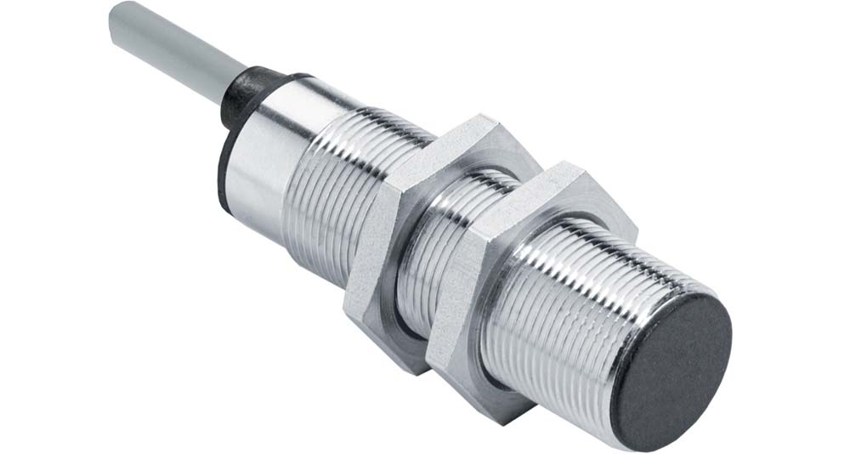
Illustration: IGEX20a inductive proximity switch for zone 0/20 hazardous areas

Illustrations: | igex20a | Char.s: | 987
File name: | 201903046_pm_igex20a_proximity_switch_en | Date: | 07-10-2019
About EGE
EGE-Elektronik Spezial-Sensoren GmbH has been developing and manufacturing special purpose sensors for automation applications since 1976. The company serves leading international producers from a wide range of industries. Its product portfolio includes flow controllers, infrared, opto and ultrasonic sensors, capacitive proximity switches, light barriers and inductive proximity switches. EGE also provides sensors for highly sensitive applications, e.g. hazardous areas. The development department's highly qualified staff cooperates closely with all customers, ensuring continuous product updates and enhancement. A total of 89 employees, including 20 engineers and technicians, generate gross sales of approx. 19.5 million Euros worldwide.

Contact:  EGE-Elektronik Spezial-Sensoren GmbH  Sven-Eric Hiss  Ravensberg 34  24214 Gettorf  Germany  Phone: +49 . 4346 . 4158-0  Fax: +49 . 4346 . 5658  Email: info@ege-elektronik.com  Internet: www.ege-elektronik.com | gii die Presse-Agentur GmbH  Immanuelkirchstr. 12  10405 Berlin  Germany  Phone: +49 . 30 . 538 965-0  Fax: +49 . 30 . 538 965-29  Email: info@gii.de  Internet: www.gii.de

