Press Release

IECEx-certified processing units for intrinsically safe EGE sensors

EGE now offers ATEX- and IECEx-certified signal processing units for the growing range of ATEX- and IECEx-approved two-wire sensors. IECEx certification greatly facilitates exporting the intrinsically safe sensors to many countries around the world – machine manufacturers and plant engineers will find it much easier to use such products in markets where they could not be used previously or required very tedious special certification. Type IKMb 122 Ex signal processing units connect to intrinsically safe EGE two-wire sensors for hazardous gas and dust atmospheres. They feature a space-saving, 22 mm wide DIN rail housing and are installed outside the hazardous area. Green, yellow, and red LEDs on the front side indicate the operating status and signal alarms if the integrated cable breakage detection or the short-circuit monitoring is triggered. The output can be set as normally closed or normally open.

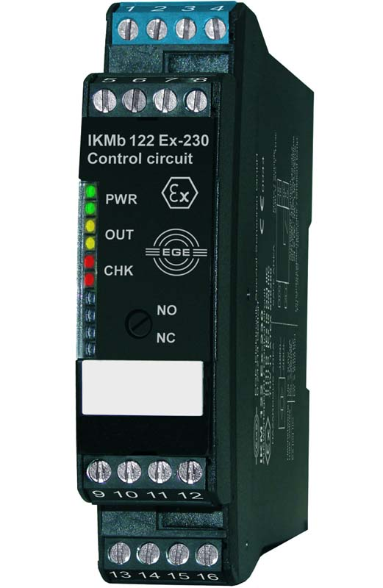
Illustration: The IECEx-certified signal processing unit for installation outside gas and dust explosion hazard zones connects to intrinsically safe two-wire sensors

Illustrations: | IKMb_122_ex | Char.s: | 914
File name: | 201903047_pm_ikmb_processing_unit_en | Date: | 04-01-2019
About EGE
EGE-Elektronik Spezial-Sensoren GmbH has been developing and manufacturing special purpose sensors for automation applications since 1976. The company serves leading international producers from a wide range of industries. Its product portfolio includes flow controllers, infrared, opto and ultrasonic sensors, capacitive proximity switches, light barriers and inductive proximity switches. EGE also provides sensors for highly sensitive applications, e.g. hazardous areas. The development department's highly qualified staff cooperates closely with all customers, ensuring continuous product updates and enhancement. A total of 89 employees, including 20 engineers and technicians, generate gross sales of approx. 19.5 million Euros worldwide.

Contact:  EGE-Elektronik Spezial-Sensoren GmbH  Sven-Eric Hiss  Ravensberg 34  24214 Gettorf  Germany  Phone: +49 . 4346 . 4158-0  Fax: +49 . 4346 . 5658  Email: info@ege-elektronik.com  Internet: www.ege-elektronik.com | gii die Presse-Agentur GmbH  Immanuelkirchstr. 12  10405 Berlin  Germany  Phone: +49 . 30 . 538 965-0  Fax: +49 . 30 . 538 965-29  Email: info@gii.de  Internet: www.gii.de

