Press Release

Custom-assembled level sensors with guided microwave

EGE offers to configure level controllers with guided microwave according to customer specifications. Based on its proven standard level gauge, the German manufacturer is able to adapt the sensors to suit various tank geometries, mounting conditions, or demanding media in no time. Options include angled probes that can be mounted on the side of tanks. EGE employs special materials such as Hastelloy or titanium to manufacture probes for use in aggressive media. EGE also specifically adapts the sensors to dielectric constants and to the temperature ranges of the liquid to be measured to ensure precise results in challenging media and cramped installation conditions.

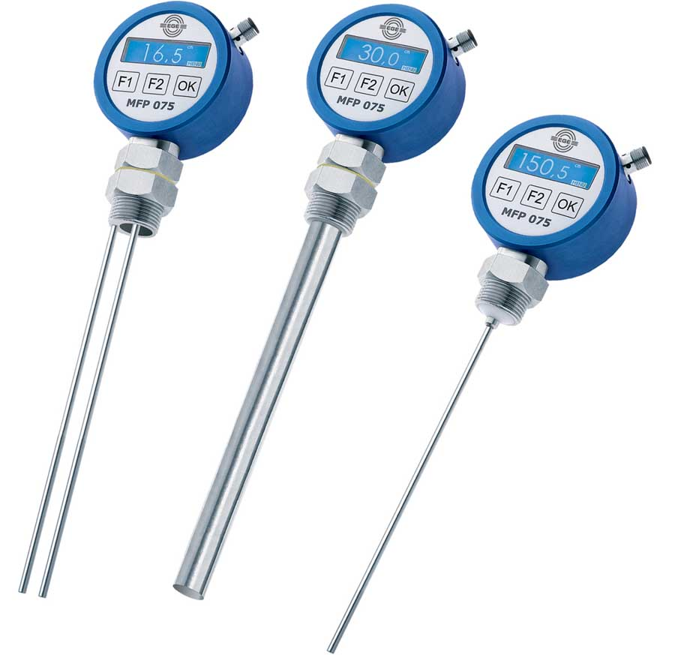
Illustration: Sensor specialist EGE offers to custom-configure level controllers with guided microwave

Illustrations: | MFP_gruppe | Char.s: | 672
File name: | 201903049_pm_mfp_level_controllers_en | Date: | 04-01-2019
About EGE
EGE-Elektronik Spezial-Sensoren GmbH has been developing and manufacturing special purpose sensors for automation applications since 1976. The company serves leading international producers from a wide range of industries. Its product portfolio includes flow controllers, infrared, opto and ultrasonic sensors, capacitive proximity switches, light barriers and inductive proximity switches. EGE also provides sensors for highly sensitive applications, e.g. hazardous areas. The development department's highly qualified staff cooperates closely with all customers, ensuring continuous product updates and enhancement. A total of 89 employees, including 20 engineers and technicians, generate gross sales of approx. 19.5 million Euros worldwide.

Contact:  EGE-Elektronik Spezial-Sensoren GmbH  Sven-Eric Hiss  Ravensberg 34  24214 Gettorf  Germany  Phone: +49 . 4346 . 4158-0  Fax: +49 . 4346 . 5658  Email: info@ege-elektronik.com  Internet: www.ege-elektronik.com | gii die Presse-Agentur GmbH  Immanuelkirchstr. 12  10405 Berlin  Germany  Phone: +49 . 30 . 538 965-0  Fax: +49 . 30 . 538 965-29  Email: info@gii.de  Internet: www.gii.de

