Press Release

High-functionality multimeters

Introducing the METRALINE series, Gossen Metrawatt provides a new family of professional measuring and testing equipment that offers high functionality and reliability at an optimized price–performance ratio. The new product line includes three digital multimeters with different feature sets. All of these are equipped with automatic-blocking sockets, which prevent the incorrect connection of measuring lines and thus provide complete protection for the user. The DM 62 is designed as a TRMS multimeter with true value measurement up to 2 kHz for demanding measurement tasks in AC and DC networks. It covers a voltage range of 100 μV...1000 V and a current measurement range of 10 μA...10 A and furthermore provides all necessary functions for resistance, temperature, frequency, capacitance, and duty cycle measurement, as well as continuity and diode testing. Another model, the DM 61, is a universal multimeter with an adjustable clip for connecting a current clamp. Gossen Metrawatt's WZ1001 current clamp, for instance, is optimally tailored to the DM 61.

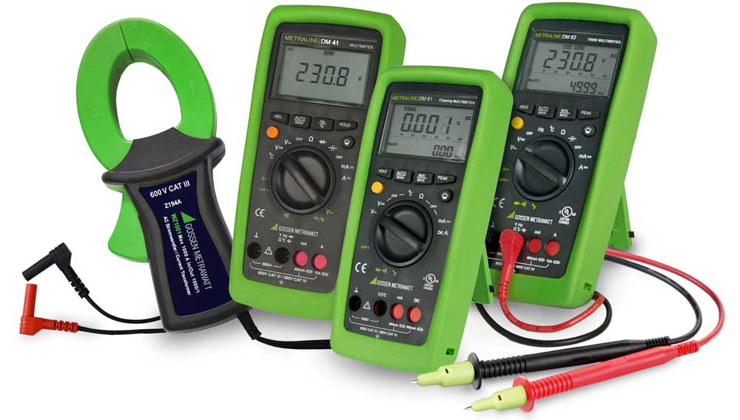
Illustration: The new METRALINE series with three digital multimeters includes TRMS measurement functionality and current clamp adapters

Both these multimeters are secure according to measuring categories CAT IV (300 V) or CAT III (600 V). They feature automatic and manual measurement range selection as well as a backlit dual digital display with an analog scale. The third model, the DM 41, is a non-TRMS multimeter with a versatile range of functions for all standard measuring tasks. In addition, the METRALINE series comprises a DIN VDE 0701-0702 PAT device tester for testing portable equipment, which works with the new IZYTRONIQ testing software via an Android app, as well as a digital a low-resistance ohmmeter for testing protective conductors, ground conductors, and equipotential bonding conductors. Three handy, battery-powered instruments for examining protective measures, specified for checking insulation resistance, RCDs, and loop resistance, respectively, complete the product line. These lightweight testers can be comfortably carried in a belt pouch and are ideal for electricians who have to assure the functional safety of systems.

Illustrations: | metraline_dm_gruppe | Char.s: | 2081
File name: | 201903054_pm_metraline_multimeters_en | Date: | 04-10-2019
About Gossen Metrawatt
GMC-I Messtechnik is one of the world's leading suppliers of measurement systems. Under the GOSSEN METRAWATT brand, the company develops and distributes a wide range of high-quality measuring and test devices for the electrical trade, industry, and the medical sector. The scope of products includes measuring and testing equipment for standardized testing of electrical systems and appliances, multimeters, calibrators, network analyzers, power supplies, as well as transducers and power meters for high-voltage and moving-coil measurement. GMC-I Messtechnik also provides a varied offering of training courses for customers and develops energy management concepts. The corporate group runs its own DakkS-certified calibration center that performs DakkS, ISO, and factory calibrations for virtually all electrical measured values. GMC-I Messtechnik is part of the GMC Instruments group, which also includes other specialized manufacturers for measurement and testing technology – notably, Camille Bauer Metrawatt, Dranetz, Prosys, Seaward and Rigel, and Kurth Electronic. The group's production sites in Germany, Switzerland, England, and the United States are complemented by a global sales network.

Contact:  GMC-I Messtechnik GmbH  Christian Widder  Leitung Marketing Kommunikation  Suedwestpark 15  90449 Nürnberg  Germany  Phone: +49 . 911 . 8602-572  Fax: +49 . 911 . 8602-699  Email: christian.widder@gossenmetrawatt.com  Internet: www.gossenmetrawatt.com | gii die Presse-Agentur GmbH  Immanuelkirchstr. 12  10405 Berlin  Germany  Phone: +49 . 30 . 538 965-0  Fax: +49 . 30 . 538 965-29  Email: info@gii.de  Internet: www.gii.de

