Press Release

Compact device tester for DGUV-compliant testing

Gossen Metrawatt has further expanded its METRALINE product series. Adding the METRALINE PAT, the measurement technology specialist has launched an economical, intuitive device for testing portable equipment in accordance with DGUV Regulation 3. (DGUV is the umbrella association of German statutory occupational accident institutions.) Weighing only 1.3 kg, the compact device tester enables a wide range of protection tests and individual measurements, which can be accessed via shortcut buttons. The tester covers all necessary measurements for repaired or modified electrical devices as well as repeat tests according to DIN VDE 0701-0702. This includes safe and fast testing and measurement of protective conductor resistance, insulation resistance, PE current, touch current, and voltage in SELV circuits.

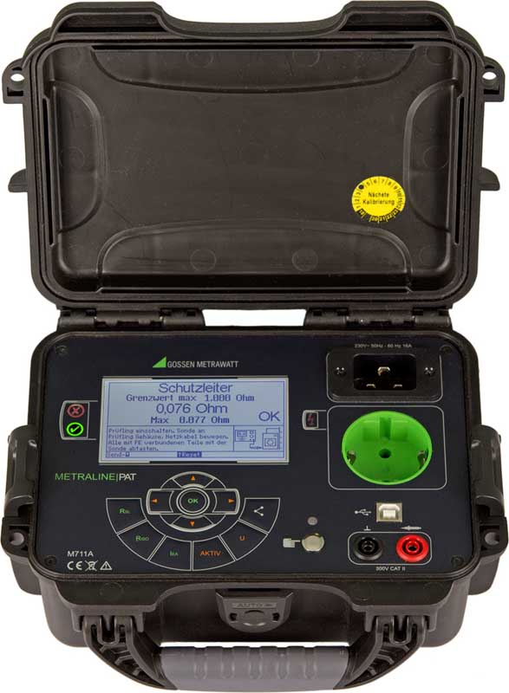
Illustration: The compact portable METRALINE PAT tester covers all necessary tests for mobile equipment in accordance with DGUV Regulation 3

The tester features automatic rating according to normative limits for measuring protective conductor resistance, insulation resistance, leakage currents, and voltages in ELV circuits. All active tests are carried out in just one step, including functional testing and displaying the RMS values. The high-contrast LC display clearly shows selection menus, available settings, limits, measurements, notes, error messages, and I/O settings. Plain text operation with schematic circuit diagrams as well as red and green signaling LEDs for evaluation of measured values simplify testing. The tester runs on 230 VAC mains voltage. The tested device is connected via the 16 A test socket. METRALINE PAT ensures safe testing by checking the protective ground conductor of the power connection, checking the tested device for short circuits, and triggering an automatic shutdown in case of dangerous leakage currents. The tester features USB and Bluetooth interfaces to transmit measurement and test data. This enables operators using the ELEXONIQ METRALINE app (available in the Google Play store) to feed measured values via Bluetooth to the IZYTRONIQ testing software that supports multiple devices.

Illustrations: | metralinepat_front | Char.s: | 2005
File name: | 201904026_pm_metraline_pat_tester_en | Date: | 05-15-2019
About Gossen Metrawatt
GMC-I Messtechnik is one of the world's leading suppliers of measurement systems. Under the GOSSEN METRAWATT brand, the company develops and distributes a wide range of high-quality measuring and test devices for the electrical trade, industry, and the medical sector. The scope of products includes measuring and testing equipment for standardized testing of electrical systems and appliances, multimeters, calibrators, network analyzers, power supplies, as well as transducers and power meters for high-voltage and moving-coil measurement. GMC-I Messtechnik also provides a varied offering of training courses for customers and develops energy management concepts. The corporate group runs its own DakkS-certified calibration center that performs DakkS, ISO, and factory calibrations for virtually all electrical measured values. GMC-I Messtechnik is part of the GMC Instruments group, which also includes other specialized manufacturers for measurement and testing technology – notably, Camille Bauer Metrawatt, Dranetz, Prosys, Seaward and Rigel, and Kurth Electronic. The group's production sites in Germany, Switzerland, England, and the United States are complemented by a global sales network.

Contact:  GMC-I Messtechnik GmbH  Christian Widder  Leitung Marketing Kommunikation  Suedwestpark 15  90449 Nürnberg  Germany  Phone: +49 . 911 . 8602-572  Fax: +49 . 911 . 8602-699  Email: christian.widder@gossenmetrawatt.com  Internet: www.gossenmetrawatt.com | gii die Presse-Agentur GmbH  Immanuelkirchstr. 12  10405 Berlin  Germany  Phone: +49 . 30 . 538 965-0  Fax: +49 . 30 . 538 965-29  Email: info@gii.de  Internet: www.gii.de

