Press Release

Direct Modbus connection to PLCs

GSM-PRO2 series communication modules from CONTA-CLIP feature a Modbus RTU (RS485) interface that enables easy data exchange with other controllers. The modules operate in slave mode and can, for example, provide a PLC with added GSM functionality via an easy plug connection to the RS485 port directly on the C-type mounting rail. The GSM-PRO-CON extension module from CONTA-CLIP makes wiring even simpler. Plugged into the GSM-PRO2 module, it offers front-access terminals for connection to the controller. The GSM-PRO2 parameterization software can be programmed to send a text or email fault message to specified recipients when the status of the PLC input changes. Prompted by a text message that is sent to the GSM-PRO2 module, data is written into the PLC's digital and analog registers via the Modbus RTU interface. The PLC, acting as a master, reads out the data in order to trigger the corresponding actions. Various communication modules with and without GPS functionality are available for all common wireless standards up to 4G. Apps for iPhone and Android devices enable flexible monitoring and control and provide an instant overview over the statuses of several modules at once. Users do not need any programming skills to parameterize the modules. Firmware updates and online configuration changes can be easily carried out at any time via the GSM network, even after installing and commissioning the modules.

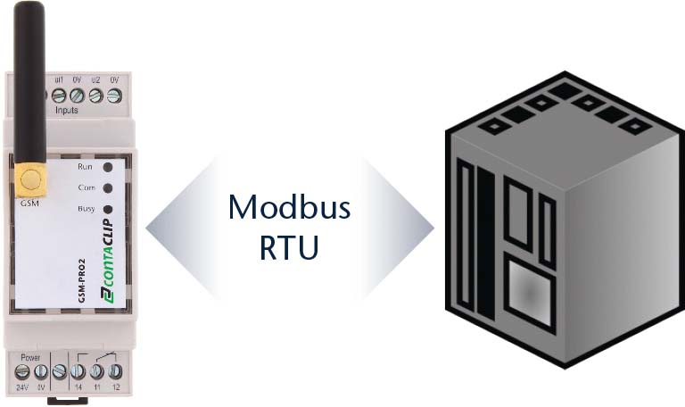
Illustration: The compact communication module features a Modbus RTU interface for easy data exchange with the PLC

Illustrations: | gsm_pro2_sps | Char.s: | 1426
File name: | 201904031_pm_gsm-pro2_modbus_en | Date: | 07-18-2019
About CONTA-CLIP
CONTA-CLIP is one of Europe’s leading manufacturers of electrical and electronic connection elements and cable management solutions. Based in Hövelhof, Germany, the medium-sized, family-run company has been producing electric and electronic connection systems for the process and automation industries for 40 years. CONTA-CLIP supplies all industry sectors, focusing on railroad industries, shipbuilding, building automation, conveyor technology, machine and plant engineering and construction, instrumentation and control technology, control panel manufacturing, transformer manufacturing, and environmental technology. The company consists of three specialized branches: CONTA-CONNECT for electric connection technology, CONTA-ELECTRONICS for electronics and CONTA-CON for PCB edge connectors. Additionally, CONTA-CLIP provides services such as customizing housings and mounting rails, labeling and supplying user-specific electronic components.

Contact:  CONTA-CLIP  Verbindungstechnik GmbH  Christian Quade  Otto-Hahn-Str. 7  33161 Hövelhof  Germany  Phone: +49 . 5257 . 9833 - 0  Fax: +49 . 5257 . 9833 - 33  Email: christian.quade@conta-clip.de  Internet: www.conta-clip.com | gii die Presse-Agentur GmbH  Immanuelkirchstr. 12  10405 Berlin  Germany  Phone: +49 . 30 . 538 965 - 0  Fax: +49 . 30 . 538 965 - 29  Email: info@gii.de  Internet: www.gii.de

