Press Release

Emergency stop switches with M12 plug terminals

Complementing the tried-and-tested pushbuttons, selector switches, keylock switches, and LED signal lamps, RAFI also supplies emergency stop switches in its RAMO product range. RAMO E switches are designed for 22.3 mm and 30.3 mm mounting hole diameters. They feature two NC contacts for a 35 V switching voltage and comply with all relevant ISO and IEC standards. The design ensures simple, time-saving installation. Like all RAMO devices, the emergency stop switches feature easy-assembly M12 plug terminals that require minimum wiring work. Customers can specify any cable length from the manufacturer of their choice for the plug & play solution that guarantees easy commissioning, even by untrained personnel. The RAMO series' hallmark single-part, fully enclosed mono-housings can be mounted directly on aluminum profile rails using the RAMO EDGE mounting bracket. No additional housing is necessary. This makes RAMO operating components a flexible, highly economical standalone solution for distributed industrial applications. All RAMO emergency stop switches provide IP65 ingress protection according to DIN EN 60529 on the front side. Featuring maximum mounting depths of 30.2 mm (RAMO 22 E) or 36.4 mm (RAMO 30 E), they are also suitable for applications with restricted space. The RAMO series is designed to fit the look and dimensions of the RAFIX FS+ series, allowing users to mix and match control components from both series as they wish.
Data for RAMO E – including stp files for import into CAD systems – are available at https://components.rafi.de.

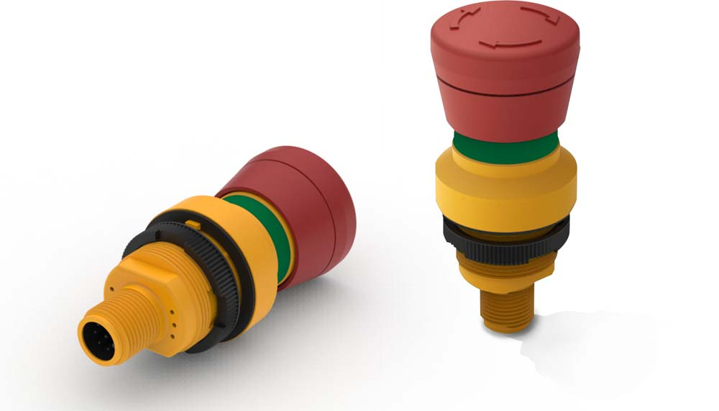
Caption: RAMO emergency stop switches feature single-part, fully enclosed housings and assembly-friendly M12 plug terminals

Image/s: | ramo-estop | Characters: | 1566
File name: | 201906004_pm_ramo_e_e-stop_en | Date: | 10-30-2019
About RAFI
Founded in 1900, RAFI today develops and manufactures electromechanical components and systems for human–machine interaction. The range of products includes pushbuttons, switches, touchscreens, and operating systems, as well as electronic assemblies. RAFI products are employed in automation, medical technology, machine and plant engineering, vehicles, rolling stock, household appliances, and telecommunications. The RAFI group operates internationally with 2,500 employees at sites in Germany, Europe, China, and the USA. Its headquarters are in Berg, Germany.

Contact:  RAFI GmbH & Co. KG  Artur Krug  Ravensburger Str. 128-134  88276 Berg  Germany  Phone: +49 . 751 . 891 307  Fax: +49 . 751 . 891 300  Email: artur.krug@rafi.de  Internet: www.rafi.de | gii die Presse-Agentur GmbH  Immanuelkirchstr. 12  10405 Berlin  Germany  Phone: +49 . 30 . 5389 650  Fax: +49 . 30 . 5389 6529  Email: info@gii.de  Internet: www.gii.de

