Press Release

IP66 cable entries for all shapes and sizes

Connection technology expert CONTA-CLIP supplies versatile components for simple and time-saving cable management. The tool-less KDS and KES cable entry systems enable easy routing and flexible rearrangement of cables and conduits in enclosures and control cabinets, with reliable strain relief and IP66 ingress protection. To install any number of differently sized and shaped cables, enclosures no longer need to be fitted with variously sized openings, reducing the machining effort to a minimum. This enables manufacturers to supply fully sealed, preconfigured machine enclosures and control cabinets without knowing the exact final wiring requirements.

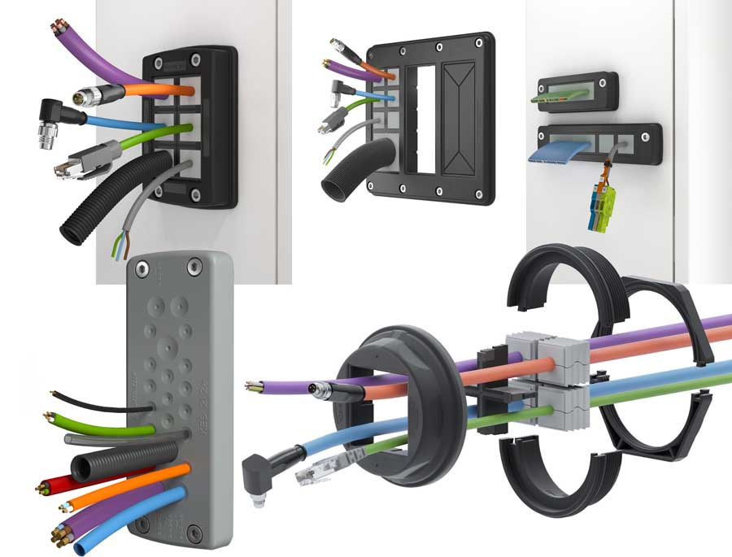
Illustration: The KDS and KES product families enable easy, variable cable management for all diameters and shapes

One-piece KES plates with push-through membranes enable high-density routing of up to 32 unassembled cables, wires, or conduits. The multi-part KDS system features a frame that can always stay in place once it is installed – removable sealing elements in different sizes can be inserted to change the assembly as needed. As a result, stock-keeping costs are also significantly reduced, since there is no need for various same-size enclosures with a range of different prepared openings. The KDSClick system consists of only three basic components: frames, inlays, and sealing elements. The sealing elements are available in over 100 variants for diameters ranging from 2 mm to 35 mm, with 1, 2, and 4 slots, for industrial flat ribbon cables, and as blind plugs. The frames are available for 4, 6, 8, or 10 sealing elements. Featuring an injected foam gasket, they preserve the IP66 protection rating even on painted or rough surfaces. To accommodate the selected sealing elements, various inlays (available in I, T, +, and ++ shapes) can be simply inserted in the frame. KDS-FP flange plates hold two or three KDSClick modules and provide space for a total of up to 30 sealing element positions, making them ideal for control cabinets that require a lot of wiring. CONTA-CLIP furthermore offers the KDS-R series for quick, tool-less assembly in metric M20 to M63 round enclosure openings. This system consists of a frame with an integrated gasket, a thread and locking adapter, a locknut, and sealing elements with optional inlays. The KDS program also includes KDS-FB frames for industrial flat ribbon cables. These are available in four frame widths and different partitions for flat as well as round cables.

Illustrations: | kes-kds-gruppe | Char.s: | 2368
File name: | 201906020_pm_kds_kes_cable_entries_en | Date: | 06-19-2019
About CONTA-CLIP
CONTA-CLIP is one of Europe’s leading manufacturers of electrical and electronic connection elements and cable management solutions. Based in Hövelhof, Germany, the medium-sized, family-run company has been producing electric and electronic connection systems for the process and automation industries for 40 years. CONTA-CLIP supplies all industry sectors, focusing on railroad industries, shipbuilding, building automation, conveyor technology, machine and plant engineering and construction, instrumentation and control technology, control panel manufacturing, transformer manufacturing, and environmental technology. The company consists of three specialized branches: CONTA-CONNECT for electric connection technology, CONTA-ELECTRONICS for electronics and CONTA-CON for PCB edge connectors. Additionally, CONTA-CLIP provides services such as customizing housings and mounting rails, labeling and supplying user-specific electronic components.

Contact:  CONTA-CLIP  Verbindungstechnik GmbH  Christian Quade  Otto-Hahn-Str. 7  33161 Hövelhof  Germany  Phone: +49 . 5257 . 9833 - 0  Fax: +49 . 5257 . 9833 - 33  Email: christian.quade@conta-clip.de  Internet: www.conta-clip.com | gii die Presse-Agentur GmbH  Immanuelkirchstr. 12  10405 Berlin  Germany  Phone: +49 . 30 . 538 965 - 0  Fax: +49 . 30 . 538 965 - 29  Email: info@gii.de  Internet: www.gii.de

