Press Release

Compact, highly reliable pushbuttons and Emergency Stop buttons

RAFI's LUMOTAST 16 pushbuttons and illuminated pushbuttons for 16.2 mm mounting holes are especially suitable for handheld control devices, or any application that requires robust switch functions in a low profile. They are very compact and provide distinct haptic feedback. The series offers various design options and allows for individual labeling, to create appealing customer-specific user interfaces. LUMOTAST 16 pushbuttons have an external diameter of only 22.3 mm and fit in 25 mm x 25 mm arrays. They take up very little space inside the housing, featuring a mounting depth of only 18 mm.

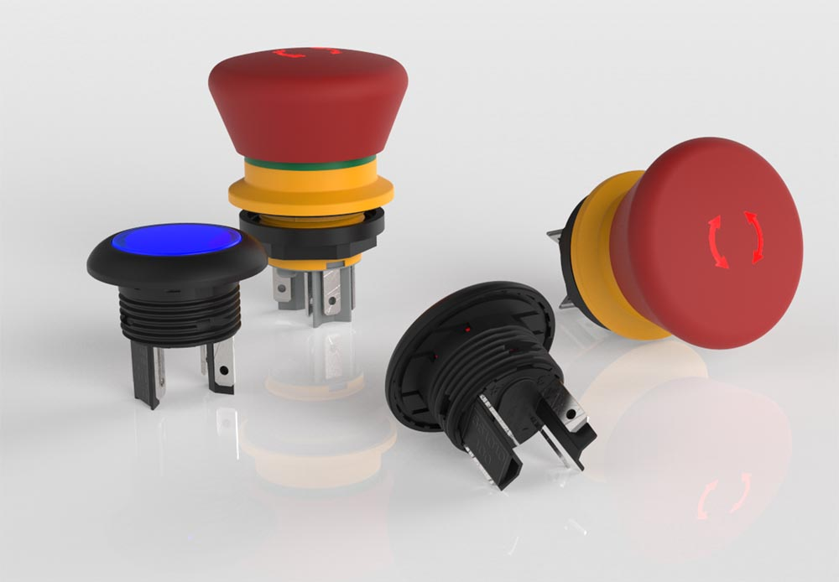
Illustration 1: The LUMOTAST 16 series provides a wide range of compact pushbuttons and Emergency Stop pushbuttons

Complementing the (illuminated) pushbutton range, the series also includes different types of Emergency Stop pushbuttons: an innovative active/inactive version for detachable or wireless control units has a translucent plastic mushroom head that lights up red when properly connected to the Emergency Stop function of the machine/system. When inactive, the mushroom is colorless and cannot be mistaken for an E-Stop according to DIN EN ISO 13850. The second alternative in the series are conventional Emergency Stop pushbuttons with one or two NC contacts or two NC and one NO contact. Installing the devices takes mere seconds: once inserted into the mounting hole, they are attached by a single threaded nut behind the housing front panel. They can easily be connected via 2.8 x 0.5 mm quick-connect terminals. Bezels are available in six colors according to EN 60073, to clearly show what function has been assigned to a switch. The C-LAB variant additionally offers colored or metallized front rings. C-LAB legend inserts and bezels allow for customer-specific labeling of the pushbuttons. RAFI can also supply LUMOTAST 16 pushbuttons with customer-specific printing upon request. The switch contacts utilize high-quality gold contacts to ensure precise switching in harsh environments in the long term. Emergency Stop pushbuttons for large currents are available with silver contacts. All pushbuttons and E-Stops feature IP65/IP67 ingress protection.

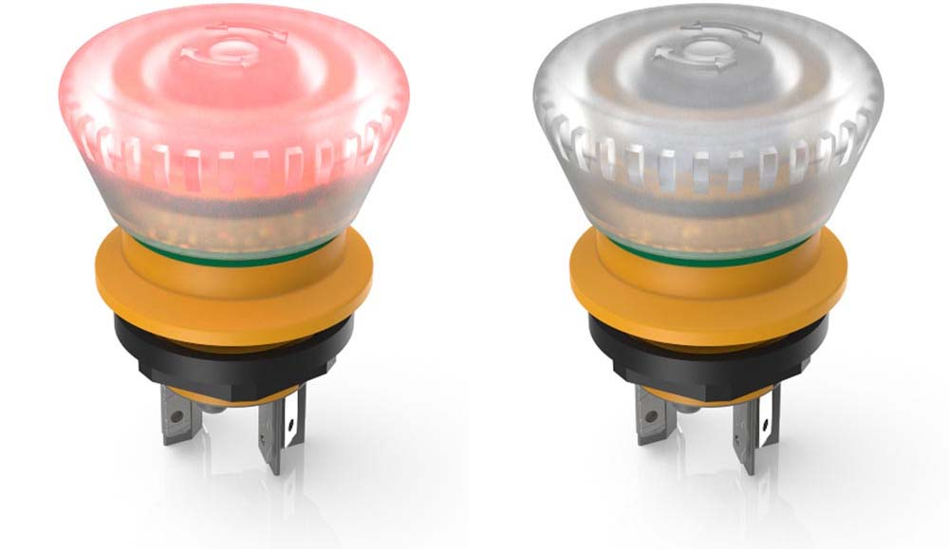
Illustration 2: The LUMOTAST 16 kill switch changes its color to red only when its Emergency Stop function is active

Illustrations: | LUMOTAST_16_Gruppe  LUMOTAST16_E-stop_active_inactive | Char.s: | 2053
File name: | 201907010_pm_lumotast_16_pushbuttons_en | Date: | 07-31-2019
About RAFI
Founded in 1900, RAFI now develops and produces electromechanical components such as pushbuttons and switches, operating systems such as touch screens, keyboards, electronic components, and systems for man-machine communication. RAFI products are employed in more than 30 industries, e.g., in medical equipment, mechanical engineering, road and railway vehicles, household appliances, and telecommunications. The RAFI group operates internationally with approx. 2,500 employees at ten sites in Germany, Europe, China, and the USA. The group’s headquarters are located in Berg (Baden-Württemberg, Germany).

Contact:  RAFI GmbH & Co. KG  Artur Krug  Ravensburger Str. 128-134  88276 Berg  Germany  Phone: +49 . 751 . 891 307  Fax: +49 . 751 . 891 300  Email: artur.krug@rafi.de  Internet: www.rafi.de | gii die Presse-Agentur GmbH  Immanuelkirchstr. 12  10405 Berlin  Germany  Phone: +49 . 30 . 5389 650  Fax: +49 . 30 . 5389 6529  Email: info@gii.de  Internet: www.gii.de

