Press Release

Tactile control elements for blind operation of industrial touchscreens

RAFI provides tactile control solutions for its GLASSCAPE industrial touchscreens in applications that require the operator's constant attention. The innovative FLEXSCAPE ONE and FLEXSCAPE WHEEL control elements are integrated directly into the touchscreen surface, enabling safe blind operation. The FLEXSCAPE ONE pushbutton is used for tactile switching. It is activated by touch and requires a threshold pressure to trigger actuation. Actuation is confirmed by distinctive haptic and acoustic feedback. The FLEXSCAPE WHEEL rotary button enables users to select functions or set parameters according to context. Featuring regular indentations, the circular finger guidance provides haptic orientation without looking. Due to their compatible geometries, both control elements can also be combined into one element covering all functions for additional operating safety. For example, customers can specify that functions or values selected by wheel must be confirmed by pressing the button. RAFI equips its touchscreens with several FLEXSCAPE elements anywhere on the closed glass surface according to customer specifications. The touchscreen keeps its high degrees of resilience and ingress protection, since the actuators are fixed without cut-outs or holes in the surface. Additional diagnostic electronics are not required. Needing no elaborate surface preparation, FLEXSCAPE models are a low-cost alternative to milled contours.

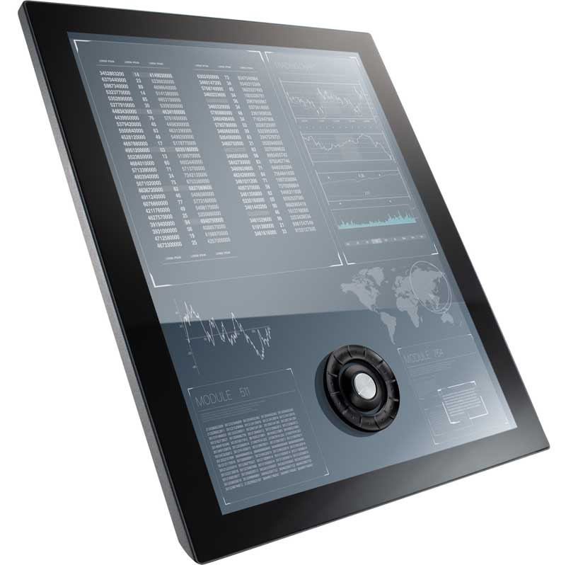
Caption: The combination of FLEXSCAPE WHEEL and FLEXSCAPE ONE tactile control elements enables safe blind operation of industrial touchscreens

Image/s: | flexscape_one_wheel | Characters: | 1434
File name: | 201909013_pm_flexscape_controls_en | Date: | 09-18-2019
About RAFI
Founded in 1900, RAFI now develops and produces electromechanical components such as pushbuttons and switches, operating systems such as touch screens, keyboards, electronic components, and systems for man-machine communication. RAFI products are employed in more than 30 industries, e.g., in medical equipment, mechanical engineering, road and railway vehicles, household appliances, and telecommunications. The RAFI group operates internationally with approx. 2,500 employees at ten sites in Germany, Europe, China, and the USA. The group’s headquarters are located in Berg (Baden-Württemberg, Germany).

Contact:  RAFI GmbH & Co. KG  Artur Krug  Ravensburger Str. 128-134  88276 Berg  Germany  Phone: +49 . 751 . 891 307  Email: artur.krug@rafi.de  Internet: www.rafi.de | gii die Presse-Agentur GmbH  Immanuelkirchstr. 12  10405 Berlin  Germany  Phone: +49 . 30 . 538 9650  Email: info@gii.de  Internet: www.gii.de

