Press Release

Agritechnica: Operating solutions for agricultural machinery and commercial vehicles

RAFI presents its innovative control components and operating solutions for agricultural machinery and commercial vehicles at the 2019 Agritechnica trade show in Hanover, Germany, in Hall 17, at Booth B19. The HMI specialist particularly highlights armrest systems developed for VALTRA tractors and PistenBully snow plows, the extended JOYSCAPE joystick platform, the new touchscreen input technology TWIN TOUCH, the RAFIX 22 FSR series of control and signal components, and the RAMO pushbutton series. Trade show visitors are welcome to test the SmartTouch armrest of current VALTRA tractors in an agricultural simulator. This integrated control system, manufactured entirely by RAFI and awarded with the Red Dot Design Award for its ergonomics, allows operators to customize all functions.

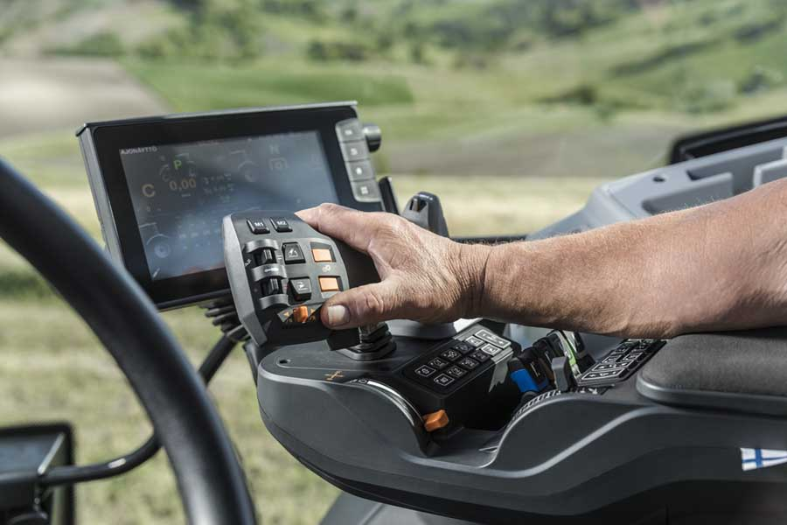
Caption: RAFI has developed the multifunctional lever for VALTRA tractors based on its JOYSCAPE joystick platform (photo credit: Valtra)

As further proof of its development competence, RAFI presents the armrest control panel designed for the Kässbohrer PistenBully. Both the innovative multifunction lever and the four-axis joystick for controlling the snow plow blade are based on RAFI's JOYSCAPE joystick platform, which enables speedy customization of levers and joysticks for all kinds of applications and with varying degrees of complexity. Additional showcases include a joystick for the latest generation of Fendt tractors and the new elementary component JOYSCAPE TINY, an extremely compact thumb joystick for space-saving integration into joystick handles. RAFI's new TWIN TOUCH input technology is an innovation in the field of PCAP touchscreens for mobile machinery. It combines touch and force detection, preventing accidental incorrect input and enabling new safety and input functions. There is a working model at the booth, which visitors are invited to try out themselves. RAFI furthermore exhibits electronic assemblies that the company produces as an EMS service provider for manufacturers of mobile machinery and industrial vehicles. Also on display, RAFIX 22 FSR control and signal components boast high thermal resistance, high resistance to dirt and dust, and tolerate cleaning with high-pressure cleaners. To complete the selective overview of RAFI's extensive portfolio, RAMO pushbuttons are especially suited for easy integration in offset applications and require no additional housing.

Visit RAFI at the 2019 Agritechnica exhibition!
Hanover, Germany, 10 – 16 November 2019
Hall 17, Booth B19

Image/s: | smarttouch_hand_Bildquelle_Valtra | Characters: | 2266
File name: | 201911007_pm_agritechnica_en | Date: | 11-11-2019
About the RAFI group
Founded in 1900, RAFI today develops and manufactures electromechanical components and systems for human–machine interaction. The range of products includes pushbuttons, switches, touchscreens, and operating systems, as well as electronic assemblies. RAFI products are employed in automation, medical technology, machine and plant engineering, vehicles, rolling stock, household appliances, and telecommunications. The RAFI group operates internationally with 2,500 employees at sites in Germany, Europe, China, and the USA. Its headquarters are in Berg, Germany.

Contact:  RAFI GmbH & Co. KG  Artur Krug  Ravensburger Str. 128-134  88276 Berg  Germany  Phone: +49 . 751 . 891 307  Email: artur.krug@rafi.de  Internet: www.rafi.de | gii die Presse-Agentur GmbH  Immanuelkirchstr. 12  10405 Berlin  Germany  Phone: +49 . 30 . 538 9650  Email: info@gii.de  Internet: www.gii.de

