Press Release

Versatile new battery tester

Introducing a portable battery tester, Gossen Metrawatt expands its lineup of measuring and test devices, which help professionals ensure the safe configuration and functioning of electrical equipment. The brand-new METRACELL BT Pro is a versatile solution for testing battery storage systems in DC voltage infrastructures. Above and beyond the required capacity tests, this battery tester can also perform demanding maintenance tasks – it detects premature aging of batteries and thus assures that projected energy output levels are met. For this purpose, the tester measures the electrical and electrochemical resistance, which increase with battery use and aging. A temperature sensor can be connected to the device. Additional METRACELL BT Pro functions include interval measurement with simultaneous logging of the battery block's or battery system's voltage up to 600 V and of the charging/discharge current. An integrated RFID transponder system facilitates efficient management of all necessary measurement tasks for hundreds of energy storage facilities and helps eliminate sources of error. The METRACELL BT Pro tester features an interface for Anton Paar DMA35 density sensors to allow maintenance personnel to determine the essential density and temperature values for closed batteries.

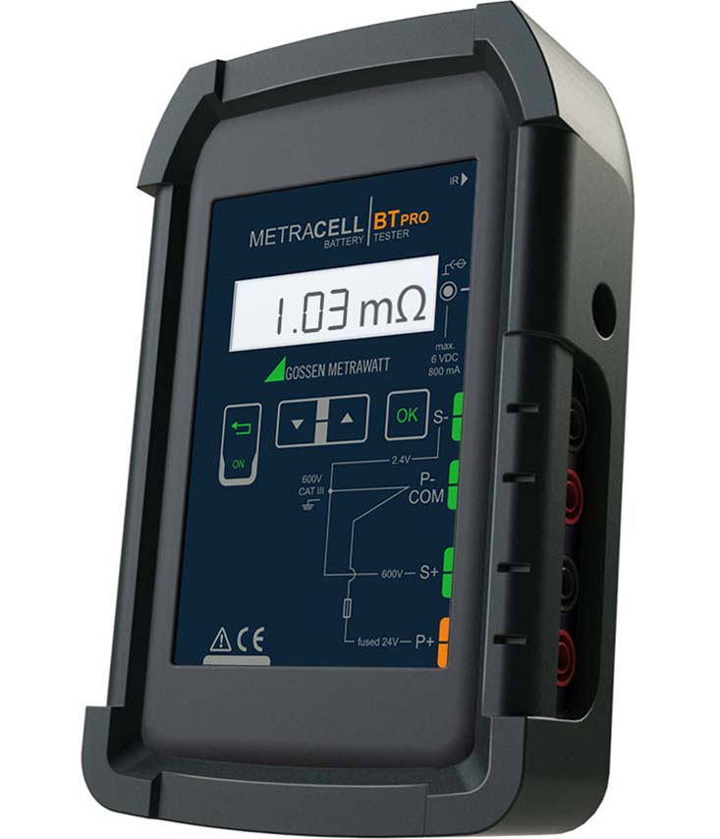
Caption: The new METRACELL BT Pro battery tester from Gossen Metrawatt enables professional functional testing and maintenance of battery storage systems

Image/s: | bt-metracell_2000 | Characters: | 1298
File name: | 201911022_pm_metracell_battery_tester_en | Date: | 12-04-2019
About Gossen Metrawatt
GMC-I Messtechnik is one of the world's leading suppliers of measurement systems. Under the GOSSEN METRAWATT brand, the company develops and distributes a wide range of high-quality measuring and test devices for the electrical trade, industry, and the medical sector. The scope of products includes measuring and testing equipment for standardized testing of electrical systems and appliances, multimeters, calibrators, network analyzers, power supplies, as well as transducers and power meters for high-voltage and moving-coil measurement. GMC-I Messtechnik also provides a varied offering of training courses for customers and develops energy management concepts. The corporate group runs its own DakkS-certified calibration center that performs DakkS, ISO, and factory calibrations for virtually all electrical measured values. GMC-I Messtechnik is part of the GMC Instruments group, which also includes other specialized manufacturers for measurement and testing technology – notably, Camille Bauer Metrawatt, Dranetz, Prosys, Seaward and Rigel, and Kurth Electronic. The group's production sites in Germany, Switzerland, England, and the United States are complemented by a global sales network.

Contact:  GMC-I Messtechnik GmbH  Christian Widder  Leitung Marketing Kommunikation  Suedwestpark 15  90449 Nuremberg  Germany  Phone: +49 . 911 . 8602-572  Email: christian.widder@gossenmetrawatt.com  Internet: www.gossenmetrawatt.com | gii die Presse-Agentur GmbH  Immanuelkirchstr. 12  10405 Berlin  Germany  Phone: +49 . 30 . 538 9650  Email: info@gii.de  Internet: www.gii.de

