Press Release

New IO-Link level controllers from EGE

EGE introduces a new generation of level controllers with guided microwave: the MFN series sensors feature an IO-Link interface and thereby enable continuous access of PLCs to process and parameterization data. Using a corresponding master, the level controllers can be connected to any common bus system and conveniently parameterized via PC or notebook. The guided microwave measuring principle ensures high reliability due to its insensitivity to external influences such as temperature, pressure, or density. It provides for precise measurements in liquids such as water, oil, and emulsions as well as in viscous media. MFN sensors stand out due to their particularly short reaction times in case of level changes. Their display units can be configured to show the measured level in mm, cm, inch, liter, or percent. The housings can be rotated by 360° along with integrated LED indicators and control panels, allowing users easy access for configuring the devices and reading measured values. The level controllers feature IP67 ingress protection and are designed for an ambient temperature range of -25 °C to +85 °C. EGE's level controller portfolio includes variants with coaxial, single, and double probes for use in different media. The company also manufactures probes from special materials such as Hastelloy or titanium for use in aggressive media. Moreover, EGE also adapts sensors to customer-specific tank geometries and difficult installation conditions, on request.

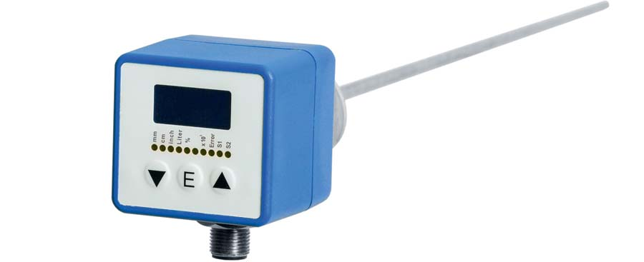
Caption: EGE supplies its new MFN level controllers with guided microwave and IO-Link interface with coaxial, single, or double probes

Image/s: | MFN_075_GAPL | Characters: | 1481
File name: | 201911035_pm_mfn_level_controllers_en | Date: | 02-05-2020
About EGE
EGE-Elektronik Spezial-Sensoren GmbH has been developing and manufacturing special purpose sensors for automation applications since 1976. The company serves leading international producers from a wide range of industries. Its product portfolio includes flow controllers, infrared, opto and ultrasonic sensors, capacitive proximity switches, light barriers and inductive proximity switches. EGE also provides sensors for highly sensitive applications, e.g. hazardous areas. The development department's highly qualified staff cooperates closely with all customers, ensuring continuous product updates and enhancement. A total of 89 employees, including 20 engineers and technicians, generate gross sales of approx. 19.5 million Euros worldwide.

Contact:  EGE-Elektronik Spezial-Sensoren GmbH  Sven-Eric Hiss  Ravensberg 34  24214 Gettorf  Germany  Phone: +49 . 4346 . 4158-0  Fax: +49 . 4346 . 5658  Email: info@ege-elektronik.com  Internet: www.ege-elektronik.com | gii die Presse-Agentur GmbH  Immanuelkirchstr. 12  10405 Berlin  Germany  Phone: +49 . 30 . 538 965-0  Fax: +49 . 30 . 538 965-29  Email: info@gii.de  Internet: www.gii.de

