Press Release

Enhanced-sensitivity amplifier for industrial metal detectors

EGE has developed a new compact, rugged MDVH amplifier with enhanced sensitivity for its System 3000 industrial metal detector. The completely redesigned amplifier is characterized by higher adjustable sensitivity levels, reduced susceptibility to interference, and a more robust housing with IP67 ingress protection. Featuring automatic self-calibration, the unit works reliably even if the detector coil comes near metal fittings. Users can adjust the sensitivity of the detector coil as required via a rotary potentiometer on the housing front. The amplifier has a 260 x 160 x 90 mm wide aluminum housing. It is designed for an extended temperature range of -25 °C to +70 °C. EGE's System 3000 is used in conveyor lines for noncontact detection of metal parts that could damage downstream machines or degrade the quality of bulk solids. Thanks to its rugged design, it is suited for outdoor use in harsh and dirty environments. The size of detected parts varies for different models. The MDVH unit is optimized for medium-sized parts such as nails, nuts, wire, or silverware. MDV series devices are designed to protect machinery by identifying larger metal parts such as excavation bucket teeth or parts of tools and enclosures.

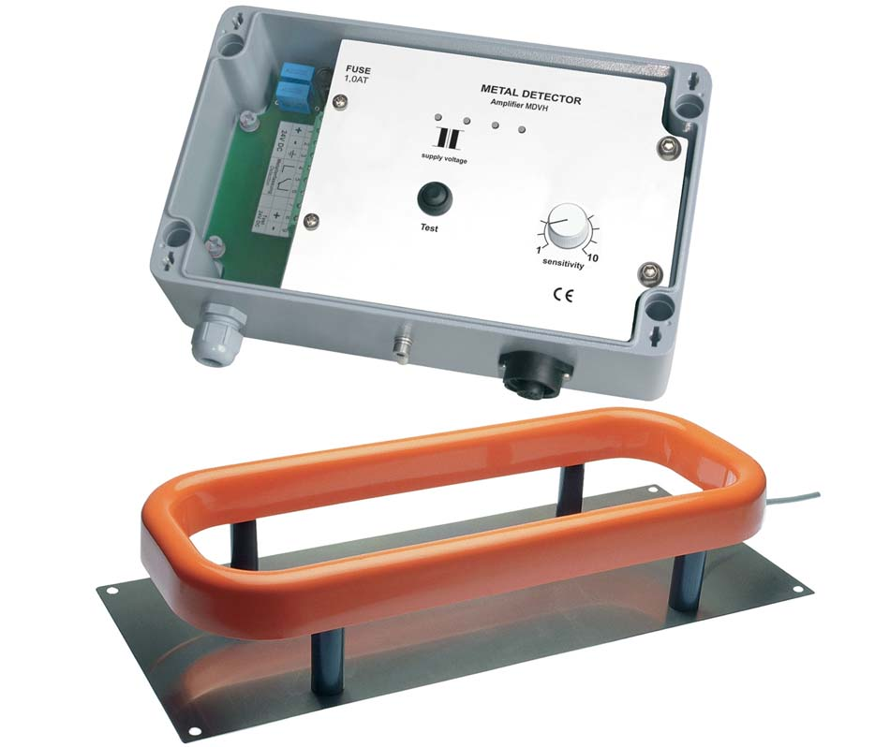
Caption: EGE has developed a new compact and robust amplifier with enhanced sensitivity for its System 3000 metal detector

Image/s: | MDVH_3161 | Characters: | 1231
File name: | 201911036_pm_mdvh_metal_detector_amplifier_en | Date: | 01-09-2020
About EGE
EGE-Elektronik Spezial-Sensoren GmbH has been developing and manufacturing special purpose sensors for automation applications since 1976. The company serves leading international producers from a wide range of industries. Its product portfolio includes flow controllers, infrared, opto and ultrasonic sensors, capacitive proximity switches, light barriers and inductive proximity switches. EGE also provides sensors for highly sensitive applications, e.g. hazardous areas. The development department's highly qualified staff cooperates closely with all customers, ensuring continuous product updates and enhancement. A total of 89 employees, including 20 engineers and technicians, generate gross sales of approx. 19.5 million Euros worldwide.

Contact:  EGE-Elektronik Spezial-Sensoren GmbH  Sven-Eric Hiss  Ravensberg 34  24214 Gettorf  Germany  Phone: +49 . 4346 . 4158-0  Fax: +49 . 4346 . 5658  Email: info@ege-elektronik.com  Internet: www.ege-elektronik.com | gii die Presse-Agentur GmbH  Immanuelkirchstr. 12  10405 Berlin  Germany  Phone: +49 . 30 . 538 965-0  Fax: +49 . 30 . 538 965-29  Email: info@gii.de  Internet: www.gii.de

