Press Release

RAMO K: Keylock switch with M12 terminal for stand-alone assembly

The keylock switches from RAFI’s RAMO K range offer a rugged, fast-assembly control solution for decentralized applications where it is necessary to lock critical actuation functions. Like all control elements and indicators from the RAMO program, the keylock switches do not require any additional installation housing. The completely closed housing with IP65 degree of protection and the M12 terminal ensure rapid on-site assembly without time-consuming manual wiring. Thanks to the Plug&Play connection via standard M12 plug terminals, even untrained personnel can commission the devices from the RAMO 22 and RAMO 30 series for 22.3 mm or 30.3 mm mounting holes. With the RAMO EDGE 90° mounting angle for individual mounting, the switches can also be mounted as required on any vertical surface and on 40-mm profile rails. RAFI supplies the RAMO K keylock switches in a variety of types with rotating angles of 40°, 60°, or 90° as well as various rotating angle shapes. The switches are also available with distinctive haptic qualities for up to three switching positions with momentary contact, latching, or combined actuating functions. The RAMO 22 and 30 models differ not only in their dimensions, but also in design, with black front rings made of synthetic material or flat stainless-steel front rings.
RAFI presents the RAMO range of operating and indicating elements as well as feedthroughs at www.rafi.de/en/ramo-2230.

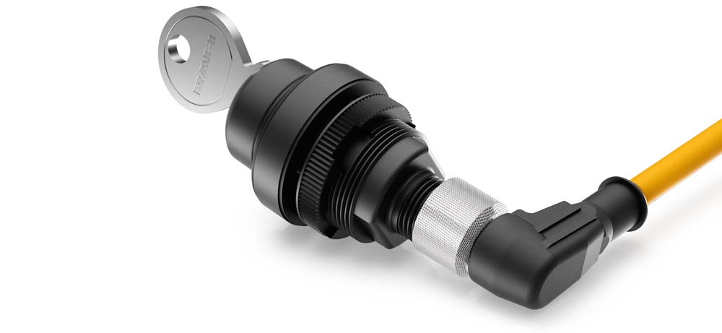
Caption: Keylock switch from the RAMO K series with M12 terminal

Image/s: | RAMO22_K | Characters: | 1430
File name: | 201911037_pm_ramo_k_en | Date: | 12-04-2019
About the RAFI group
Founded in 1900, RAFI today develops and produces electromechanical components and systems for human–machine interaction. The range of products includes pushbuttons, switches, touchscreens, control systems and electronic assemblies. RAFI products are employed in many industries including automation, medical technology, machine and plant engineering, road and railway vehicles, household appliances and telecommunication. The RAFI group operates internationally with approx. 2,500 employees at sites in Germany, Europe, China and the USA. Its headquarters are in Berg, Germany.

Contact:

RAFI GmbH & Co. KG
Artur Krug
Ravensburger Str. 128-134
88276 Berg
Germany
Phone: +49 . 751 . 891 307
Email: artur.krug@rafi.de
Internet: www.rafi.de

