Press Release

Leading-edge control solutions from RAFI

RAFI exhibited its developments and products in the field of control components, system components, and capacitive input technologies at the 2019 SPS trade show in Nuremberg, Germany. Introducing Smart Solutions, RAFI presented a new technology concept for wireless condition and progress signaling for use in intralogistics processes. The portal-based system intelligently links mobile pushbutton units with freely positionable signal lamps via WiFi. What makes Smart Solutions stand out are the universal application options, simple use, and fast setup. The pushbutton boxes and signal lamps integrate WiFi interfaces. The units come with an unambiguous ID and a USB port connector. To start up the system, the user simply logs in to the RAFI portal once, defines the linking logic required, and saves a digital twin of its application. Another RAFI highlight at the trade fair was a representative cross-section of the company’s solutions for renowned customers in machine and plant engineering, automotive and commercial vehicle manufacturing, communications electronics, and household appliances. The product range on show covered everything from handheld units and operating panels to electronic assemblies and fully integrated complete solutions for commercial vehicle control.

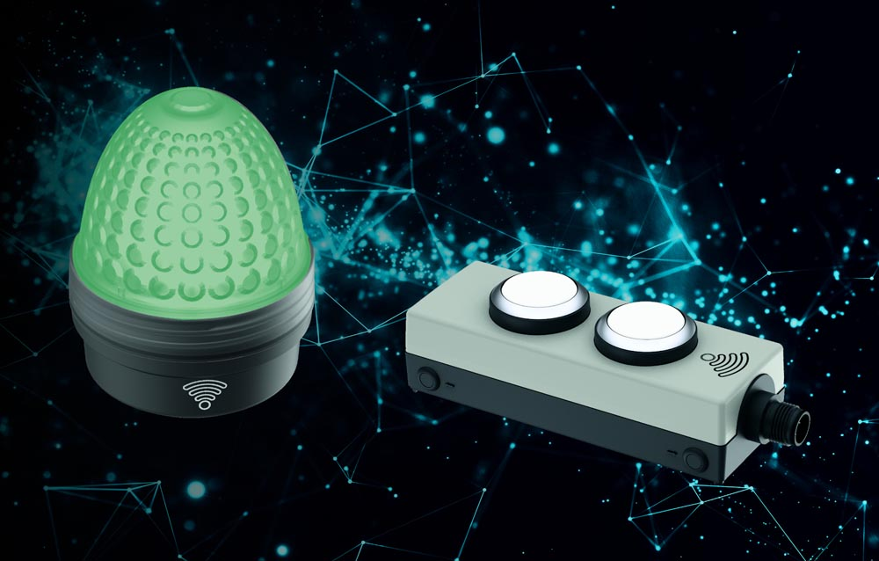
Caption: RAFI also presented Smart Solutions, its new, portal-based signaling system

RAFI is not only one of Germany’s largest contract manufacturers of electronics, but also ranks among Europe’s leading manufacturers of capacitive industrial touchscreens. With its Twin Touch technology, RAFI has launched a new generation of industrial touch data entry systems featuring combined touch and force detection. This solution prevents accidental input errors and opens up scope for new input levels. It means users can select or set function menus or parameters by varying the pressure exerted on the display. Another innovation, the mechanical key switches and finger guidance solutions in the FLEXSCAPE range enable reliable blind operation of touchscreen functions. The touchscreen keeps its high degrees of resilience and ingress protection because the actuators are fixed without openings or holes in the surface. Other areas of the trade fair stand were dedicated to compact embedded control units (ECU) for HMIs and control systems, new basic models for the JOYSCAPE joystick platform, and RAFI’s successful switch and key switch programs.

Image/s: | smartsolutions | Characters: | 2342
File name: | 201912001_pm_sps_trade_show_en | Date: | 12-04-2019
About the RAFI group
Founded in 1900, RAFI today develops and produces electromechanical components and systems for human–machine interaction. The range of products includes pushbuttons, switches, touchscreens, control systems and electronic assemblies. RAFI products are employed in many industries including automation, medical technology, machine and plant engineering, road and railway vehicles, household appliances and telecommunication. The RAFI group operates internationally with approx. 2,500 employees at sites in Germany, Europe, China and the USA. Its headquarters are in Berg, Germany.

Contact:

RAFI GmbH & Co. KG
Artur Krug
Ravensburger Str. 128-134
88276 Berg
Germany
Phone: +49 . 751 . 891 307
Email: artur.krug@rafi.de
Internet: www.rafi.de

