Press Release

Blind plates for sealing enclosure openings

CONTA-CLIP adds new KDS-BP blind plates to the range of accessories for its proven KES cable entry and KDS cable feedthrough systems. The black screw-on blind plates are designed for quickly and reliably closing pre-configured enclosure openings with standard dimensions of 86 mm x 36 mm and 112 mm x 36 mm. The plates made of impact-resistant PA 6.6 feature an all-round injected TPE gasket. They protect the inside of machines or control cabinets from dust and strong jet water according to IP66.

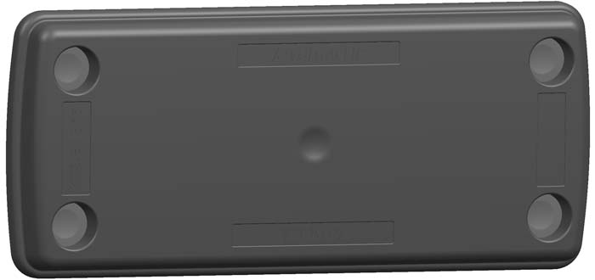
Caption: KDS-BP blind plates enable provisional sealing of enclosure openings

Image/s: | KDS-BP_8-16 | Characters: | 498
File name: | 201912016_pm_kds-bp_blind_plates_en | Date: | 01-29-2020
About CONTA-CLIP
CONTA-CLIP is one of Europe’s leading manufacturers of electrical and electronic connection elements and cable management solutions. Based in Hövelhof, Germany, the medium-sized, family-run company has been producing electric and electronic connection systems for the process and automation industries for 40 years. CONTA-CLIP supplies all industry sectors, focusing on railroad industries, shipbuilding, building automation, conveyor technology, machine and plant engineering and construction, instrumentation and control technology, control panel manufacturing, transformer manufacturing, and environmental technology. The company consists of many specialized branches: CONTA-CONNECT for electric connection technology, CONTA-CABLE for cable management systems, CONTA-ELECTRONICS for electronics and CONTA-CON for PCB edge connectors. Additionally, CONTA-CLIP provides services such as customizing housings and mounting rails, labeling and supplying user-specific electronic components.

Contact:  CONTA-CLIP  Verbindungstechnik GmbH  Christian Quade  Otto-Hahn-Str. 7  33161 Hövelhof  Germany  Phone: +49 . 5257 . 9833 - 0  Fax: +49 . 5257 . 9833 - 33  Email: christian.quade@conta-clip.de  Internet: www.conta-clip.com | gii die Presse-Agentur GmbH  Immanuelkirchstr. 12  10405 Berlin  Germany  Phone: +49 . 30 . 538 965 - 0  Fax: +49 . 30 . 538 965 - 29  Email: info@gii.de  Internet: www.gii.de

