Press Release

LogiMAT exhibition: New Embedded Vision approaches

Vision Components will present its latest embedded vision systems and MIPI camera modules at the 2020 LogiMAT trade fair in Stuttgart, Germany. Co-exhibitor Retenua will demonstrate its advanced driver assistance system (ADAS) for forklift trucks, which is based on an intelligent VC stereo camera. The board camera detects the reflective stripes on high-visibility clothing and prevents accidents and injuries. This innovative approach is very effective at low system costs. The near-infrared flash is another new feature of this type of camera-based ADAS; it ensures very good results both in the dark and in bright sunlight. Vision Components pursues a new approach to OEM projects, launching its VC MIPI range. These high-tech components enable easy connection of various image sensors to more than 20 CPU boards, including NVIDIA Jetson, DragonBoard, all Raspberry Pi boards, and all 96Boards. Vision Components has even integrated non-native MIPI sensors in MIPI camera modules, using a specially developed adapter board. Examples for these are IMX250 and IMX252 sensors from the Sony Pregius series, which is characterized by high light sensitivity and very low dark noise. The broad choice of MIPI camera modules allows OEMs to configure their embedded vision projects with great flexibility.

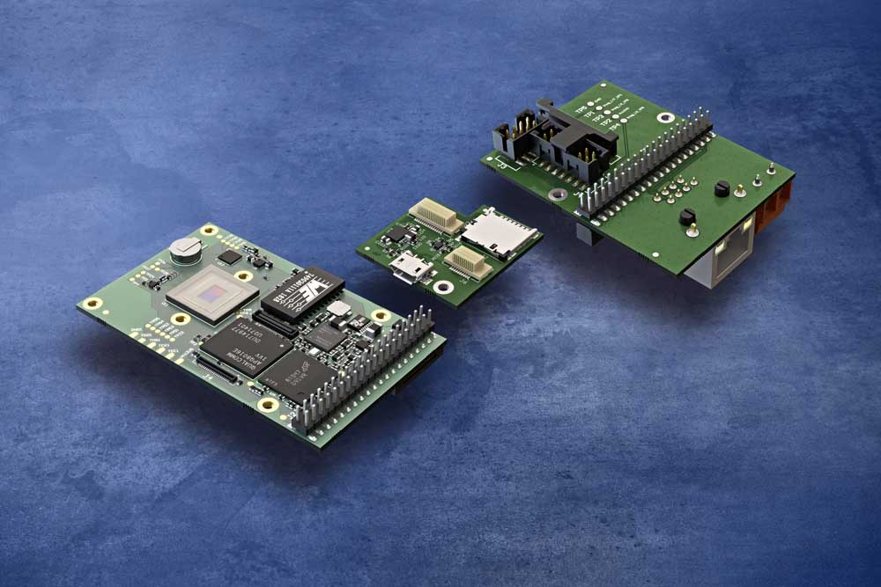
Caption: Board cameras with slots for modular interface extensions enable flexible and cost-sensitive configuration of embedded vision systems

Vision Components has also emphasized the flexibility factor, developing its latest embedded vision systems with a quad-core processor. All models from the VCSBC DragonCam series feature a Snapdragon 410 processor at 1.2 GHz clock rate, 1 GB RAM, and 16 GB flash memory. They also come with a GigE interface and 12 GPIOs and can be extended by two optional add-on boards with an SD card slot and more interfaces: serial interface, I²C, RS232, DSI, RJ45 Ethernet adapter, and power interface.
More about MIPI: www.mipi-modules.com
Vision Components at the LogiMAT trade fair
Stuttgart, Germany, 10 – 12 March 2020
Hall 4, Stand G64

Image/s: | quad-core_vc_cam__sd_card__interface_board | Characters: | 1791
File name: | 201912019_pm_logimat_trade_fair_en | Date: | 12-16-2019
About Vision Components
Vision Components is a leading international manufacturer of embedded vision systems. The freely programmable cameras with powerful onboard CPUs perform image processing tasks on their own without the need for an additional computer. Vision Components offers OEMs versatile Linux-based embedded systems for 2D and 3D image processing, supplied as board cameras or in protective casings. These are complemented by a growing range of ultracompact MIPI camera boards, which connect to a variety of different CPU boards. In addition, Vision Components offers software libraries and develops customized solutions on request. The team of experts can draw on extensive knowledge and over 20 years of experience with imaging applications. The company based in Ettlingen in southwestern Germany was founded in 1996 by Michael Engel, the inventor of the first industrial-grade intelligent camera. More world premieres followed, including the world's first intelligent vision sensors and the first-ever embedded 3D laser profiler. Today, Vision Components has sales offices in the United States and Japan and works with local partners in over 25 countries to provide consistent customer focus and readily available expertise throughout the world.

Contact:  Vision Components GmbH  Miriam Schreiber  Ottostr. 2  76275 Ettlingen  Germany  Phone: +49 . 7243 . 216 716  Email: miriam.schreiber@vision-components.com  Internet: www.vision-components.com | gii die Presse-Agentur GmbH  Immanuelkirchstr. 12  10405 Berlin  Germany  Phone: +49 . 30 . 538 9650  Email: info@gii.de  Internet: www.gii.de

