Press Release

Wilco Imaging becomes Vision Components distributor

Vision Components welcomes Wilco Imaging as its new distribution partner in the U.S. Based in El Dorado Hills near Sacramento (CA), Wilco is an expert in machine vision and embedded vision systems of long standing, serving customers across North America. In addition to supplying quality imaging products, Wilco builds custom solutions for industrial, robotics, medtech, and other applications. The team boasts a deep understanding of sensors, optics, lighting, and computational power and is excellently situated to serve the growing demand for vision technology.

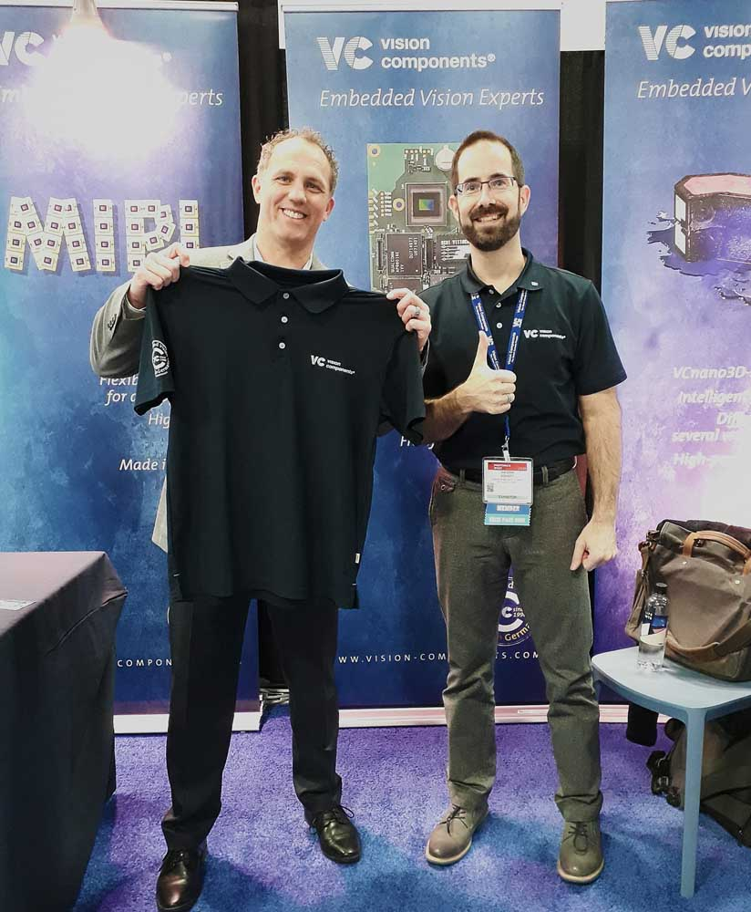
Caption: William Corns, CEO of Wilco Imaging (left), is welcomed into the Vision Components fold by Jan-Erik Schmitt, vice president of sales (right)

The German-based manufacturer Vision Components is the home of embedded vision, having started business in 1996 with the launch of the very first industrial embedded camera. The VC portfolio includes freely programmable embedded vision systems: board cameras, cameras with a protective housing, and laser profilers for 3D imaging along with versatile software libraries. Vision Components is also the leading manufacturer of MIPI camera boards with an ever-growing sensor range and supplying large volumes at consumer prices. The high-end, high-tech MIPI boards enable vision applications powered by various current CPU boards, such as Raspberry Pi, 96Boards, NVIDIA, and others, enabling highly economic designs, ideal for rapid prototyping.

Contact:
Wilco Imaging, Inc.
William Corns
4822 Golden Foothill Parkway
Suite 9
El Dorado Hills, CA 95762
Phone: +1-858-689-9050
www.wilcoimaging.com

Image/s: | william_corns__j-e_schmitt | Characters: | 1306
File name: | 202002023_pm_wilco_imaging_en | Date: | 02-19-2020
About Vision Components
Vision Components is a leading international manufacturer of embedded vision systems. The freely programmable cameras with powerful onboard CPUs perform image processing tasks on their own without the need for an additional computer. Vision Components offers OEMs versatile Linux-based embedded systems for 2D and 3D image processing, supplied as board cameras or in protective casings. These are complemented by a growing range of ultracompact MIPI camera boards, which connect to a variety of different CPU boards. In addition, Vision Components offers software libraries and develops customized solutions on request. The team of experts can draw on extensive knowledge and over 20 years of experience with imaging applications. The company based in Ettlingen in southwestern Germany was founded in 1996 by Michael Engel, the inventor of the first industrial-grade intelligent camera. More world premieres followed, including the world's first intelligent vision sensors and the first-ever embedded 3D laser profiler. Today, Vision Components has sales offices in the United States and Japan and works with local partners in over 25 countries to provide consistent customer focus and readily available expertise throughout the world.

Contact:  Vision Components GmbH  Miriam Schreiber  Ottostr. 2  76275 Ettlingen  Germany  Phone: +49 . 7243 . 216 716  Email: miriam.schreiber@vision-components.com  Internet: www.vision-components.com | gii die Presse-Agentur GmbH  Immanuelkirchstr. 12  10405 Berlin  Germany  Phone: +49 . 30 . 538 9650  Email: info@gii.de  Internet: www.gii.de

