Press Release

ISC West expo:
Embedded vision systems and components

At ISC West, Vision Components presents its extended range of high-end camera modules with a MIPI CSI-2 port. The German embedded vision expert has integrated a bigger variety of image sensors in industrial MIPI boards than any other manufacturer. The lineup of MIPI camera modules for repeatable automatic processing even includes machine vision sensors that do not have a native MIPI interface, such as Sony Pregius IMX250 and IMX252, which are ideal for security applications due to their high light sensitivity and very low dark noise. The VC MIPI portfolio for embedded vision designs based on CPU boards such as the NVIDIA models Jetson and DragonBoard is geared at applications with multiple cameras such as smart city and surveillance. Available accessories include high-performance shielded FPC cables and repeater boards for the full MIPI bandwidth over distances of more than one meter. Another ISC West showcase, the VC DragonCam, is the latest addition to the range of embedded cameras. Featuring a quad-core Snapdragon 410 processor, it provides a substantial performance boost over previous generations: 1.2 GHz clock rate, 1 GB RAM, 16 GB flash memory. In addition to various built-in interfaces like GigE and 12 GPIOs, this board camera is available with optional extension boards that enable easy, flexible addition of an SD card slot and more interfaces: serial interface, I²C, RS232, DSI, RJ45 Ethernet adapter, and power interface.

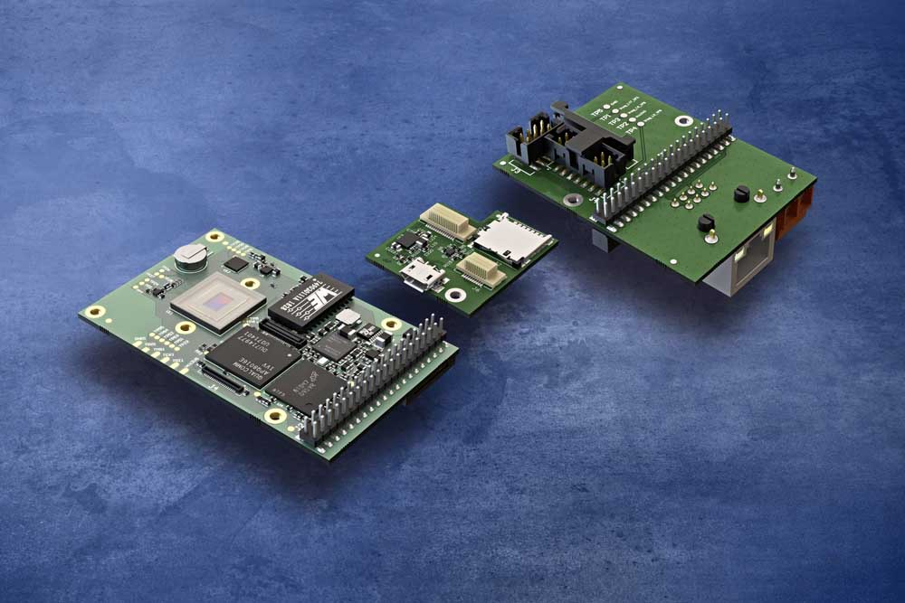
Caption: The brand-new VC DragonCam quad-core embedded camera allows for modular addition of boards with SD card slots and various interfaces

Vision Components shares the ISC West booth with its subsidiary Carrida Technologies, specialized in hardware and software solutions for automatic license plate recognition (ALPR). The compact, low-maintenance autonomous embedded vision systems are the perfect solution for remote applications. The Carrida software can process all common image and video file formats as well as video streams. It is hardware and vendor independent and can be used to enhance existing parking and traffic control applications and the like. The team is looking forward to advising ISC West visitors on the best solutions for all their security-related vision applications.
Vision Components at ISC West
Las Vegas, 17 – 20 March 2020
Booth #3060

Image/s: | quad-core_vc_cam__sd_card__interface_board | Characters: | 2106
File name: | 202003009_pm_isc_west_en | Date: | 03-04-2020
About Vision Components
Vision Components is a leading international manufacturer of embedded vision systems. The freely programmable cameras with powerful onboard CPUs perform image processing tasks on their own without the need for an additional computer. Vision Components offers OEMs versatile Linux-based embedded systems for 2D and 3D image processing, supplied as board cameras or in protective casings. These are complemented by a growing range of ultracompact MIPI camera boards, which connect to a variety of different CPU boards. In addition, Vision Components offers software libraries and develops customized solutions on request. The team of experts can draw on extensive knowledge and over 20 years of experience with imaging applications. The company based in Ettlingen in southwestern Germany was founded in 1996 by Michael Engel, the inventor of the first industrial-grade intelligent camera. More world premieres followed, including the world's first intelligent vision sensors and the first-ever embedded 3D laser profiler. Today, Vision Components has sales offices in the United States and Japan and works with local partners in over 25 countries to provide consistent customer focus and readily available expertise throughout the world.

Contact:  Vision Components GmbH  Miriam Schreiber  Ottostr. 2  76275 Ettlingen  Germany  Phone: +49 . 7243 . 216 716  Email: miriam.schreiber@vision-components.com  Internet: www.vision-components.com | gii die Presse-Agentur GmbH  Immanuelkirchstr. 12  10405 Berlin  Germany  Phone: +49 . 30 . 538 9650  Email: info@gii.de  Internet: www.gii.de

