Press Release

Carrida Technologies at ISC West:
Universal ALPR solution

Carrida Technologies presents its software engine for automatic license plate recognition (ALPR) at the ISC West exposition. The powerful OEM software library integrates plates from most countries in the world and covers a wide range of different applications from access control and fleet management to toll systems and red-light enforcement, as well as ITS and smart city applications. It is thus a truly universal ALPR solution. The Carrida software suite includes an AI tool for Make&Model recognition employing deep learning to ensure high recognition rates for vehicles from all over the world. This feature increases recognition accuracy in ALPR applications. Delivering very fast processing speeds of typically 15 to 20 ms per frame, it reads license plates of vehicles traveling at up to 240 km/h (150 mph) with typical recognition rates >99 % under real world conditions. The Carrida software is easy to integrate into existing security and surveillance applications. It is fully hardware and vendor independent and runs on Windows and Linux PCs and ARM architectures on Linux and Android. The software can be used with any C and C++ project via an application program interface (API). The most recent new announcement from Carrida Technologies is an Android-operated software development kit (SDK). Even mid-range Android devices can easily read full HD images.

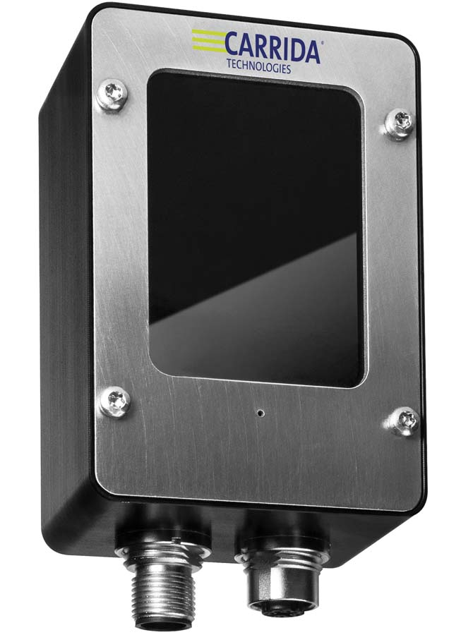
Caption: The Carrida Cam Basic+ running the automatic license plate recognition software is probably the smallest and most effective available ALPR camera

The manufacturer offers customers a comprehensive software and hardware package: the Carrida Cam is probably the world’s smallest standalone ALPR camera at just 91 mm high. It is capable of processing all application data onboard and autonomously managing ALPR applications such access control based on blacklists and whitelists. The camera has an IP67 protective housing with M12 cable connectors. Carrida Technologies exhibits together with its mother company Vision Components, a manufacturer of embedded vision systems for all kinds of security and surveillance applications.
Carrida Technologies at ISC West
Las Vegas, 17 – 20 March 2020
Booth #3060

Image/s: | carrida_cam | Characters: | 1951
File name: | 202003010_pm_carrida_isc_west_en | Date: | 03-04-2020
About Carrida Technologies
Carrida Technologies GmbH is based in Germany, with an office in the U.S. and serving international markets. The computer vision manufacturer specializes in automatic license/number plate recognition (ALPR/ANPR). The hardware-independent Carrida software engine runs on Windows, Linux, or Android on PC or ARM architectures. The manufacturer also offers dedicated solutions for parking management and vehicle make & model recognition as well as a network-compatible standalone ALPR camera with guaranteed availability. The company has implemented solutions worldwide providing a recognition accuracy >99 %.

Contact:  Carrida Technologies GmbH  Mr. Endre J. Tóth  10 Hedgerow Drive  Hudson, NH 03051  USA  Tel.: +1 603 598 2588  Email: info@carrida-technologies.com  www.carrida-technologies.com | gii die Presse-Agentur GmbH  Immanuelkirchstr. 12  10405 Berlin  Germany  Phone: +49 . 30 . 538 9650  Email: info@gii.de  www.gii.de

