Press Release

3D line sensors sized to fit

Vision Components manufactures intelligent laser profilers for a wide range of applications. The standard VCnano3D-Z models cover working distances from 50 mm to 2025 mm and between 40 mm and 1250 mm horizontal field of view. They provide high precision with resolutions down to 10 µm. The series offers OEMs an exact fit for their measurement task so that they can save the effort for elaborate, costly hardware adaptations. Currently, there are about 100 models in four sizes ranging in length from about 140 mm to 472 mm. In addition, the manufacturer also offers on-demand customer-specific configurations with a quick turnaround. The 3D embedded vision systems are compact, lightweight, and easy to integrate into OEM applications. They contain a Xilinx Zynq SoC featuring a dual-core ARM processor and an FPGA. The 3D profiles are calculated solely and entirely on the FPGA, allowing the ARM processor to be programmed for additional application tasks. Vision Components’ proprietary ambient light suppression technology enables measurements with laser profilers under up to 100,000 lux. The high ambient light immunity results from a high-intensity blue laser (450 nm), which is nevertheless rated laser class 2, combined with extremely short exposure times. Featuring a GigE interface and scan rates of up to 2 kHz, the laser profilers are ideally suited for real-time applications. Latest-generation CMOS image sensors ensure high image quality with minimal noise. At list prices under EUR 4,000, they moreover provide an excellent price—performance ratio.
More about applications and available models: https://www.vision-components.com/en/products/oem/3d-systems/arm-laser-triangulation/

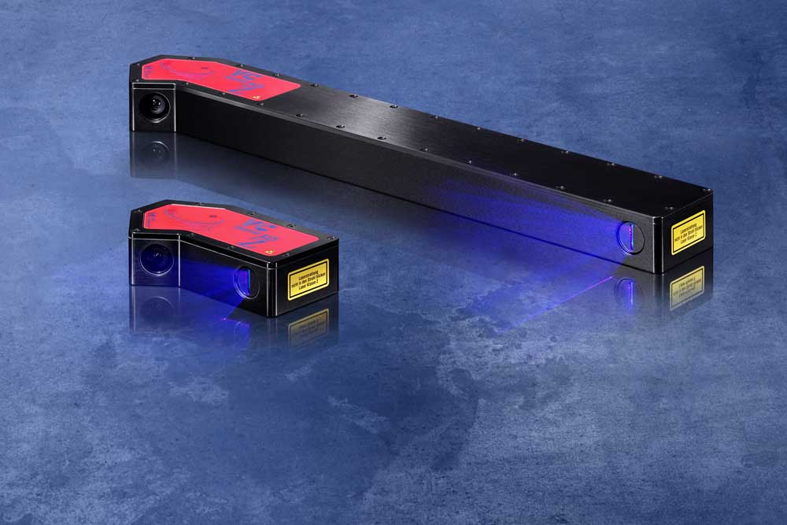
Caption: Suitable for various 3D applications, the laser profilers share the same powerful integrated electronics

Image/s: | vcnano3d-z_2_sizes_blue | Characters: | 1565
File name: | 202005010_pm_vcnano3d-z_sizes_en | Date: | 05-19-2020
About Vision Components
Vision Components is a leading international manufacturer of embedded vision systems. The freely programmable cameras with powerful onboard CPUs perform image processing tasks on their own without the need for an additional computer. Vision Components offers OEMs versatile Linux-based embedded systems for 2D and 3D image processing, supplied as board cameras or in protective casings. These are complemented by a growing range of ultracompact MIPI camera boards, which connect to a variety of different CPU boards. In addition, Vision Components offers software libraries and develops customized solutions on request. The team of experts can draw on extensive knowledge and over 20 years of experience with imaging applications. The company based in Ettlingen in southwestern Germany was founded in 1996 by Michael Engel, the inventor of the first industrial-grade intelligent camera. More world premieres followed, including the world's first intelligent vision sensors and the first-ever embedded 3D laser profiler. Today, Vision Components has sales offices in the United States and Japan and works with local partners in over 25 countries to provide consistent customer focus and readily available expertise throughout the world.

Contact:  Vision Components GmbH  Miriam Schreiber  Ottostr. 2  76275 Ettlingen  Germany  Phone: +49 . 7243 . 216 716  Email: miriam.schreiber@vision-components.com  Internet: www.vision-components.com | gii die Presse-Agentur GmbH  Immanuelkirchstr. 12  10405 Berlin  Germany  Phone: +49 . 30 . 538 9650  Email: info@gii.de  Internet: www.gii.de

