Press Release

Raspi CM goes embedded vision with VC MIPI

Launching its new VC MIPI Embedded Vision Kit for the Raspberry Pi Compute Module 3 or 3+, Vision Components enables quick setup of full-fledged, industrial-grade embedded vision systems. This is a cost-effective and powerful solution for all development processes from concept design to prototype development to serial production. To meet OEM requirements and qualify for industrial use, the kit’s long-term availability is ensured. Designed and manufactured in Germany, all components have been optimized for full interoperability. The Raspi CM is simply inserted in the newly developed VC Compute Module Interface (CMI) board, the central part of the VC MIPI Embedded Vision Kit. The CMI board features a VC MIPI camera module including a software driver, an FPC (flexible printed circuit) VC MIPI cable, and an S-mount/M12 lens holder. Trigger functionality, crucial for industrial vision applications, is also a standard feature. By default, the bundle contains OmniVision's OV9281 image sensor with a 1-MP resolution, 120 fps frame rate, and global shutter. As an alternative, customers can choose from the full range of VC MIPI camera modules, all of which connect to the CMI board: high-resolution image sensors up to over 20 MP, with either global shutter, global reset shutter, or rolling shutter. Remarkably, Vision Components even offers MIPI modules with sensors that do not have a native MIPI interface but are well-suited for industrial embedded vision applications.

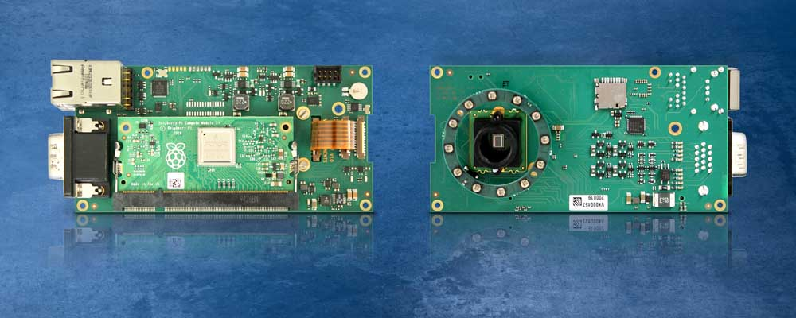
Caption: Fast track to embedded vision solutions: the board for inserting a Raspberry Pi Compute Module contains a MIPI camera, a lens holder, and numerous interfaces

To facilitate integration in OEM designs, the VC CMI board comprises an SD card slot for additional memory, GigE and USB interfaces, a trigger input, a flash trigger output, digital interfaces (four inputs, four outputs), a display output, and sockets for two MIPI camera modules for optional stereo vision applications. The freely programmable integrated FPGA enables customer-specific adjustments of image acquisition and trigger functionality. As the default setting, an external trigger signal is sent synchronously to the two MIPI modules. The manufacturer also offers an LED ring light with a rated power of up to 2 x 1.5 A, which is powered and controlled by the integrated lighting controller.

Image/s: | vc_cmi_board_back_front | Characters: | 2182
File name: | 202006010_pm_vc_mipi_embedded_vision_kit_en | Date: | 06-18-2020
About Vision Components
Vision Components is a leading international manufacturer of embedded vision systems. The freely programmable cameras with powerful onboard CPUs perform image processing tasks on their own without the need for an additional computer. Vision Components offers OEMs versatile Linux-based embedded systems for 2D and 3D image processing, supplied as board cameras or in protective casings. These are complemented by a growing range of ultracompact MIPI camera boards, which connect to a variety of different CPU boards. In addition, Vision Components offers software libraries and develops customized solutions on request. The team of experts can draw on extensive knowledge and over 20 years of experience with imaging applications. The company based in Ettlingen in southwestern Germany was founded in 1996 by Michael Engel, the inventor of the first industrial-grade intelligent camera. More world premieres followed, including the world's first intelligent vision sensors and the first-ever embedded 3D laser profiler. Today, Vision Components has sales offices in the United States and Japan and works with local partners in over 25 countries to provide consistent customer focus and readily available expertise throughout the world.

Contact:  Vision Components GmbH  Miriam Schreiber  Ottostr. 2  76275 Ettlingen  Germany  Phone: +49 . 7243 . 216 716  Email: miriam.schreiber@vision-components.com  Internet: www.vision-components.com | gii die Presse-Agentur GmbH  Immanuelkirchstr. 12  10405 Berlin  Germany  Phone: +49 . 30 . 538 9650  Email: info@gii.de  Internet: www.gii.de

