Press Release

Compact system for precision positioning of industrial cameras

autoVimation has launched a new, particularly compact system for positioning and precise alignment of protective camera enclosures. At the heart of the modular system, fine positioning axes with a 150-mm adjusting range feature hand cranks with 1.5 mm feed per revolution for maximum adjustment accuracy. The axes are more compact than conventional types, since slides travel directly on the spindle channel's dovetail profile. At 40 mm x 16 mm, the axes' profile cross-section is similar in size to a matchbox.

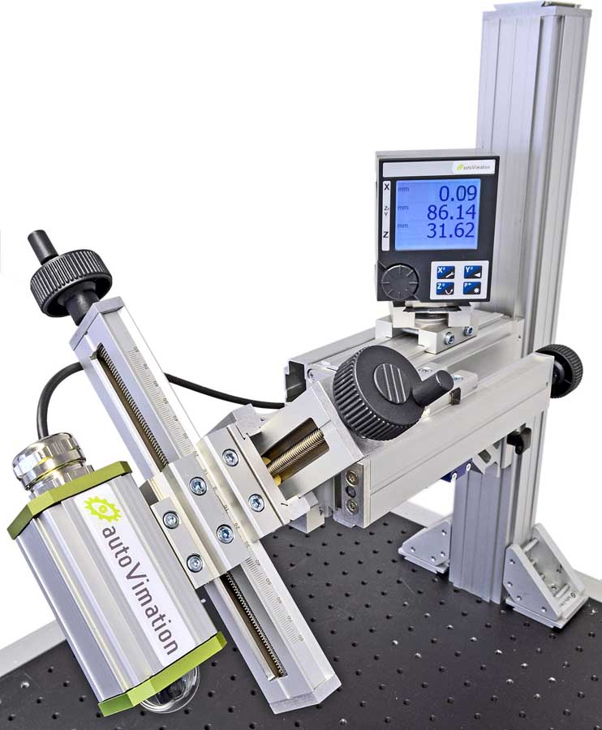
Caption: The fine positioning system from autoVimation is robust, versatile, and compact

Cameras can be freely positioned at any angle. The system includes a comprehensive range of accessories – profile rails, rotary axes, angles, and exchangeable positioning tables for vertical or parallel-axis mounting – which allow for rapid construction of multi-axis assemblies. Unlike existing products, the autoVimation system requires no adapter plates, since all components feature the same profile systems. Camera housings or other axes can be mounted on the positioning tables by means of dovetail brackets. For ergonomic handling in any position, the feed cranks can be mounted on either end as required. A millimeter scale on the side of the profile facilitates exact adjustment of the slide position. Alternatively, autoVimation offers fine positioning axes with an integrated position sensor and an accuracy of 10 µm, accompanied by digital display modules that can visualize positioning data for up to three axes. Fixed in place, form-fit dovetail brackets withstand replacement forces up to 2000 N. They prevent scratching of the profiles and provide a secure hold even of vertically mounted axes and under high loads. Even with the bracket lose, the self-locking spindle drive prevents uncontrolled movement of the load in axial direction.

Image/s: | Feinpositioniersystem_3-A_Drehg_Anz | Characters: | 1764
File name: | 202006019_pm_fine_positioning_axes_en | Date: | 06-24-2020
About autoVimation
Established in 2008, Karlsruhe-based autoVimation was founded by Peter Neuhaus to provide solutions for easier installation and adjustment of image processing components. The company has developed a modular construction kit that simplifies the connection of all required components, which does away with costly and time-consuming manufacturing of dedicated mounting brackets. The product portfolio also includes compact, easy-to-integrate enclosures that provide optimal protection for cameras and lenses in industrial applications, and ensure good heat dissipation. autoVimation supplies complete, ready-to-install mechanical solutions for cameras and light fittings, and enables the integration of special lenses, filters, light barriers, encoders, or other sensors.
autoVimation's customers include renowned companies from various industry branches, such as the pharmaceutical and food industry, measuring technology, quality control, and security technology.

Contact:  autoVimation GmbH  Peter Neuhaus  Roemerweg 1  76287 Rheinstetten  Germany  Phone: +49 . 721 . 627 6756  Email: sales@autovimation.com  Internet: www.autovimation.com | gii die Presse-Agentur GmbH  Immanuelkirchstr. 12  10405 Berlin  Germany  Phone: +49 . 30 . 538 9650  Email: info@gii.de  Internet: www.gii.de

