Press Release

Hygienic door handle for tool-less mounting

CONTA-CLIP has launched HYDH, an ergonomically optimized Hygienic Door Handle that is quick and easy to install. Because of the ongoing coronavirus pandemic, hospitals and other public institutions and commercial buildings have a greater need for hands-free door handles as a way to lower the spread of infection. Various manufacturers have launched products that are operated with the forearm instead. However, most existing solutions require screw attachment, can slip or tilt, or come in two different versions for left and right hinged doors. Therefore, CONTA-CLIP has designed a universal hands-free handle that fits left and right hinged doors with round, oval, or rectangular latches and that allows for secure attachment without screws or tools.

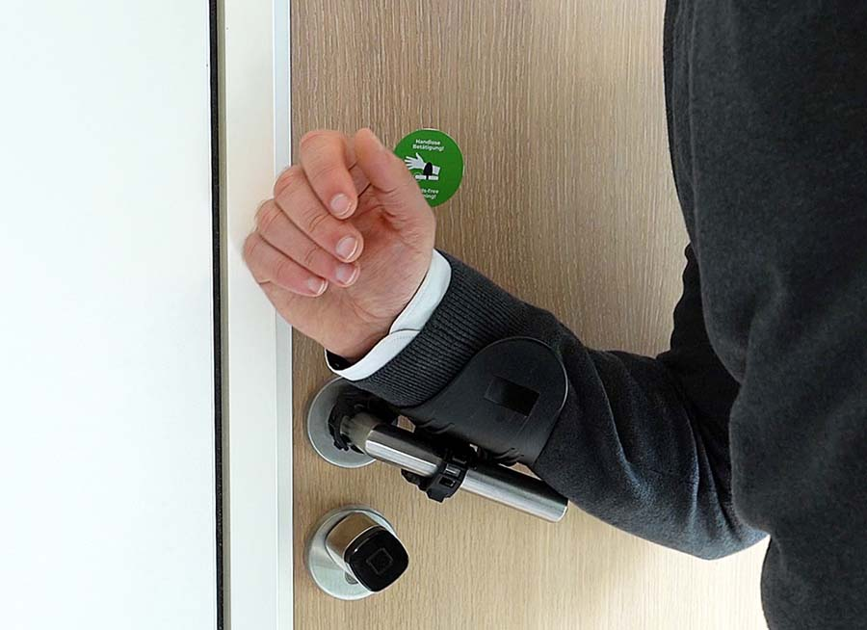
Caption 1: The CONTA-CLIP HYDH is a hygienic, easy-to-install hands-free door handle

Featuring an ergonomic jacket design, HYDH allows for comfortable use with the forearm or elbow. The one-size-fits-all clasp is simply slipped onto the door handle where it latches tightly. Flexible spacers facing the door keep it firmly in place even if it is pushed or pulled with strong forces. If fixed with the tamper-protection clamps included in delivery, HYDH can afterwards only be removed with a screwdriver. Made of durable, chemical-resistant plastic, the hygienic door handle withstands frequent disinfection with aggressive cleaning agents. HYDH is available in nine colors. In addition, CONTA-CLIP offers to provide individual colors, lettering, or logos for hotels, restaurants, and other customers interested in maintaining a uniform corporate design. More information as well as a short demo video on installation of the door handle are available at www.hydh.de.

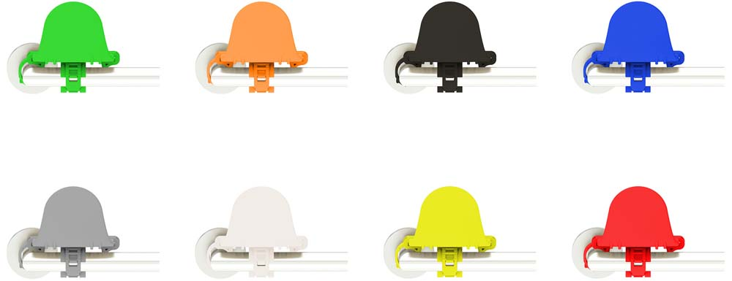
Caption 2: CONTA-CLIP supplies HYDH in various colors and, on demand, in the customer’s corporate design

Image/s: | HYDH_Hand  HYDH-Modelle | Characters: | 1633
File name: | 202007025_pm_hydh_hygienic_door_handle_en | Date: | 07-29-2020
About CONTA-CLIP
CONTA-CLIP is one of Europe’s leading manufacturers of electrical and electronic connection elements and cable management solutions. Based in Hövelhof, Germany, the medium-sized, family-run company has been producing electric and electronic connection systems for the process and automation industries for 40 years. CONTA-CLIP supplies all industry sectors, focusing on railroad industries, shipbuilding, building automation, conveyor technology, machine and plant engineering and construction, instrumentation and control technology, control panel manufacturing, transformer manufacturing, and environmental technology. The company consists of many specialized branches: CONTA-CONNECT for electric connection technology, CONTA-CABLE for cable management systems, CONTA-ELECTRONICS for electronics and CONTA-CON for PCB edge connectors. Additionally, CONTA-CLIP provides services such as customizing housings and mounting rails, labeling and supplying user-specific electronic components.

Contact:  CONTA-CLIP  Verbindungstechnik GmbH  Christian Quade  Otto-Hahn-Str. 7  33161 Hövelhof  Germany  Phone: +49 . 5257 . 9833 - 0  Fax: +49 . 5257 . 9833 - 33  Email: christian.quade@conta-clip.de  Internet: www.conta-clip.com | gii die Presse-Agentur GmbH  Immanuelkirchstr. 12  10405 Berlin  Germany  Phone: +49 . 30 . 538 965 - 0  Fax: +49 . 30 . 538 965 - 29  Email: info@gii.de  Internet: www.gii.de

