Press Release

All-in-one multimeter for electric machines

Gossen Metrawatt has expanded its newly developed, DAkkS-calibrated multimeter generation, adding a device for the automotive sector. The new METRAHIT IM E DRIVE is an all-in-one solution combining all relevant test and measurement functions for maintenance, service, and diagnostics of electric machines, drives, and systems. Over and above typical multimeter functions, the compact, robust handheld unit integrates various additional measurement methods for safety tests in the automotive industry, avionics, and electrical engineering. The extended functional spectrum includes 4-wire milliohm measurements for precise detection of minimal resistances with resolutions up to 1 μΩ, high-voltage system tests according to UN ECE R100, and insulation resistance measurements with up to 1000 V according to EN 61557-2/VDE 0413- 2. The multimeter also enables 2-wire R_{low} measurements with 200 mA test current according to EN 61557-4/VDE 0413-4. Using the optional coil adapter, users can test electric machines for interturn short-circuits by running a 1000 V impulse voltage test.

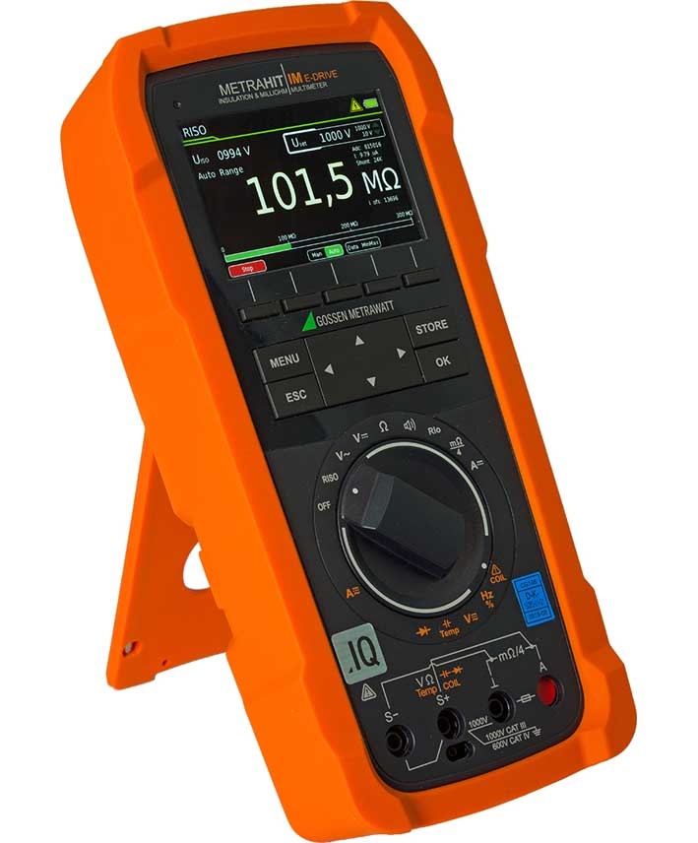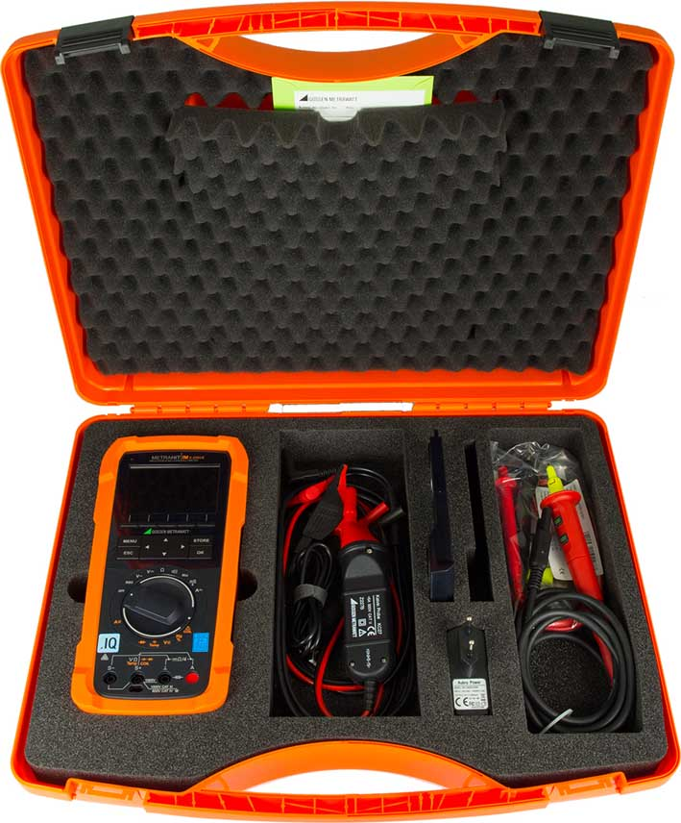
Caption: The new universal multimeter METRAHIT IM E DRIVE features comprehensive measuring and testing functions for the automotive and avionics industries

4-wire milliohm measurement enables bonding tests by means of equipotential bonding measurement in order to check the discharge capability of the outer skin of aircrafts, for example. METRAHIT IM E DRIVE meets the requirements of the measuring categories CAT III (1000 V) and CAT IV (600 V). Test sequences, measured values, and help texts are clearly displayed on the device's 3.5" TFT color graphics display. The multimeter allows users to program their own test sequences. It stores up to 300,000 measured values with time stamps. Current results can be wirelessly transmitted to the accompanying IZYTRONIQ Business Starter test software with the push of a button. The multimeter features Bluetooth and Wi-Fi interfaces. The optional power supply module includes a USB port. In mobile mode, the device runs on a quick-change lithium-ion battery, which can be recharged via micro USB.

Image/s: | metrahitimedrive  metrahitimedrive_case | Characters: | 1966
File name: | 202008015_pm_metrahit_im_e_drive_en | Date: | 08-27-2020
About Gossen Metrawatt
GMC-I Messtechnik is one of the world's leading suppliers of measurement systems. Under the GOSSEN METRAWATT brand, the company develops and distributes a wide range of high-quality measuring and test devices for the electrical trade, industry, and the medical sector. The scope of products includes measuring and testing equipment for standardized testing of electrical systems and appliances, multimeters, calibrators, network analyzers, power supplies, as well as transducers and power meters for high-voltage and moving-coil measurement. GMC-I Messtechnik also provides a varied offering of training courses for customers and develops energy management concepts. The corporate group runs its own DakkS-certified calibration center that performs DakkS, ISO, and factory calibrations for virtually all electrical measured values. GMC-I Messtechnik is part of the GMC Instruments group, which also includes other specialized manufacturers for measurement and testing technology – notably, Camille Bauer Metrawatt, Dranetz, Prosys, Seaward, Daytronic, Electrotek Concepts, and Kurth Electronic. The group's production sites in Germany, Switzerland, England, and the United States are complemented by a global sales network.

Contact:  GMC-I Messtechnik GmbH  Christian Widder  Leitung Marketing Kommunikation  Suedwestpark 15  90449 Nuremberg  Germany  Phone: +49 . 911 . 8602-572  Email: christian.widder@gossenmetrawatt.com  Internet: www.gossenmetrawatt.com | gii die Presse-Agentur GmbH  Immanuelkirchstr. 12  10405 Berlin  Germany  Phone: +49 . 30 . 538 9650  Email: info@gii.de  Internet: www.gii.de

