Press Release

Multimeter adapter for mobile interturn short-circuit tests

Gossen Metrawatt extends the unique functional spectrum of its latest multimeter generation METRAHIT IM XTRA, introducing an adapter for interturn short-circuit tests. Combined with the new COIL ADAPTER XTRA, the robust handheld digital multimeters cover all safety checks for troubleshooting and diagnostics of electric machines, motors, and generators. In addition to insulation defects between winding and housing, users can now also detect interturn short-circuits within a winding of an electric motor with this portable device for field use. In a surge test with 1 kV impulse voltage, the METRAHIT IM and the connected coil adapter reliably recognize even those defects that occur only when operating voltage is applied.

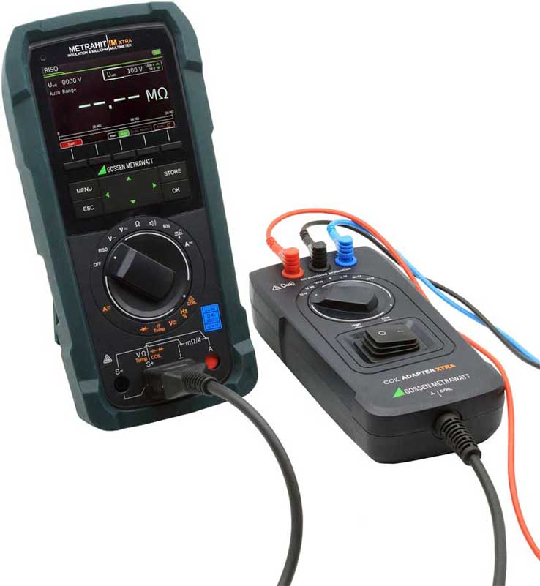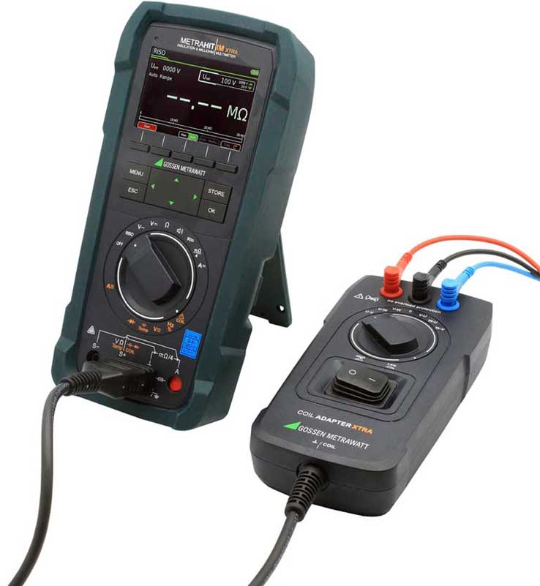
Caption: The portable METRAHIT IM XTRA multimeter and coil adapter enable interturn short-circuit detection in electric machines directly in the field

[image versions A and B]

The coil adapter is designed for windings with inductances from 10 μH to 5 H. This corresponds to rated outputs of about 160 VA to 80 MVA for 3-phase machines with 400 V rated voltage. After connection to terminals U, V, and W, the semi-automatic test sequence is triggered by a rotary switch. Polarity reversal can also compensate for remanence effects in the rotor. The new coil adapter is available as an optional accessory for the METRAHIT IM XTRA multimeter and the automotive version IM E DRIVE. These are the only available portable universal multimeters that also enable 4-wire milliohm measurements for precise detection of minimal resistances with resolutions up to 1 μΩ. Their functional range includes insulation resistance tests with up to 1000 V, 2-wire R_{low} measurements with 200 mA test current according to EN 61557-4/VDE 0413-4, TRMS current and voltage measurements up to 10 or 100 kHz, high-precision temperature measurements with RTD and TC-K sensors, capacitance measurements, and measurements of the polarization and absorption index. To ensure protection from high short-circuit currents in electric vehicles, the battery-powered multimeters meet the demands of measurement categories CAT III (1000 V) and CAT IV (600 V). The devices are designed for convenient one-hand operation. Their 3.5" TFT color graphic display ensures excellent readability.

Image/s: | metrahit-im-xtra_coil_a  metrahit-im-xtra_coil_b | Characters: | 2099
File name: | 202008016_pm_metrahit_coil_adapter_xtra_en | Date: | 08-13-2020
About Gossen Metrawatt
GMC-I Messtechnik is one of the world's leading suppliers of measurement systems. Under the GOSSEN METRAWATT brand, the company develops and distributes a wide range of high-quality measuring and test devices for the electrical trade, industry, and the medical sector. The scope of products includes measuring and testing equipment for standardized testing of electrical systems and appliances, multimeters, calibrators, network analyzers, power supplies, as well as transducers and power meters for high-voltage and moving-coil measurement. GMC-I Messtechnik also provides a varied offering of training courses for customers and develops energy management concepts. The corporate group runs its own DakkS-certified calibration center that performs DakkS, ISO, and factory calibrations for virtually all electrical measured values. GMC-I Messtechnik is part of the GMC Instruments group, which also includes other specialized manufacturers for measurement and testing technology – notably, Camille Bauer Metrawatt, Dranetz, Prosys, Seaward, Daytronic, Electrotek Concepts, and Kurth Electronic. The group's production sites in Germany, Switzerland, England, and the United States are complemented by a global sales network.

Contact:  GMC-I Messtechnik GmbH  Christian Widder  Leitung Marketing Kommunikation  Suedwestpark 15  90449 Nuremberg  Germany  Phone: +49 . 911 . 8602-572  Email: christian.widder@gossenmetrawatt.com  Internet: www.gossenmetrawatt.com | gii die Presse-Agentur GmbH  Immanuelkirchstr. 12  10405 Berlin  Germany  Phone: +49 . 30 . 538 9650  Email: info@gii.de  Internet: www.gii.de

