Press Release

Connect with Vision Components at the first virtual Embedded Vision Summit

Vision Components will take part in the Embedded Vision Summit on 15 – 25 September 2020. The fully virtual event will offer abundant opportunities to connect with international industry experts. The German company Vision Components will showcase its varied solutions for developers of embedded vision applications. Firstly, the company is eager to promote its further expanded range of MIPI camera modules. These high-quality sensor boards, along with tested and proven drivers and high-bandwidth MIPI cables, are all it takes to enable common CPU boards for embedded vision. Prominent amongst the compatible computers with full driver support are the Raspberry Pi Compute Module and several NVIDIA platform boards, for instance the Jetson Nano Developer Kit, which are all excellent for commercial projects and for low-cost rapid prototyping.

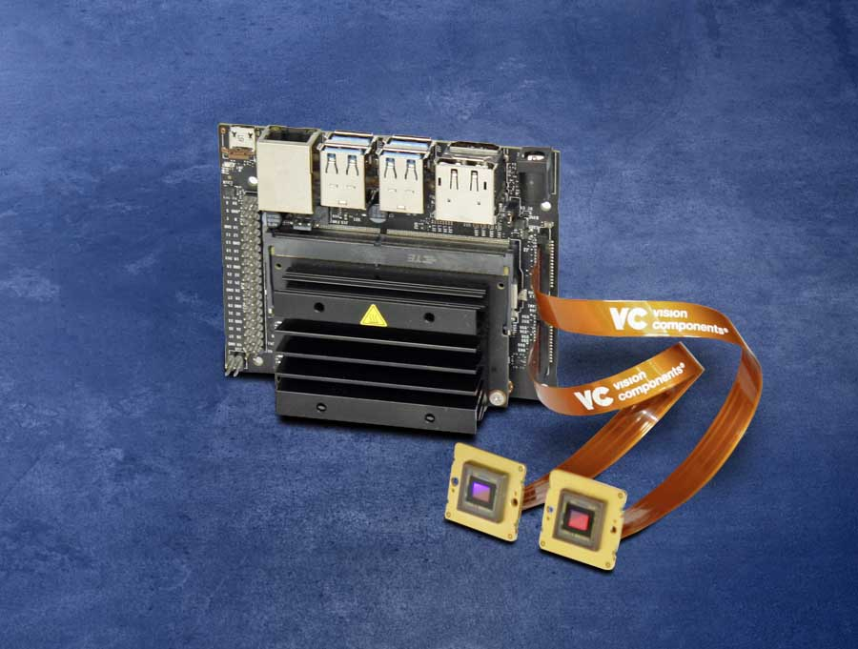
Caption: Vision Components manufactures MIPI cameras with full driver support for popular developer platforms like the NVIDIA Jetson family

As a second major product group, Vision Components will present its portfolio of embedded vision systems. These are versatile, freely programmable cameras featuring a multi-core ARM platform with a VC Linux operating system and free access to the VC Lib computer vision library containing more than 300 functions. The latest addition to this series, VC DragonCam is now ready for shipping. This board camera is based on a quad-core Snapdragon 410 processor with 1.2 GHz clock rate, 1 GB RAM, and 16 GB flash memory. In addition to various built-in interfaces like GigE and 12 GPIOs, VC DragonCam is available with optional extension boards that enable easy, flexible addition of an SD card slot and more interfaces: serial interface, I²C, RS232, DSI, RJ45 Ethernet adapter, and power interface.

Image/s: | vc_mipi_nvidia_jetson_nano_dev_kit | Characters: | 1638
File name: | 202009007_pm_embedded_vision_summit_en | Date: | 09-01-2020
About Vision Components
Vision Components is a leading international manufacturer of embedded vision systems. The freely programmable cameras with powerful onboard CPUs perform image processing tasks on their own without the need for an additional computer. Vision Components offers OEMs versatile Linux-based embedded systems for 2D and 3D image processing, supplied as board cameras or in protective casings. These are complemented by a growing range of ultracompact MIPI camera boards, which connect to a variety of different CPU boards. In addition, Vision Components offers software libraries and develops customized solutions on request. The team of experts can draw on extensive knowledge and over 20 years of experience with imaging applications. The company based in Ettlingen in southwestern Germany was founded in 1996 by Michael Engel, the inventor of the first industrial-grade intelligent camera. More world premieres followed, including the world's first intelligent vision sensors and the first-ever embedded 3D laser profiler. Today, Vision Components has sales offices in the United States and Japan and works with local partners in over 25 countries to provide consistent customer focus and readily available expertise throughout the world.

Contact:  Vision Components GmbH  Jan-Erik Schmitt  Ottostr. 2  76275 Ettlingen  Germany  Phone: +49 . 7243 . 21670  Email: schmitt@vision-components.com  Internet: www.vision-components.com | gii die Presse-Agentur GmbH  Immanuelkirchstr. 12  10405 Berlin  Germany  Phone: +49 . 30 . 538 9650  Email: info@gii.de  Internet: www.gii.de

