Press Release

New website of intra-logistics expert LOSYCO

LOSYCO announces the relaunch of its company website with a modern look and clearly structured menu navigation. At www.losyco.com, the intra-logistics expert provides information on its extensive range of services and current developments in production logistics. LOSYCO designs and implements holistic concepts for lean manufacturing, cooperating with technology partners from mechanical engineering, process optimization, and productivity research. The redesigned web pages focus on the LOXrail system for easy handling of loads weighing several tons, on its components and new product innovations. Animated videos demonstrate newly developed solutions such as the 15-ton steering platform AllRounder or the onboard, sensor-controlled automatic brake. Sample references from successful projects illustrate the wide range of possible LOXrail applications and expansion options. The portfolio also includes tailor-made solutions for material logistics based on various conveyor belts or roller conveyors as well as easy-to-assemble modular systems for material management according to kanban methods. In addition, the company designs and manufactures individual machine covers, soundproof booths, as well as auxiliary and supply systems, and supplies modular solutions for ergonomic workplace design. Website visitors will find the latest brochures and press releases in the download area, and they can subscribe to company newsletter and use the contact form to send inquiries directly to LOSYCO.

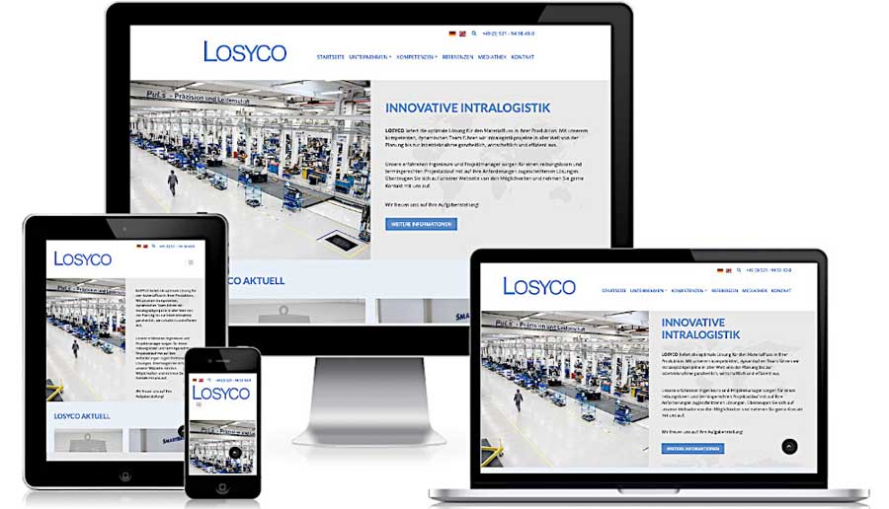
Caption: The new website of the intra-logistics expert LOSYCO offers comprehensive information and features a modern look and clear menu navigation

Image/s: | website_1500px | Characters: | 1497
File name: | 202009012_pm_website_relaunch_en | Date: | 09-01-2020
About Losyco
Based in Bielefeld, Germany, Losyco designs, manufactures, and deploys intra-logistics systems for industrial customers. Founded by experienced engineers in 2016, the company's first core product is LOXrail®: with this novel round bar rail system, loads weighing several tons can be easily moved around, precisely to the desired spot. It can be operated manually or with auxiliary drives. Losyco also supplies conveying and handling equipment such as chain and roller conveyors, material management and storage systems, sound-proof cabins, and machine covers. In addition, Losyco offers support and guidance for customers wishing to transform their production processes to implement lean manufacturing and continuous flow production. Losyco is a member of the DRECKSHAGE Family.

Contact:  LOSYCO GmbH  Member of the DRECKSHAGE Family  Manuel Granz  Walter-Werning-Str. 7  33699 Bielefeld  Germany  Tel.: +49 . 521 . 945 643-0  Fax: +49 . 521 . 945 643-399  Email: info@losyco.com  Internet: www.losyco.com | gii die Presse-Agentur GmbH  Immanuelkirchstr. 12  10405 Berlin  Germany  Tel.: +49 . 30 . 538 965-0  Fax: +49 . 30 . 538 965-29  Email: info@gii.de  Internet: www.gii.de

