Press Release

Connecting multiple VC MIPI cameras to NVIDIA developer kits

Vision Components offers software support for Auvidea GmbH adapter boards, which can connect multiple VC MIPI camera modules to NVIDIA Jetson TX2 and Xavier AGX developer kits. Drivers are provided, enabling developers to start work on their embedded vision projects immediately. Auvidea's tested and validated J20 adapter board supports all available VC MIPI cameras. The VC MIPI portfolio features a wide range of machine vision sensors up to 20 megapixels and is constantly being expanded. Notably, it also includes Sony Pregius IMX250 and IMX252 sensors, which have no native MIPI interface. The camera modules meeting the MIPI CSI-2 specification are manufactured by Vision Components with dowel holes for precise and repeatable mounting. The company’s 200-mm FPC (flexible circuit board) cables, which are especially developed for the MIPI modules, ensure interference-free data transmission at high bandwidths.
More about the MIPI camera portfolio: www.mipi-modules.com

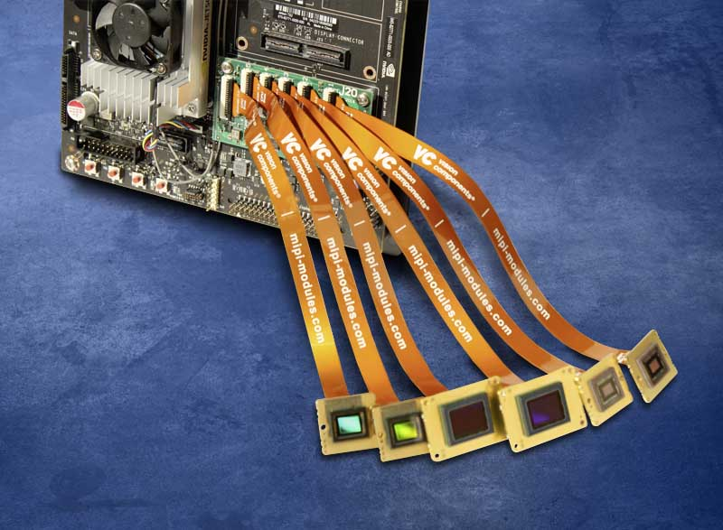
Caption: The Auvidea J20 adapter board enables a quick start into embedded vision development with NVIDIA developer kits and VC MIPI cameras

Image/s: | auvidea_mipi_platine | Characters: | 917
File name: | 202009029_pm_auvidea_mipi_adapter_en | Date: | 09-22-2020
About Auvidea
Auvidea GmbH is a supplier of standard products in the field of digital data processing and a developer of customized hardware solutions, located near Munich, Germany. The company develops and manufactures in Germany and operates worldwide. It markets products for edge processing of visual data using artificial intelligence (AI). Auvidea is a well-known manufacturer of video processors, encoders/decoders, and embedded motherboards (carrier boards), focusing on compute modules from the entire NVIDIA Jetson family such as Nano, TX2, Xavier NX, and AGX Xavier. Auvidea’s customers are located all over the world and work in various fields such as robotics, automotive, autonomous driving, communications, video processing, diagnostics, surveillance, and quality control. Auvidea has a fully automated in-house production line with 3D automated optical inspection (AOI) and is therefore able to produce large quantities at high quality standards as well as customized products. The manufacturer specializes in quickly and efficiently adapting standard products to customer-specific requirements using its in-house resources.
More: auvidea.eu
About Vision Components
Vision Components is a leading international manufacturer of embedded vision systems. The freely programmable cameras with powerful onboard CPUs perform image processing tasks on their own without the need for an additional computer. Vision Components offers OEMs versatile Linux-based embedded systems for 2D and 3D image processing, supplied as board cameras or in protective casings. These are complemented by a growing range of ultracompact MIPI camera boards, which connect to a variety of different CPU boards. In addition, Vision Components offers software libraries and develops customized solutions on request. The team of experts can draw on extensive knowledge and over 20 years of experience with imaging applications. The company based in Ettlingen in southwestern Germany was founded in 1996 by Michael Engel, the inventor of the first industrial-grade intelligent camera. More world premieres followed, including the world's first intelligent vision sensors and the first-ever embedded 3D laser profiler. Today, Vision Components has sales offices in the United States and Japan and works with local partners in over 25 countries to provide consistent customer focus and readily available expertise throughout the world.

Contact:  Vision Components GmbH  Jan-Erik Schmitt  Ottostr. 2  76275 Ettlingen  Germany  Phone: +49 . 7243 . 21670  Email: schmitt@vision-components.com  Internet: www.vision-components.com | gii die Presse-Agentur GmbH  Immanuelkirchstr. 12  10405 Berlin  Germany  Phone: +49 . 30 . 538 9650  Email: info@gii.de  Internet: www.gii.de

