Press Release

Double-decker material feed solution

Intra-logistics specialist LOSYCO has developed a new two-story trolley concept for automatic loading and unloading of heavy parts, based on its LOXrail transport system. Two double-track LOXrail 25 lines, each 25 meters in length, provide high feeding capacities on a small footprint. Two types of trolleys using different tracks and one fitting under the other can travel on the floor-level rails independent of each other. They can overtake each other, allowing for maximum flexibility in feeding raw material into the manufacturing cell and unloading processed panels. The four trolleys have a payload of 6.5 tons each. The upper trolleys had to be additionally reinforced to accommodate for such heavy loads; this was challenging because of the space constraints due to the raised design. In addition, their surfaces were fitted with cutouts for easier access to the transported parts. For a drive solution that requires minimal space, Losyco mounted geared motors on the wheelsets. These are powered via covered energy-guiding chains. The trolleys are integrated in the plant control system for exact coordination of the loading procedures and the handling portal. Upon reaching the end position, they send a load/unload signal to the controller. The trolleys’ integrated sensor unit ensures the high positioning precision required for smooth handover to and from the handling portal. This new solution extends the range of applications for the LOXrail system beyond production logistics in assembly lines to applications where large, heavy, or bulky material has to be loaded in and unloaded from processing equipment.

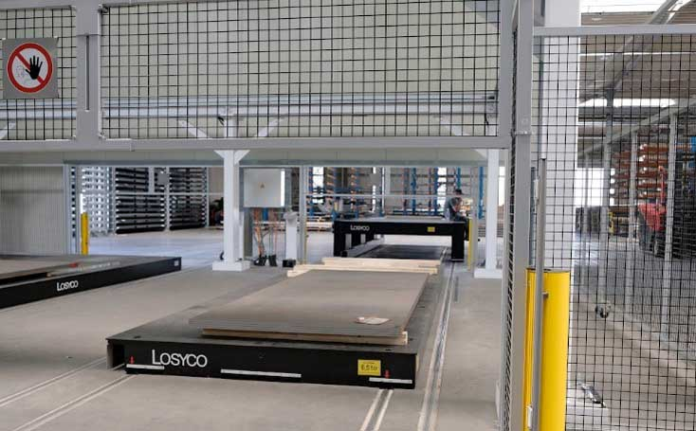
Caption: The new two-story trolley solution for feeding oversized sheet metal panels into a laser cutting cell

Image/s: | mat-zufuehrung_loxrail_3000px | Characters: | 1625
File name: | 202010019_pm_material_feed_en | Date: | 11-11-2020
About Losyco
Based in Bielefeld, Germany, Losyco designs, manufactures, and deploys intra-logistics systems for industrial customers. Founded by experienced engineers in 2016, the company's first core product is LOXrail®: with this novel round bar rail system, loads weighing several tons can be easily moved around, precisely to the desired spot. It can be operated manually or with auxiliary drives. Losyco also supplies conveying and handling equipment such as chain and roller conveyors, material management and storage systems, sound-proof cabins, and machine covers. In addition, Losyco offers support and guidance for customers wishing to transform their production processes to implement lean manufacturing and continuous flow production. Losyco is a member of the DRECKSHAGE Family.

Contact:  LOSYCO GmbH  Member of the DRECKSHAGE Family  Manuel Granz  Walter-Werning-Str. 7  33699 Bielefeld  Germany  Tel.: +49 . 521 . 945 643-0  Fax: +49 . 521 . 945 643-399  Email: info@losyco.com  Internet: www.losyco.com | gii die Presse-Agentur GmbH  Immanuelkirchstr. 12  10405 Berlin  Germany  Tel.: +49 . 30 . 538 965-0  Fax: +49 . 30 . 538 965-29  Email: info@gii.de  Internet: www.gii.de

