Press Release

Powerful, industrial-grade, economic:
VC DragonCam with Snapdragon processor ships now

Vision Components based its new VC DragonCam on the powerful Qualcomm Snapdragon 410 processor. The company thus utilizes the computing power and price efficiency of a quad-core processor that has been proven in countless consumer products for an industrial-grade embedded vision system. The VC DragonCam board camera integrates an image sensor, various customary interfaces, and the processor, which runs a Debian-based operating system, on a small 65 x 40 mm footprint. This makes the programmable embedded vision system ideal for OEM designs.

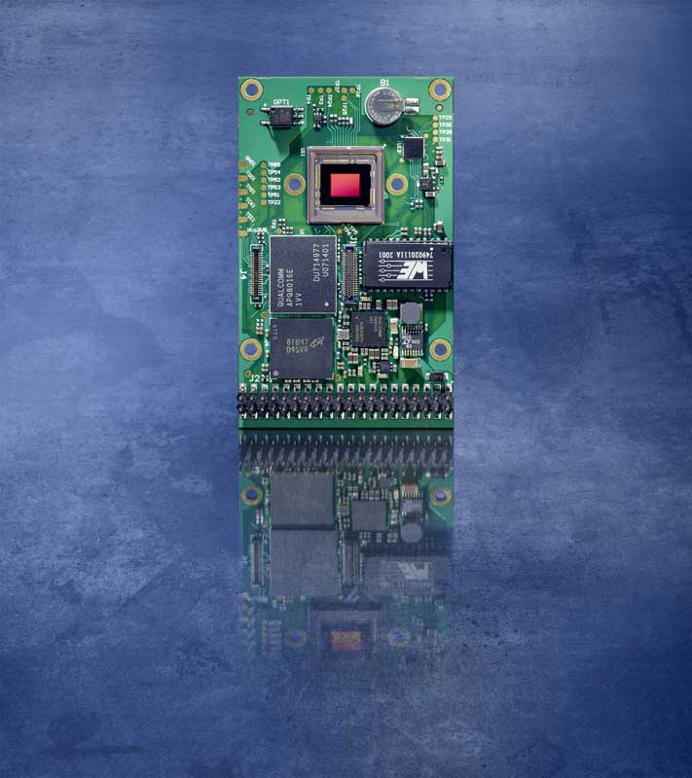
Caption: VC DragonCam integrates an image sensor, a powerful Snapdragon processor, and customary interfaces on a 65 x 40 mm board

VC DragonCam features twelve GPIOs, 1 GB memory, and up to 32 GB flash memory, with standard interfaces such as GBit Ethernet and RS-232 integrated onboard. Two adapter boards with additional interfaces provided as conventional sockets enable easy connection of peripherals, ideal for fast prototyping. Vision Components integrates high-end CMOS sensors in the new embedded vision system series, starting with Sony Pregius IMX 273. This global shutter sensor featuring a 1456 x 1088 pixel resolution and 225 fps frame rate is optimally suited for applications with short exposure times and high speeds. In addition to the monochrome model, a color camera is available on request. VC DragonCam models with additional Sony sensors are on the road map. As with all VC cameras, the manufacturer ensures long-term availability.

Find out more and get in touch via https://www.vision-components.com/en/products/oem/arm-linux/board-cameras/vc-dragoncam/

Image/s: | vc_dragoncam | Characters: | 1367
File name: | 202010024_pm_vc_dragoncam_available_en | Date: | 10-21-2020
About Vision Components
Vision Components is a leading international manufacturer of embedded vision systems. The freely programmable cameras with powerful onboard CPUs perform image processing tasks on their own without the need for an additional computer. Vision Components offers OEMs versatile Linux-based embedded systems for 2D and 3D image processing, supplied as board cameras or in protective casings. These are complemented by a growing range of ultracompact MIPI camera boards, which connect to a variety of different CPU boards. In addition, Vision Components offers software libraries and develops customized solutions on request. The team of experts can draw on extensive knowledge and over 20 years of experience with imaging applications. The company based in Ettlingen in southwestern Germany was founded in 1996 by Michael Engel, the inventor of the first industrial-grade intelligent camera. More world premieres followed, including the world's first intelligent vision sensors and the first-ever embedded 3D laser profiler. Today, Vision Components has sales offices in the United States and Japan and works with local partners in over 25 countries to provide consistent customer focus and readily available expertise throughout the world.

Contact:  Vision Components GmbH  Jan-Erik Schmitt  Ottostr. 2  76275 Ettlingen  Germany  Phone: +49 . 7243 . 21670  Email: schmitt@vision-components.com  Internet: www.vision-components.com | gii die Presse-Agentur GmbH  Immanuelkirchstr. 12  10405 Berlin  Germany  Phone: +49 . 30 . 538 9650  Email: info@gii.de  Internet: www.gii.de

