Press Release

40 A DC power supplies for test fields and laboratories

LABKON P series computer controllable KONSTANTERs provide users with DC power supplies for manual and remote control and for laboratory and system use. Their manufacturer GOSSEN METRAWATT now extends the existing product portfolio by two new models for supply voltages up to 20 V. The power supplies with nominal ratings of 500 W and 800 W generate maximum currents of 25 A and 40 A respectively. “Given the large number of applications for 12 V onboard power supplies and the need for higher currents in this voltage range, we have expanded our KONSTANTER portfolio, adding two new LABKON P models,” says Andreas Stollberg, product manager at GOSSEN METRAWATT. All LABKON P devices have good dynamic characteristics with regard to setpoint changes and sudden load changes. The specified nominal values can be delivered continuously thanks to the power output’s outstanding stability, and they can be duplicated at any time with accurate, digital setpoint specification, which assures reproducible results. Users can store individual device configurations to setup memory and retrieve them as required. This saves time when setting up an instrument for recurrent testing tasks. In addition to the standard RS232 port, USB and GPIB (IEEE-488) interfaces are optionally available. The SCPI command set allows for trouble-free integration into automated test systems. The LABKON P series comprises KONSTANTERs with nominal power ratings of 500 W and 800 W. These power supplies provide output voltages between 20 V and 120 V and currents up to 40 A, and thereby cover a wide range of applications.

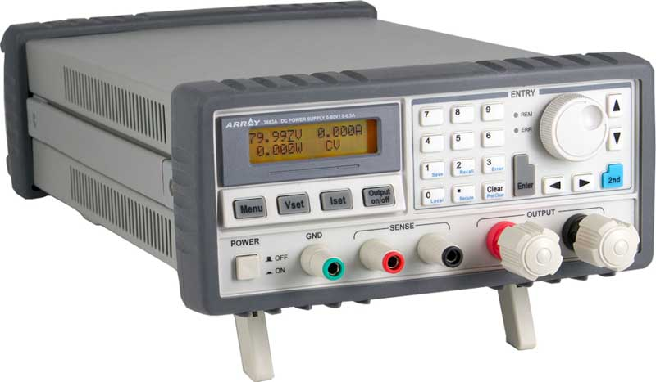
Caption: GOSSEN METRAWATT expands its LABKON P series, adding new computer controllable DC power supplies up to 40 A

Image/s: | labkon_konstanter_1000px | Characters: | 1594
File name: | 202010026_pm_labkon_p_power_supplies_en | Date: | 10-21-2020
About Gossen Metrawatt
GMC-I Messtechnik is one of the world's leading suppliers of measurement systems. Under the GOSSEN METRAWATT brand, the company develops and distributes a wide range of high-quality measuring and test devices for the electrical trade, industry, and the medical sector. The scope of products includes measuring and testing equipment for standardized testing of electrical systems and appliances, multimeters, calibrators, network analyzers, power supplies, as well as transducers and power meters for high-voltage and moving-coil measurement. GMC-I Messtechnik also provides a varied offering of training courses for customers and develops energy management concepts. The corporate group runs its own DakkS-certified calibration center that performs DakkS, ISO, and factory calibrations for virtually all electrical measured values. GMC-I Messtechnik is part of the GMC Instruments group, which also includes other specialized manufacturers for measurement and testing technology – notably, Camille Bauer Metrawatt, Dranetz, Prosys, Seaward, Daytronic, Electrotek Concepts, and Kurth Electronic. The group's production sites in Germany, Switzerland, England, and the United States are complemented by a global sales network.

Contact:  GMC-I Messtechnik GmbH  Christian Widder  Leitung Marketing Kommunikation  Suedwestpark 15  90449 Nuremberg  Germany  Phone: +49 . 911 . 8602-572  Email: christian.widder@gossenmetrawatt.com  Internet: www.gossenmetrawatt.com | gii die Presse-Agentur GmbH  Immanuelkirchstr. 12  10405 Berlin  Germany  Phone: +49 . 30 . 538 9650  Email: info@gii.de  Internet: www.gii.de

