Press Release

Gossen Metrawatt – Synonymous with Quality and Safety
Leading Metrology Specialist Announces Rebranding

Nuremberg – Nuremberg-based GMC-I Messtechnik GmbH will do business under the name of its own “Gossen Metrawatt” brand as of the 1st of October, 2020. The new Gossen Metrawatt GmbH will thus consolidate the strong reputation of its brand name amongst its customers. “Our customers have known us for decades as Gossen Metrawatt. It only makes sense to include such a strong brand name in the company name as well,” explains Marcel Hutka, Managing Director Technology & Sales.

The globally leading specialist in the field of measuring technology has been offering top quality products and solutions made in Germany for more than 114 years. The company’s scope of products and services ranges from measuring and test technology, e-mobility, battery testing technology, medical engineering, energy management, power quality and laboratory power supplies, right on up to digital services for customers. Digitalization is one of the future issues which is being assigned especially high priority at Gossen Metrawatt. “Our intelligent cloud solutions are just one of the many examples of our innovative force in this area,” adds Hutka. “Our innovative effort is focused primarily on electrical safety, as well as reliable and efficient energy supply. Our ultimate goal, both now and in the future, is to provide our customers with expert support for their requirements and to sustainably satisfy them with reliable, future-proof products and solutions with focus on customer.”

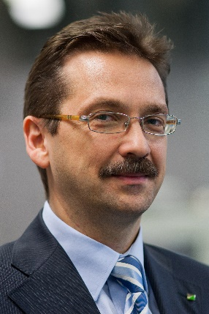 | 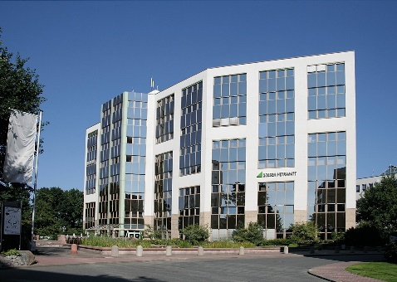
Figure 1: Marcel Hutka, Managing Director | Figure 2: Company Headquarters at Südwestpark in Nuremberg

Image/s: | hutka_m_gf_2000px  gm_hauptsitz_2000px | Characters: | 1.457
File name: | 202010_pm_gmc_rebranding_en.docx | Date: | 10-08-2020

Company Background

As one of the world’s leading suppliers of metrological systems, GMC-I Messtechnik develops and markets a comprehensive spectrum of high quality measuring and test technology for the electrical trades, industry and the field of medical technology under its brand name GOSSEN METRAWATT. The product portfolio includes measuring and test instruments for standards-compliant testing of electrical systems and devices, multimeters, calibrators, power analyzers and power supplies, as well as measuring transducers and power meters for heavy current and rotation angle measurement. Beyond this, the company supports its customers with extensive training offerings and develops concepts for energy management. The group of companies maintains its own calibration department as well as several DakkS accredited calibration centers which perform DakkS, ISO and factory calibration for nearly all electrical and optical measured quantities. GMC-I Messtechnik is a member of the GMC Instruments Group, which also comprises other specialized manufacturers of measuring and test technology including Camille Bauer Metrawatt, Dranetz, Prosys, Seaward, Daytronic and Electrotek Concepts, as well as Kurth Electronic. The group has production locations in Germany, Switzerland, England and the USA, and maintains a global sales network.

Contact:  GMC-I Messtechnik GmbH  Christian Widder  Leitung Marketing Kommunikation  Suedwestpark 15  90449 Nuremberg  Germany  Phone: +49 . 911 . 8602-572  Email: christian.widder@gossenmetrawatt.com  Internet: www.gossenmetrawatt.com | gii die Presse-Agentur GmbH  Immanuelkirchstr. 12  10405 Berlin  Germany  Phone: +49 . 30 . 538 9650  Email: info@gii.de  Internet: www.gii.de

