Press Release

High-end MIPI camera modules for medical technology

Focusing medical technology, diagnostic, and laboratory applications, Vision Components launches a series of new MIPI camera modules that make proven high-end sensors accessible for integration with a wide range of embedded processor platforms. These new VC MIPI modules feature high image resolutions, high light sensitivity, low noise, and fast frame rates, combined with the advantages of the MIPI CSI-2 interface: they are cost-effective, low-power camera boards that can be connected to various embedded processors. The VC MIPI series is fully in line with the ongoing trend towards miniaturization and edge computing. The series design enables vision solutions with an optimal price–performance ratio. Vision Components uses a select choice of tried and tested, long-term available Sony Pregius and Starvis sensors for medical applications. Since these sensors have no native MIPI interface, the manufacturer has developed a MIPI converter that is integrated into the ultracompact camera modules.

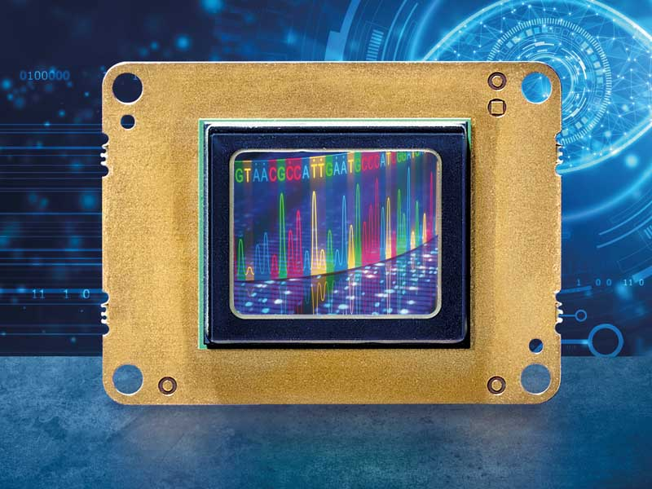
Caption: Perfect for use in medical technology: Vision Components integrates additional Sony Pregius and Starvis sensors with high image quality, light sensitivity, and frame rates in its VC MIPI camera modules

New modules include VC MIPI IMX183 with a 20-megapixel resolution, 4K video support, and a global reset shutter – ideal for applications requiring maximum image quality and speed. The Sony Starvis sensor's backside illuminated (BSI) technology ensures high light sensitivity and a wide contrast range. VC MIPI IMX226 and VC MIPI IMX178 with 12 MP and 6.4 MP resolution respectively exhibit the same technologies. Vision Components has also integrated Sony Pregius IMX250 series sensors for applications with high frame rates and IMX260 series sensors for price-sensitive applications with lower speeds. The new MIPI modules are suitable for commercial solutions and long-term available like all VC cameras. Additional VC MIPI camera modules for medtech and life science applications are already on the road map. The manufacturer also completes customized developments.
More information: www.mipi-modules.com

Image/s: | vc_mipi_sony_sensors_medtech | Characters: | 1870
File name: | 202101008_pm_mipi_cameras_medtech_en | Date: | 01-27-2021
About Vision Components
Vision Components is a leading international manufacturer of embedded vision systems. The freely programmable cameras with powerful onboard CPUs perform image processing tasks on their own without the need for an additional computer. Vision Components offers OEMs versatile Linux-based embedded systems for 2D and 3D image processing, supplied as board cameras or in protective casings. These are complemented by a growing range of ultracompact MIPI camera boards, which connect to a variety of different CPU boards. In addition, Vision Components offers software libraries and develops customized solutions on request. The team of experts can draw on extensive knowledge and over 20 years of experience with imaging applications. The company based in Ettlingen in southwestern Germany was founded in 1996 by Michael Engel, the inventor of the first industrial-grade intelligent camera. More world premieres followed, including the world's first intelligent vision sensors and the first-ever embedded 3D laser profiler. Today, Vision Components has sales offices in the United States and Japan and works with local partners in over 25 countries to provide consistent customer focus and readily available expertise throughout the world.

Contact:  Vision Components GmbH  Jan-Erik Schmitt  Ottostr. 2  76275 Ettlingen  Germany  Phone: +49 . 7243 . 21670  Email: schmitt@vision-components.com  Internet: www.vision-components.com | gii die Presse-Agentur GmbH  Immanuelkirchstr. 12  10405 Berlin  Germany  Phone: +49 . 30 . 538 9650  Email: info@gii.de  Internet: www.gii.de

