Press Release

embedded world:
Vision Components presents smallest embedded vision system

Probably the world's smallest embedded vision system – fully integrated in one board and hardly bigger than an image sensor module: VC picoSmart from Vision Components will premiere at embedded world 2021 DIGITAL (March 1–5). Only 22 mm x 23.5 mm in size, this board camera yet contains all components necessary for image processing: 1-megapixel CMOS sensor with global shutter, FPGA module, high-end FPU processor, and memory. An interface board can be connected via the integrated FPC connector. This makes VC picoSmart the perfect base for rapid development of cost-effective, application-specific, and compact vision sensors. Vision Components' long-proven VCRT operating system enables real-time image processing, for instance for object recognition, position control, barcode reading, as well as web edge and level control.

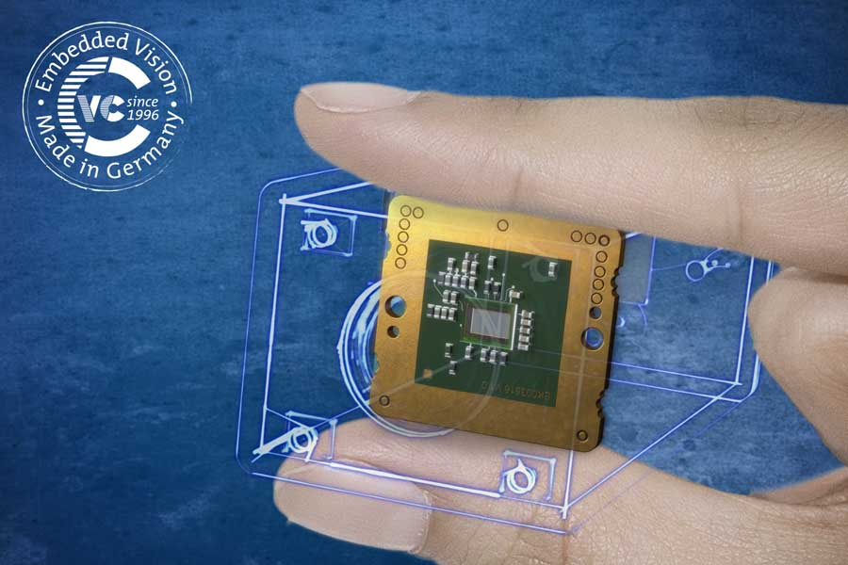
Caption: Vision Components presents several innovations, including the world's smallest embedded vision system, VC picoSmart

The German manufacturer, which celebrates its 25th anniversary in 2021, will also present new MIPI camera modules at the virtual tradeshow. These are designed for flexible embedded vision designs and easy connection to CPU boards such as NVIDIA Jetson, the NXP i.MX 8M Mini/Nano/Plus processor family, and Raspberry Pi Compute Modules. Additional image sensors are continuously being added to the lineup of VC MIPI modules, such as high-end sensors from the Sony Pregius and Sony Starvis series with high resolutions, light sensitivities, and frame rates. At embedded world, Vision Components will also announce VC MIPI camera modules with the latest Sony SWIR sensors. Interested parties are invited to acquaint themselves with the VC solutions for embedded vision and to arrange individual chats with the team.
More information and free tickets: www.tinyurl.com/1xds9sr1
Video: https://www.youtube.com/watch?v=zHuKJ6YudoI

Image/s: | vc_picosmart_finger_logo | Characters: | 1641
File name: | 202102016_pm_embedded_world_en | Date: | 02-10-2021
About Vision Components
Vision Components is a leading international manufacturer of embedded vision systems. The freely programmable cameras with powerful onboard CPUs perform image processing tasks on their own without the need for an additional computer. Vision Components offers OEMs versatile Linux-based embedded systems for 2D and 3D image processing, supplied as board cameras or in protective casings. These are complemented by a growing range of ultracompact MIPI camera boards, which connect to a variety of different CPU boards. In addition, Vision Components offers software libraries and develops customized solutions on request. The team of experts can draw on extensive knowledge and over 20 years of experience with imaging applications. The company based in Ettlingen in southwestern Germany was founded in 1996 by Michael Engel, the inventor of the first industrial-grade intelligent camera. More world premieres followed, including the world's first intelligent vision sensors and the first-ever embedded 3D laser profiler. Today, Vision Components has sales offices in the United States and Japan and works with local partners in over 25 countries to provide consistent customer focus and readily available expertise throughout the world.

Contact:  Vision Components GmbH  Jan-Erik Schmitt  Ottostr. 2  76275 Ettlingen  Germany  Phone: +49 . 7243 . 21670  Email: schmitt@vision-components.com  Internet: www.vision-components.com | gii die Presse-Agentur GmbH  Immanuelkirchstr. 12  10405 Berlin  Germany  Phone: +49 . 30 . 538 9650  Email: info@gii.de  Internet: www.gii.de

