Press Release

Embedded vision system with miniature footprint for OEM projects

Vision Components presents VC picoSmart, an embedded vision system the size of a conventional image sensor module that greatly facilitates and speeds up the development of vision sensors. Image capture and processing are integrated on a 22 x 23.5 mm board. With the image sensor, processors, memory, and operating system already proven to work together perfectly, OEMs can focus on their vision sensor's application-specific programming and hardware design. Target applications include object detection, position detection, code reading, edge detection, and fill level detection. Vision Components offers a ready-made sample application for object recognition within the OEM module VC picoSmart, using real-time processing in the FPGA. After a quick one-touch pattern teach-in, the system detects and matches the pattern in subsequent images. The manufacturer provides a developer kit for easy start and application development.

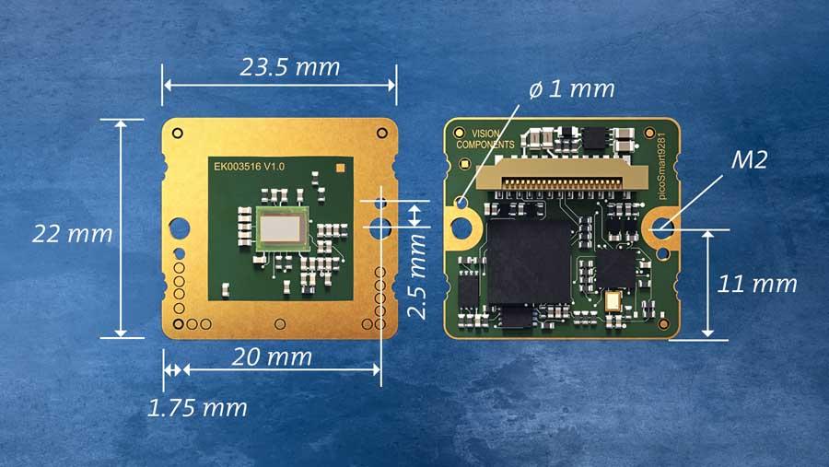
Caption 1: The image capture and processing components are perfectly attuned for excellent results and all integrated on one ultracompact board – OEMs can thereby save costs and time on vision sensor development

VC picoSmart features a monochrome 1MP global shutter sensor with high light sensitivity and high frame rates, an FPGA, a high-end FPU processor, memory, and an FPC port to connect an interface board – or a display for live image output and for interaction and control. The FPGA handles most of the image processing tasks. The FPU processor, which runs the highly efficient real-time operating system VCRT, is available for additional tasks. This combination of FPGA and FPU ensures maximum efficiency and computing power while keeping power consumption low. This makes VC picoSmart ideal for mobile applications and edge devices. VC picoSmart is available as an OEM module as of now. Like all Vision Components products, it is available for long-term use and optimized for industrial applications.
More: https://www.vision-components.com/en/products/oem/arm-linux/board-cameras/vc-picosmart/

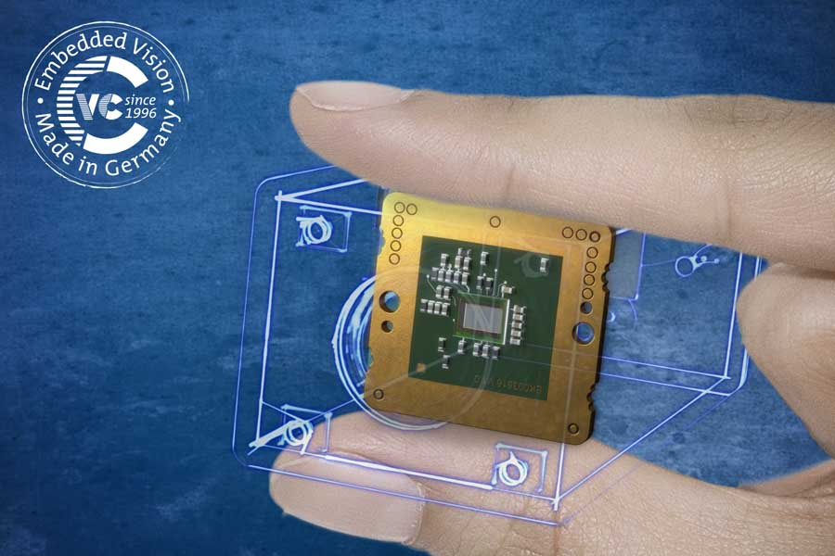
Caption 2: VC picoSmart is probably the smallest embedded vision system in the world

Image/s: | vc_picosmart_dimensions  vc_picosmart_finger_logo | Characters: | 1726
File name: | 202103028_pm_vc_picosmart_en | Date: | 03-24-2021
About Vision Components
Vision Components is a leading international manufacturer of embedded vision systems. The freely programmable cameras with powerful onboard CPUs perform image processing tasks on their own without the need for an additional computer. Vision Components offers OEMs versatile Linux-based embedded systems for 2D and 3D image processing, supplied as board cameras or in protective casings. These are complemented by a growing range of ultracompact MIPI camera boards, which connect to a variety of different CPU boards. In addition, Vision Components offers software libraries and develops customized solutions on request. The team of experts can draw on extensive knowledge and over 20 years of experience with imaging applications. The company based in Ettlingen in southwestern Germany was founded in 1996 by Michael Engel, the inventor of the first industrial-grade intelligent camera. More world premieres followed, including the world's first intelligent vision sensors and the first-ever embedded 3D laser profiler. Today, Vision Components has sales offices in the United States and Japan and works with local partners in over 25 countries to provide consistent customer focus and readily available expertise throughout the world.

Contact:  Vision Components GmbH  Jan-Erik Schmitt  Ottostr. 2  76275 Ettlingen  Germany  Phone: +49 . 7243 . 21670  Email: schmitt@vision-components.com  Internet: www.vision-components.com | gii die Presse-Agentur GmbH  Immanuelkirchstr. 12  10405 Berlin  Germany  Phone: +49 . 30 . 538 9650  Email: info@gii.de  Internet: www.gii.de

