Press Release

RAMO 22 T illuminated pushbutton with metallized front ring

Just like all the control components from the RAMO range from RAFI, the illuminated pushbuttons in the RAMO T series are available for mounting hole diameters of 22.3 mm or 30.3 mm. While the RAMO 30 T comes as a standard with stainless steel bezel, RAFI now supplies the slimmer RAMO 22 T models not only in the classic black plastic housing, but also with a metallized front ring. RAMO T models are available in a wide choice of bezel colors. They stand out for uniformly illuminated button surfaces as well as a noticeable tactile feedback. The switching elements are integrated tactile switches from RAFI’s MICON 5 range with high-quality gold contacts, which guarantee switching reliability and a long operating life. For custom legending of the button bezels, RAFI offers the FLEXLAB legending system with labelling sheets either pre-printed or for printing by the customer. Due to their closed mono-housings with IP 66 or higher degree of protection, RAMO control components are ideal for use in or retrofitting into decentral applications. The easy connection via M12 plug terminals makes extra wiring unnecessary and allows installation by untrained personnel.

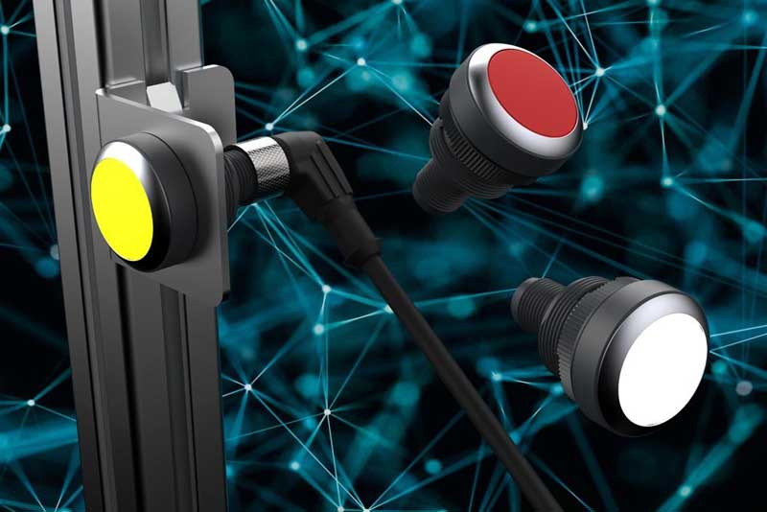
Caption: RAMO 22 T illuminated pushbutton with metallized front ring

Image/s: | RAFI-RAMO22T-Metallring | Characters: | 1,169
File name: | 202104024_pm_ramo_22_t_metallized_en | Date: | 04-28-2021
About the RAFI group
Founded in 1900, RAFI today develops and produces electromechanical components and systems for human–machine interaction. The range of products includes pushbuttons, switches, touchscreens, control systems and electronic assemblies. RAFI products are employed in many industries including automation, medical technology, machine and plant engineering, road and railway vehicles, household appliances and telecommunication. The RAFI group operates internationally with more than 2,000 employees at sites in Germany, Europe, China and the USA. Its headquarters are in Berg, Germany.

Contact:

RAFI GmbH & Co. KG
Artur Krug
Ravensburger Str. 128-134
88276 Berg
Germany
Phone: +49 . 751 . 891 307
E-Mail: artur.krug@rafi-group.com
Internet: www.rafi-group.com

