Press Release

VC MIPI modules and accessories now available from Mouser Electronics

Select MIPI modules and accessories from Vision Components are now available from Mouser Electronics. Customers can easily and quickly order the camera modules in the company’s online store. The products available from Mouser include camera modules with the Omnivision OV9281 sensor for price-sensitive applications and prototyping as well as modules with popular Sony Pregius and Starvis sensors, which meet the highest image quality requirements with resolutions up to 12.3 MPixel for the VC MIPI IMX412.
FPC cables with 15 or 22 pins for direct interfacing of the camera modules with various CPU boards, camera lenses and lens holders are available as accessories from Mouser Electronics; as is the VC MIPI Repeater Board, which enables up to five times longer camera cables and offers additional interfaces as well as a trigger input and a flash trigger output.
Vision OEMs in the prototyping phase benefit from ready availability via the distributor and from short delivery times – Mouser ships stock products on the same day.

Product range in the online store: https://eu.mouser.com/Search/Refine?Keyword=vision+components+mipi

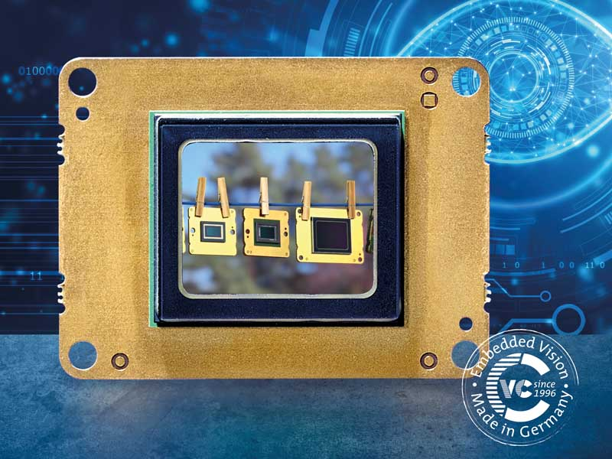
Caption: Now available at mouser.com: MIPI modules and accessories from Vision Components

Image/s: | vc_mipi_sony_pregius_starvis | Characters: | 1030
File name: | 202106026_pm_vc_in_mouser_web_store_en | Date: | 06-30-2021
About Vision Components
Vision Components is a leading international manufacturer of embedded vision systems. The freely programmable cameras with powerful onboard CPUs perform image processing tasks on their own without the need for an additional computer. Vision Components offers OEMs versatile Linux-based embedded systems for 2D and 3D image processing, supplied as board cameras or in protective casings. These are complemented by a growing range of ultracompact MIPI camera boards, which connect to a variety of different CPU boards. In addition, Vision Components offers software libraries and develops customized solutions on request. The team of experts can draw on extensive knowledge and over 20 years of experience with imaging applications. The company based in Ettlingen in southwestern Germany was founded in 1996 by Michael Engel, the inventor of the first industrial-grade intelligent camera. More world premieres followed, including the world's first intelligent vision sensors and the first-ever embedded 3D laser profiler. Today, Vision Components has sales offices in the United States and Japan and works with local partners in over 25 countries to provide consistent customer focus and readily available expertise throughout the world.

Contact:  Vision Components GmbH  Jan-Erik Schmitt  Ottostr. 2  76275 Ettlingen  Germany  Phone: +49 . 7243 . 21670  Email: schmitt@vision-components.com  Internet: www.vision-components.com | gii die Presse-Agentur GmbH  Immanuelkirchstr. 12  10405 Berlin  Germany  Phone: +49 . 30 . 538 9650  Email: info@gii.de  Internet: www.gii.de

