Press Release

Shortcut to series production: modular Maivin i.MX 8M Plus AI Vision Kit from AU-Zone, Toradex and Vision Components

For proof of concept, rapid prototyping and small series production, AU-Zone and Toradex, working in close cooperation with Vision Components, have developed the modular Maivin i.MX 8M Plus AI Vision Kit. The developer kit is based on a Toradex Verdin i.MX 8M Plus System-on-Module and a carrier board, which AU-Zone designed for vision applications and which accommodates up to two VC MIPI camera modules. The kit is scheduled to be ready for shipping in Q3 2021.

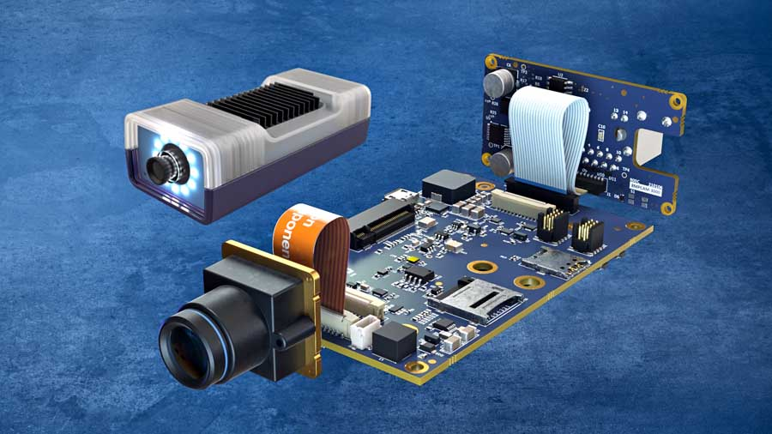
Caption: Comprehensive developer kit for rapid prototyping and small series production: the modular Maivin i.MX 8M Plus AI Vision Kit from AU-Zone, Toradex and Vision Components

Featuring a neural network processor unit and an integrated image signal processor, the i.MX 8M Plus processor from NXP is ideally suited for demanding embedded vision applications. The Verdin SoM for the kit has been extended by a variable SoM adapter and connector board from AU-Zone in order to enable users to quickly and easily build functional models on its basis. Together with the high-quality camera modules VC MIPI IMX327-C (color) and VC MIPI IMX296 (monochrome), customers have access to all components for image acquisition as well as the required interfaces and I/Os for individual rapid prototyping solutions up to small series. Additional VC camera modules are also compatible with the Maivin kit. The AU-Zone connector boards can also be custom-developed with freely definable interfaces and functionalities for individual requirements. This makes the Maivin i.MX 8M Plus AI Vision Kit ideally suited for a wide range of applications – whether in automation and robotics, medical technology or the agricultural industry. A housing for the electronics including lighting is also part of the kit.
Optimal image processing is ensured by drivers from Vision Components, which enable the direct connection and support of the VC MIPI camera modules with the NXP i.MX 8M processor family. Especially for this developer kit, they have been integrated into Toradex' software platform TorizonCore, which provides access to the image signal processor of the i.MX 8M Plus. Thus, the ISP can be used for advanced image preprocessing such as color conversion, geometry correction, HDR, gamma correction, etc. The software platform also includes comprehensive frameworks for an easy entry into development, over-the-air updates and security features.
AU-Zone's DeepView Machine Learning Toolkit is also part of the Maivin i.MX 8M Plus AI Vision Kit. It includes out-of-the-box machine learning demos for object recognition, classification, and tracking that can be customized to the users own AI models and datasets using the NXP eIQ toolkit. As recently as July 2021, NXP expanded the development environment, adding new tools, a GUI-based interface, and the DeepViewRT engine optimized for the i.MX platform. In addition, other applications, for example AU-Zone applications, can be integrated and used for vision solution development.

Vision Components drivers for the NXP i.MX 8M processor family are also available for other platforms in addition to the Toradex Verdin SoM series platforms. Support for more manufacturers, single board computers and embedded solutions with i.MX 8M processors is already on the road map.

Image/s: | vc_maivin_imx8_ai_kit |  | Characters: | 3088
File name: | 202107036_pm_vc_maivin-imx8-ai-kit_en |  | Date: | 07-28-2021
About Vision Components
Vision Components is a leading international manufacturer of embedded vision systems. The freely programmable cameras with powerful onboard CPUs perform image processing tasks on their own without the need for an additional computer. Vision Components offers OEMs versatile Linux-based embedded systems for 2D and 3D image processing, supplied as board cameras or in protective casings. These are complemented by a growing range of ultracompact MIPI camera boards, which connect to a variety of different CPU boards. In addition, Vision Components offers software libraries and develops customized solutions on request. The team of experts can draw on extensive knowledge and over 20 years of experience with imaging applications. The company based in Ettlingen in southwestern Germany was founded in 1996 by Michael Engel, the inventor of the first industrial-grade intelligent camera. More world premieres followed, including the world's first intelligent vision sensors and the first-ever embedded 3D laser profiler. Today, Vision Components has sales offices in the United States and Japan and works with local partners in over 25 countries to provide consistent customer focus and readily available expertise throughout the world.
Contact:  Vision Components GmbH  Jan-Erik Schmitt  Ottostr. 2  76275 Ettlingen  Germany  Phone: +49 . 7243 . 21670  Email: schmitt@vision-components.com  Internet: www.vision-components.com |  | gii die Presse-Agentur GmbH  Immanuelkirchstr. 12  10405 Berlin  Germany  Phone: +49 . 30 . 538 9650  Email: info@gii.de  Internet: www.gii.de

