Press Release

VISION trade fair:
Smallest embedded vision systems

Vision Components will present new developments at its VISION exhibition booth #8C31. The embedded vision manufacturer, which is celebrating its 25th anniversary in 2021, recently launched VC picoSmart, the world's smallest complete embedded vision system and has now equipped it with new functions for 3D profile measurement. This enables OEMs to develop low-priced triangulation sensors with less effort. Anyone who used to be put off by limited cable lengths when connecting MIPI camera modules will be keen to check out VC Coax. This new solution allows transmission paths of 10 meters and more. Vision Components has optimized the cables for high-speed transfer. This expansion of the manufacturer's MIPI range significantly increases flexibility in application development. Vision Components offers various MIPI camera modules up to 20 Megapixels that are compatible with all major single-board computers, as well as developer kits with robust functions for industrial applications. Further innovations are in preparation – particularly noteworthy: an FPGA-based hardware accelerator for image processing. The team is looking forward to many conversations not only about the product range but above all about practical applications, and will be happy to advise visitors to the booth on the performance of various technologies as well as hardware integration.
Vision Components at the VISION trade fair
Stuttgart, 5 – 7 October 2021, Hall 8, Stand C31

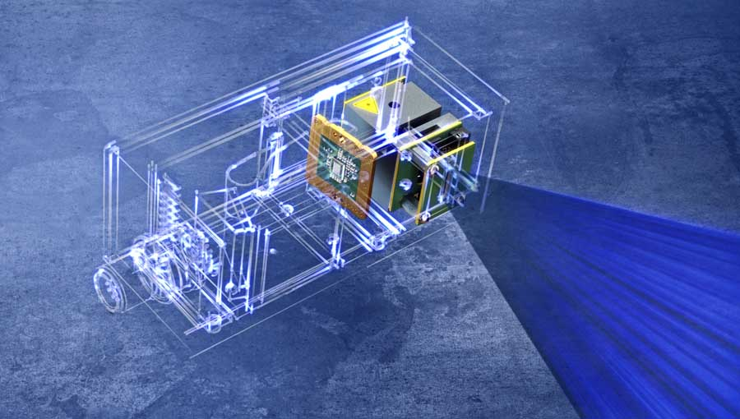
Caption: VC picoSmart is the world's smallest complete embedded vision system. Now, Vision Components shows solutions for integration in 3D profile measurement applications.

Image/s: | vc_picosmart_3d_scan | Characters: | 1364
File name: | 202109011_pm_vision_exhibition_en | Date: | 09-02-2021
About Vision Components
Vision Components is a leading international manufacturer of embedded vision systems. The freely programmable cameras with powerful onboard CPUs perform image processing tasks on their own without the need for an additional computer. Vision Components offers OEMs versatile Linux-based embedded systems for 2D and 3D image processing, supplied as board cameras or in protective casings. These are complemented by a growing range of ultracompact MIPI camera boards, which connect to a variety of different CPU boards. In addition, Vision Components offers software libraries and develops customized solutions on request. The team of experts can draw on extensive knowledge and over 20 years of experience with imaging applications. The company based in Ettlingen in southwestern Germany was founded in 1996 by Michael Engel, the inventor of the first industrial-grade intelligent camera. More world premieres followed, including the world's first intelligent vision sensors and the first-ever embedded 3D laser profiler. Today, Vision Components has sales offices in the United States and Japan and works with local partners in over 25 countries to provide consistent customer focus and readily available expertise throughout the world.
Contact:  Vision Components GmbH  Jan-Erik Schmitt  Ottostr. 2  76275 Ettlingen  Germany  Phone: +49 . 7243 . 21670  Email: schmitt@vision-components.com  Internet: www.vision-components.com |  | gii die Presse-Agentur GmbH  Immanuelkirchstr. 12  10405 Berlin  Germany  Phone: +49 . 30 . 538 9650  Email: info@gii.de  Internet: www.gii.de

