Press Release

Megalodon protective enclosures for Flir A400/700, Dalsa Linea, Jai Fusion and other large-format cameras

The new Megalodon series from autoVimation features the same outer dimensions as Orca protective camera enclosures but with a larger inner diameter. It thus provides IP66/67 protection for all those camera types that are slightly too large for the existing enclosures. Due to the 2 mm wider inside dimensions, Megalodon enclosures are suitable for Flir A400 and Dalsa Linea as well as for other, similarly sized large-format cameras, such as Jai Spark, Runner Basler and many more. autoVimation supplies a mount for cameras from the new Flir A400/700 series, as well as a special dual germanium and BK7 front window, which enables simultaneous operation of infrared and visible-light cameras. For “reverse” installations, Megalodon enclosures are designed to fit all available Orca front lids such as the dome window. The existing 30 mm or 60 mm Orca extensions allow users to increase the standard housing length of 227 mm. Thanks to the flexible Quick-Lock/Heat-Guide camera mount, lenses can be positioned directly behind the enclosure window to avoid corner shading. In addition to the high protection rating, Megalodon housings made of anodized aluminum are characterized by chemical resistance, vibration-proof camera mounting, very good heat dissipation and passive cooling of cameras by up to 23 °C. Numerous optional accessories ensure optimal configuration for demanding application scenarios: various mounting kits, deflection mirrors, sun roofs, protective shutters, heating plates and cooling units.

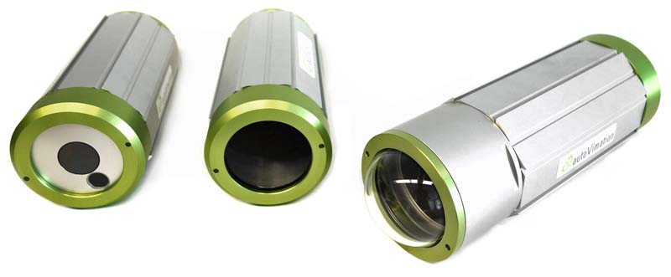
Caption: Megalodon protective enclosures with an enlarged inner diameter can accommodate large-format cameras

 | Image/s: | megalodon_reverse |  | Characters: | 1512
 | File name: | 202110010_pm_megalodon_camera_enclosures_en |  | Date: | 10-28-2021
About autoVimation
Established in 2008, Karlsruhe-based autoVimation was founded by Peter Neuhaus to provide solutions for easier installation and adjustment of image processing components. The company has developed a modular construction kit that simplifies the connection of all required components, which does away with costly and time-consuming manufacturing of dedicated mounting brackets. The product portfolio also includes compact, easy-to-integrate enclosures that provide optimal protection for cameras and lenses in industrial applications, and ensure good heat dissipation. autoVimation supplies complete, ready-to-install mechanical solutions for cameras and light fittings, and enables the integration of special lenses, filters, light barriers, encoders, or other sensors.
autoVimation's customers include renowned companies from various industry branches, such as the pharmaceutical and food industry, measuring technology, quality control, and security technology.
Contact:  autoVimation GmbH  Peter Neuhaus  Roemerweg 1  76287 Rheinstetten  Germany  Phone: +49 . 721 . 627 6756  Email: sales@autovimation.com  Internet: www.autovimation.com |  |  | gii die Presse-Agentur GmbH  Immanuelkirchstr. 12  10405 Berlin  Germany  Phone: +49 . 30 . 538 9650  Email: info@gii.de  Internet: www.gii.de

