Press Release

Polarizers and diffusers for Meganova ring light

autoVimation now offers highly efficient, easy-to-use polarization filters and diffusers for its innovative Meganova ring light for installation in Orca, Shark and Megalodon protective camera enclosures. The Meganova ring light with eight high-power LEDs, placed directly behind the enclosure front window, eliminates the need for further external lighting. The ring light design is matched to the enclosure series cited above for efficient heat dissipation. This allows for continuous operation at 200 % power and brightness under normal conditions. In standard vertical installations, coaxial orientation of light source and camera lens can cause light reflections on reflective surfaces and thus impair the inspection of metallic parts or paper packaging. The new Meganova polarizing filters solve this issue by means of two linear, crossed polarization filters, which completely eliminate light reflections into the camera lens and thus enable excellent imaging quality. The solution consists of a polarization ring placed over the ring of LEDs and a polarization disc for the central lens aperture, which eliminates the need for a polarizer on the lens. The ring and disc are simply attached to the lighting tube, then, the outer ring, which polarizes the LED light, is twisted against the inner disk until their polarization directions are offset by 90°. The newly available Meganova diffusion rings for homogenizing light distribution in the camera image are mounted analogously to the polarization ring. They are available in two versions with strong and weak diffusion at light transmission coefficients of 45 % and 80 % respectively.

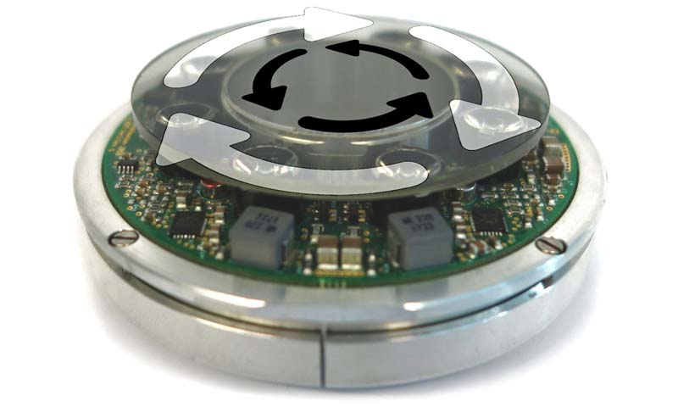
Caption 1: The Meganova ring light with polarizing filters eliminates light reflections into the camera lens

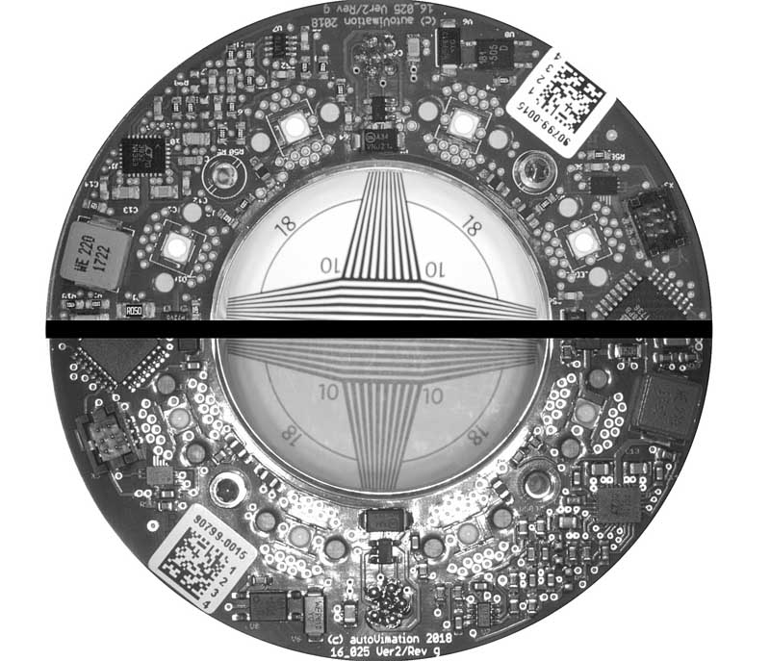
Caption 2: The upper half of the image was taken with, the lower half without Meganova cross-polarizer

 | Image/s: | filterdiskring_1_turn  vergleich_polfilter_frei |  | Characters: | 1643
 | File name: | 202110011_pm_meganova_polarizer_diffuser_en |  | Date: | 11-23-2021
About autoVimation
Established in 2008, Karlsruhe-based autoVimation was founded by Peter Neuhaus to provide solutions for easier installation and adjustment of image processing components. The company has developed a modular construction kit that simplifies the connection of all required components, which does away with costly and time-consuming manufacturing of dedicated mounting brackets. The product portfolio also includes compact, easy-to-integrate enclosures that provide optimal protection for cameras and lenses in industrial applications, and ensure good heat dissipation. autoVimation supplies complete, ready-to-install mechanical solutions for cameras and light fittings, and enables the integration of special lenses, filters, light barriers, encoders, or other sensors.
autoVimation's customers include renowned companies from various industry branches, such as the pharmaceutical and food industry, measuring technology, quality control, and security technology.
Contact:  autoVimation GmbH  Peter Neuhaus  Roemerweg 1  76287 Rheinstetten  Germany  Phone: +49 . 721 . 627 6756  Email: sales@autovimation.com  Internet: www.autovimation.com |  |  | gii die Presse-Agentur GmbH  Immanuelkirchstr. 12  10405 Berlin  Germany  Phone: +49 . 30 . 538 9650  Email: info@gii.de  Internet: www.gii.de

