Press Release

First complete hygienic assembly system for machine vision components

Launching the Hygienic Building Kit, autoVimation presents the world's first mounting system for machine vision applications that is suitable for installing cameras, lighting and lasers in the food and pharmaceutical industries or in cleanrooms. Since imaging components can be contaminated with product residues during steam-jet cleaning of conveyor systems and can thus become a source of germs themselves, they are subject to the same hygiene requirements that apply to plant components in direct contact with the product.
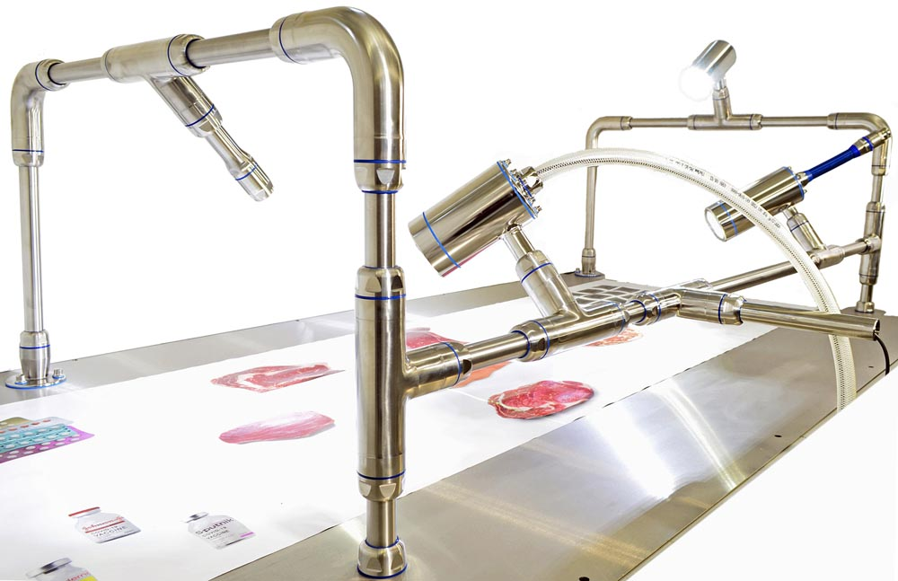
Caption: Hygienic Building Kit from autoVimation is the world's first complete assembly system for machine vision applications in hygienic areas

autoVimation's existing, proven machine vision mounting systems use aluminum dovetail profiles for easy adjustment of the camera housings and are therefore out of the question for use in hygienically sensitive areas. For one thing, the recesses and undercuts of the joints create difficult-to-clean dead spaces, for another, the materials do not have the corrosion resistance required by regular cleaning and disinfection with aggressive chemicals. In contrast, the new Hygienic Building Kit is based on autoVimation's hygienic, IP69k-protected, AISI 316L stainless-steel enclosure series Dolphin, Shark and Piranha. The camera, lighting and laser enclosures are mounted on rails made of smooth stainless-steel rods. Hygienic T-pieces enable flexible positioning and orientation. Cable routing within the tubes not only ensures optimum protection against mechanical forces, but also eliminates the need for a separate food approval of cable materials. Alternatively, hygienic protective hoses are available for cable routing; these can also be used for additional cable routes to machines etc. All gaskets as well as an acrylic window are approved for direct food contact according to FDA and EU guidelines. In addition, all components meet the strictest criteria for hygienic surface design. The kit can be mounted directly on conveyors, walls, machine covers and ceilings. For application-specific configuration, users can shorten the available shafts to the required length and machine a hole for cable entry at the required location. The tube connectors for IP69k sealing of the joints enable sturdy designs even with longer rods and eccentric loads due to their strong internal clamping. For users to easily achieve compliance in every application, autoVimation is undergoing EHEDG certification of all components of the modular system.

Image/s: | Hygienic_Building_Kit_3_bawh |  | Characters: | 2366
File name: | 202110012_pm_hygienic_building_kit_en |  | Date: | 11-10-2021
About autoVimation
Established in 2008, Karlsruhe-based autoVimation was founded by Peter Neuhaus to provide solutions for easier installation and adjustment of image processing components. The company has developed a modular construction kit that simplifies the connection of all required components, which does away with costly and time-consuming manufacturing of dedicated mounting brackets. The product portfolio also includes compact, easy-to-integrate enclosures that provide optimal protection for cameras and lenses in industrial applications, and ensure good heat dissipation. autoVimation supplies complete, ready-to-install mechanical solutions for cameras and light fittings, and enables the integration of special lenses, filters, light barriers, encoders, or other sensors.
autoVimation's customers include renowned companies from various industry branches, such as the pharmaceutical and food industry, measuring technology, quality control, and security technology.
Contact:  autoVimation GmbH  Peter Neuhaus  Roemerweg 1  76287 Rheinstetten  Germany  Phone: +49 . 721 . 627 6756  Email: sales@autovimation.com  Internet: www.autovimation.com |  | gii die Presse-Agentur GmbH  Immanuelkirchstr. 12  10405 Berlin  Germany  Phone: +49 . 30 . 538 9650  Email: info@gii.de  Internet: www.gii.de

