Press Release

Piranha: New hygienic IP69k line laser enclosures

Introducing the Piranha series of extremely robust protective laser enclosures, autoVimation completes its new Hygienic Building Kit, which is the world's first system for fully hygienic mounting of cameras, lighting and lasers in machine vision applications in the food and pharmaceutical industries and in cleanrooms.

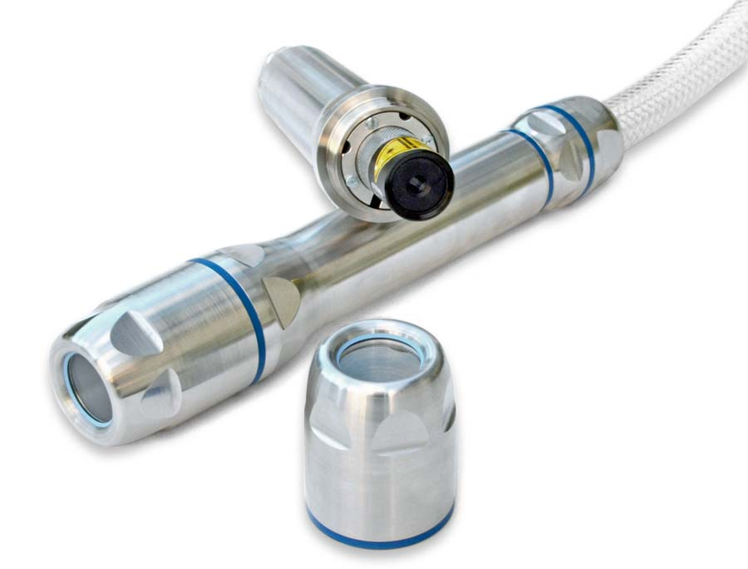
Caption: The new Piranha series provides hygienic protective laser enclosures with a IP69k protection rating

The Piranha enclosures – now available – are used to integrate line lasers with a diameter of 19 – 20 mm and up to 160 mm length with or without focusing ring. Featuring an IP69k protection rating and hygienic design without recesses, they are suitable for thorough cleaning with steam jets. The AISI 316L stainless-steel material ensures high corrosion resistance to harsh disinfectants and other aggressive chemicals. The 28 mm wide front window, which can be easily attached or replaced by means of a circlip, comes with a BK7 window with double-sided anti-reflective coating, or optionally with a sapphire or acrylic window. The deep front cover allows for placement of lasers with or without focusing ring directly behind the front window. Users can access the focusing ring at any time, simply by removing the screw cap. autoVimation supplies Piranha enclosures with a standard cable gland made of AISI 316L stainless steel for easy mounting to hygienic T-pieces and tubes. In addition, versions with hygienic cable glands and hoses are available for other mounting variants. For users to easily achieve compliance in every application, autoVimation is undergoing EHEDG certification of the protective laser enclosures.

 | Image/s: | piranha |  | Characters: | 1544
 | File name: | 202110013_pm_piranha_hygienic_laser_enclosures_en |  | Date: | 12-08-2021
About autoVimation
Established in 2008, Karlsruhe-based autoVimation was founded by Peter Neuhaus to provide solutions for easier installation and adjustment of image processing components. The company has developed a modular construction kit that simplifies the connection of all required components, which does away with costly and time-consuming manufacturing of dedicated mounting brackets. The product portfolio also includes compact, easy-to-integrate enclosures that provide optimal protection for cameras and lenses in industrial applications, and ensure good heat dissipation. autoVimation supplies complete, ready-to-install mechanical solutions for cameras and light fittings, and enables the integration of special lenses, filters, light barriers, encoders, or other sensors.
autoVimation's customers include renowned companies from various industry branches, such as the pharmaceutical and food industry, measuring technology, quality control, and security technology.
Contact:  autoVimation GmbH  Peter Neuhaus  Roemerweg 1  76287 Rheinstetten  Germany  Phone: +49 . 721 . 627 6756  Email: sales@autovimation.com  Internet: www.autovimation.com |  |  | gii die Presse-Agentur GmbH  Immanuelkirchstr. 12  10405 Berlin  Germany  Phone: +49 . 30 . 538 9650  Email: info@gii.de  Internet: www.gii.de

