Press Release

Photonics West:
New components for embedded vision

At the Photonics West exhibition, Vision Components will present new products for even more intelligence on the edge, additional applications and longer transmission paths. The FPGA-based hardware accelerator VC Power SoM was developed for complex image preprocessing. Results are directly transferred to a processor board. Multiple MIPI-CSI-2 inputs and outputs mean that the accelerator is as easy to integrate as a conventional VC MIPI camera module. OEMs can thus work with the embedded processor of their choice and use its full computing power for their particular application. The initial VC Power SoM launch comprises a completely open FPGA for customer programming and demo applications. Vision Components plans to follow this up with its own FPGA designs for applications such as color conversion, 1D barcode identification, epipolar correction, etc.

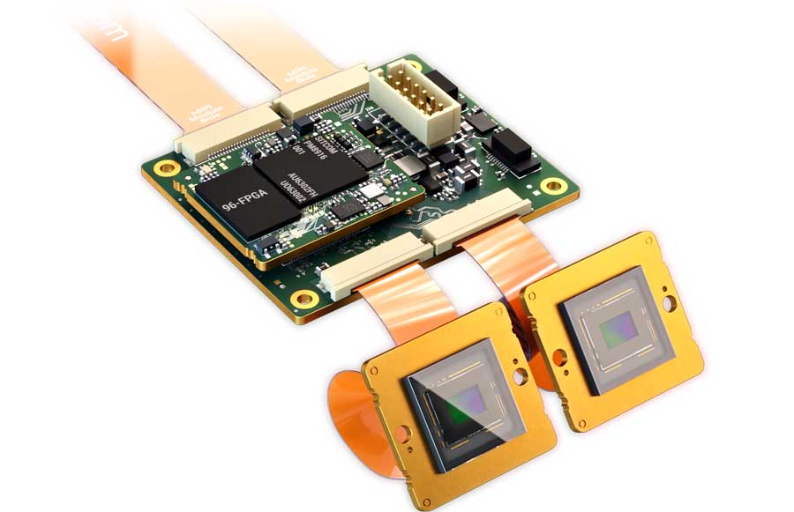
Caption: The compact, high-performance FPGA-based hardware accelerator with multiple MIPI I/Os enables complex image preprocessing on the edge

In addition to VC MIPI camera modules with Sony Pregius S sensors, Vision Components has for the first time integrated SWIR and ToF sensors to enable 3D applications and extremely low-cost SWIR applications with MIPI modules. All VC MIPI cameras are suitable for industrial use and work with common CPU boards. The manufacturer will also present the new VC Coax cable, a solution for high-speed data transmission over 10 meters and more, as well as new and proven embedded vision systems, notably, the world’s smallest complete embedded vision system, which can now also be ordered as VC picoSmart 3D with a designated, ultracompact laser line module and ready-to-use preprogrammed 3D profile measurement functions. This is the time-saving solution of choice for OEMs who wish to develop extremely low-cost triangulation sensors.
Vision Components at the Photonics West exhibition
San Francisco, 22 – 27 January 2022
Hall E, Booth 3185

Image/s: | vc_power_som | Characters: | 1689
File name: | 202111035_pm_photonics_west_en | Date: | 11-23-2021
About Vision Components
Vision Components is a leading international manufacturer of embedded vision systems. The freely programmable cameras with powerful onboard CPUs perform image processing tasks on their own without the need for an additional computer. Vision Components offers OEMs versatile Linux-based embedded systems for 2D and 3D image processing, supplied as board cameras or in protective casings. These are complemented by a growing range of ultracompact MIPI camera boards, which connect to a variety of different CPU boards. In addition, Vision Components offers software libraries and develops customized solutions on request. The team of experts can draw on extensive knowledge and over 20 years of experience with imaging applications. The company based in Ettlingen in southwestern Germany was founded in 1996 by Michael Engel, the inventor of the first industrial-grade intelligent camera. More world premieres followed, including the world's first intelligent vision sensors and the first-ever embedded 3D laser profiler. Today, Vision Components has sales offices in the United States and Japan and works with local partners in over 25 countries to provide consistent customer focus and readily available expertise throughout the world.
Contact:  Vision Components GmbH  Jan-Erik Schmitt  Ottostr. 2  76275 Ettlingen  Germany  Phone: +49 . 7243 . 21670  Email: schmitt@vision-components.com  Internet: www.vision-components.com |  | gii die Presse-Agentur GmbH  Immanuelkirchstr. 12  10405 Berlin  Germany  Phone: +49 . 30 . 538 9650  Email: info@gii.de  Internet: www.gii.de

