Press Release

BeeWaTec exclusive partner for KIS.ME since October

In October, RAFI and BeeWaTec agreed on a partnership for the sale of RAFI’s innovative KIS.ME communication and process control system. BeeWaTec is a solution provider for lean manufacturing, agile production and Industry 4.0. In the future, its customers will be able to directly order all KIS.ME hardware components and services, including application-specific system configuration, from BeeWaTec.
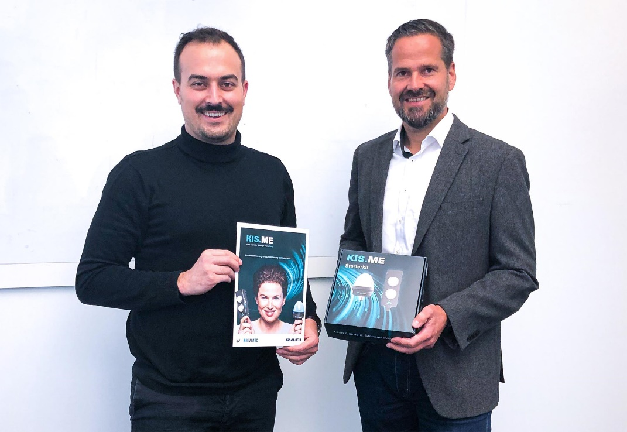
Caption: Joachim Walter of BeeWaTec (left) and Axel Zauke of the RAFI Group

KIS.ME stands for “Keep it simple. Manage everything”. The smart Plug&Play solution enables fast and easy digitalization of previously unconnected work, logistics, and production areas. The system is based on WLAN-capable control boxes and signal lamps with integrated I/Os which are networked via the KIS.MANAGER web platform. They are configured to the specific application in each case using simple logical rules. This enables customers to implement transparent signaling processes in previously non-digitalized production or logistics applications. It also allows easy integration of manual workplaces, remote delivery zones and older machines into the cloud-based control system. The data from these application areas is then captured in the cloud system and displayed in KIS.MANAGER for analysis. KIS.ME users can access KIS.MANAGER through a central web account at RAFI. As an exclusive partner of RAFI, BeeWaTec can offer its customers this service together with the required hardware from a single source.
“We are delighted to have gained such a renowned specialist for manufacturing systems as BeeWaTec to be our sales partner” explains Axel Zauke, Key Account Manager at the RAFI Group. “The interest of BeeWaTec in our product also shows that it offers the right solution for many digital retrofitting jobs.”
“In our view, previously no convincing solutions were available for the efficient collation of data from unconnected production or logistics areas and its transfer to the control system,” says Joachim Walter, COO of BeeWaTec. “KIS.ME closes this gap. Its ingenious concept also makes implementation very easy.”

Image/s: | RAFI-BeeWaTec_Contract_joachim_walter_und_axel_zauke | Characters: | 2,032
File name: | 202112017_pm_BeeWaTec_KISME_en | Date: | 12-08-2021

About the RAFI group
Founded in 1900, RAFI today develops and produces electromechanical components and systems for human–machine interaction. The range of products includes key switches, switches, touchscreens, control systems and electronic assemblies. RAFI products are employed in many industries including automation, medical technology, machine and plant engineering, road and railway vehicles, household appliances and telecommunication. The RAFI group operates internationally with more than 2,000 employees at sites in Germany, Europe, China, and the USA. Since 2020, it owns the US investment company Oaktree. Its headquarters are in Berg, Germany.

Contact:  RAFI GmbH & Co. KG  Artur Krug  Ravensburger Str. 128–134  88276 Berg, Germany  Phone: +49 751 89-1307  Email: artur.krug@rafi-group.com  Internet: www.rafi-group.com |  | gii die Presse-Agentur GmbH  Immanuelkirchstr. 12  10405 Berlin  Phone: +49 30 53 89 65-0  Email: info@gii.de  Internet: www.gii.de

