Press Release

RAFI Hungaria turns 30

On the occasion of its 30th anniversary this year, RAFI Hungaria Kft. looks back on three decades of success. In 1991, RAFI founded RAFI-BBP in Mezőtúr, Hungary, to expand its assembly capacities for electromechanical operating elements.
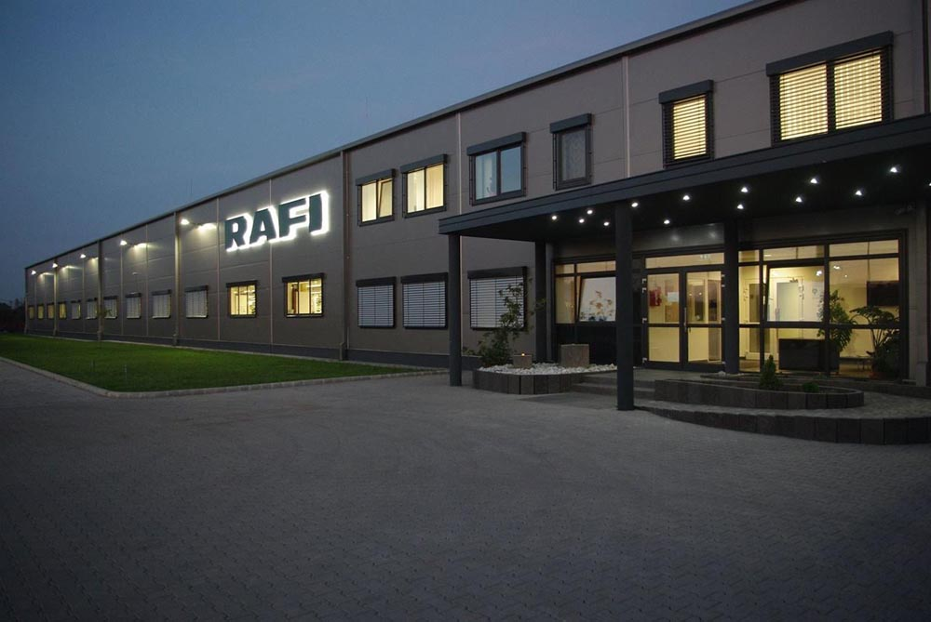
Caption 1: RAFI Hungaria celebrates its 30th anniversary this year.

Even in its first year, the number of employees increased from 5 to 21. Starting in 1995, RAFI-BBP gradually expanded its activities to include the manufacture of electronic and opto-electronic assemblies. The company also introduced quality management in compliance with ISO 9002. After continuous expansion of the manufacturing facilities and soldering systems, the company also added assembly of electronics products for the automotive industry to its range. In 2000, a new production unit was built, doubling the operating area. At the same time, the company adopted a process-oriented QM system according to EN ISO 9001:2000. Over the following years, the company expanded its production capacities by installing new high-performance assembly lines for electronic assemblies as well as a third production unit with a total useful area of 2,200 m². It also introduced a quality management system for medical products that complies with ISO 13485. Today, RAFI Hungaria operates production areas totaling 7,760 m² and has more than 500 employees. There has always been a focus at the company on training and further training to ensure a qualified current and future workforce. This prompted it to join forces with local technical school Teleki Blanka to establish a highly practical training program for electronics technicians. Furthermore, RAFI Hungaria cooperates with the University of Debrecen in its dual-studies program by offering opportunities for works students.
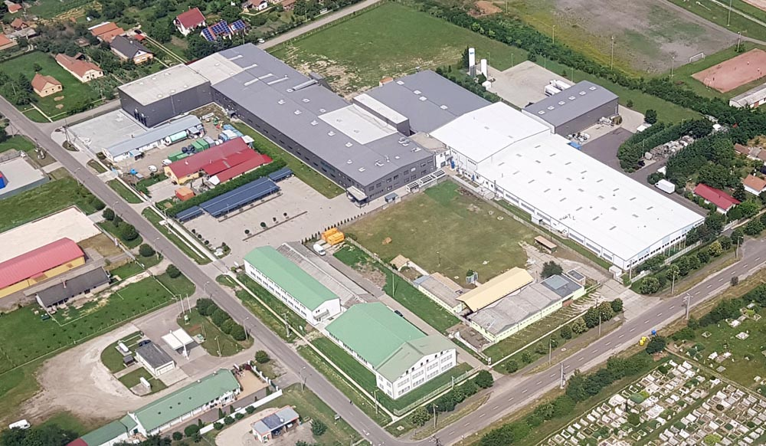
Caption 2: Bird’s-eye view of the factory in Mezőtúr

Image/s: | RAFI-Hungaria_Building  RAFI-Hungaria_Luftbild | Characters: | 1,712
File name: | 202112020_pm_30_Jahre_RAFI_Ungarn_en | Date: | 12-15-2021

About the RAFI group
Founded in 1900, RAFI today develops and produces electromechanical components and systems for human–machine interaction. The range of products includes key switches, switches, touchscreens, control systems and electronic assemblies. RAFI products are employed in many industries including automation, medical technology, machine and plant engineering, road and railway vehicles, household appliances and telecommunication. The RAFI group operates internationally with 2,000 employees at sites in Germany, Europe, China, and the USA. Its headquarters are in Berg, Germany.

Contact:  RAFI GmbH & Co. KG  Artur Krug  Ravensburger Str. 128–134  88276 Berg, Germany  Phone: +49 751 89-1307  Email: artur.krug@rafi-group.com  Internet: www.rafi-group.com |  | gii die Presse-Agentur GmbH  Immanuelkirchstr. 12  10405 Berlin  Phone: +49 30 53 89 65-0  Email: info@gii.de  Internet: www.gii.de

