Press Release

MIPI cables: Suitable for all applications and 10 meters and longer

Various connector types exist for the MIPI CSI-2 interface. Vision Components accordingly offers a range of MIPI cables and customer-specific configuration options. Thanks to a SerDes adapter board developed by VC, coax cables up to 10 meters and longer can now be used with the MIPI interface.

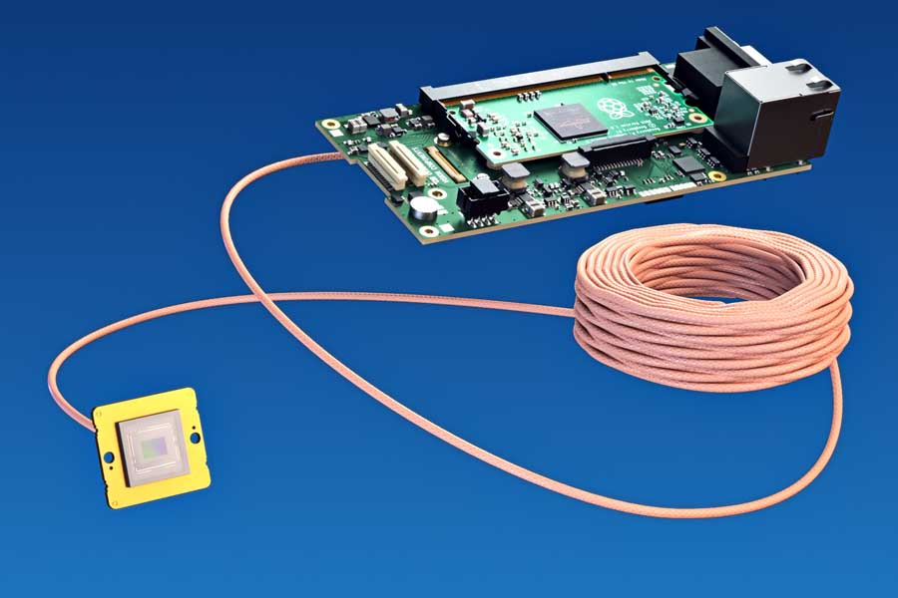
Caption 1: Thanks to an adapter board developed by VC, cables up to 10 meters and longer can now be used with the MIPI interface

VC’s specially developed FPC cable (Flexible Printed Circuit) is available in three standard versions with 15, 22 or 24 pins, in lengths of 60 mm, 100 mm or 200 mm. Thus, it connects to all common single-board computers and CPU boards. Notably, it supports the full performance of the MIPI interface. Most processors feature a processing speed of 1.5 Gbps per lane and four lanes – transfer rates of 6 Gbps are possible, which corresponds to 750 MB/s at an 8-bit pixel resolution. The FPC cables have a trigger input and a flash output. They enable video streams as well as single image acquisition and do not affect the host system. Settings such as shutter speed, gain, image size and position, and binning can be individually adjusted for each image. Using the cables with an external trigger, very fast processes can be detected and synchronized. VC also offers to design customer-specific cables for special requirements, for example, featuring an external trigger output or allowing connection of an I/O board. In addition, Vision Components has developed repeater boards that enable up to five times longer transmission paths.

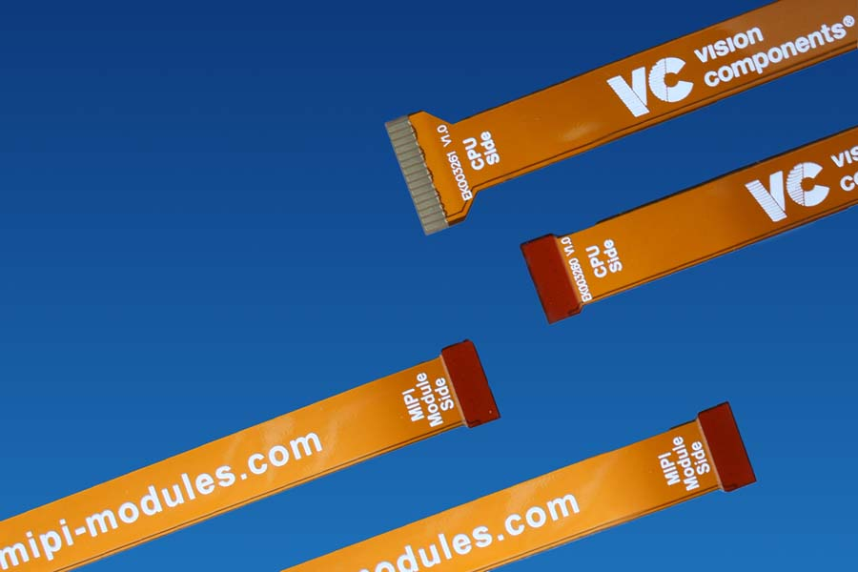
Caption 2: VC MIPI cables are available in several variants for connection of all single-board computers – including customized designs

Image/s: | vc_coax_mipi_cable  vc_mipi_cables_22-22_22-15 | Characters: | 1427
File name: | 202202012_pm_vc_mipi_cables_en | Date: | 02-22-2022
About Vision Components
Vision Components is a leading international manufacturer of embedded vision systems. The freely programmable cameras with powerful onboard CPUs perform image processing tasks on their own without the need for an additional computer. Vision Components offers OEMs versatile Linux-based embedded systems for 2D and 3D image processing, supplied as board cameras or in protective casings. These are complemented by a growing range of ultracompact MIPI camera boards, which connect to a variety of different CPU boards. In addition, Vision Components offers software libraries and develops customized solutions on request. The team of experts can draw on extensive knowledge and over 20 years of experience with imaging applications. The company based in Ettlingen in southwestern Germany was founded in 1996 by Michael Engel, the inventor of the first industrial-grade intelligent camera. More world premieres followed, including the world's first intelligent vision sensors and the first-ever embedded 3D laser profiler. Today, Vision Components has sales offices in the United States and Japan and works with local partners in over 25 countries to provide consistent customer focus and readily available expertise throughout the world.
Contact:  Vision Components GmbH  Jan-Erik Schmitt  Ottostr. 2  76275 Ettlingen  Germany  Phone: +49 . 7243 . 21670  Email: schmitt@vision-components.com  Internet: www.vision-components.com |  | gii die Presse-Agentur GmbH  Immanuelkirchstr. 12  10405 Berlin  Germany  Phone: +49 . 30 . 538 9650  Email: info@gii.de  Internet: www.gii.de

