Press Release

MedtecLIVE: Embedded Vision for optical diagnostics and life sciences – now including SWIR MIPI modules

At the MedtecLIVE trade fair in Stuttgart, Germany, Vision Components (booth #10-303) will showcase its latest MIPI camera modules and embedded vision systems for medical and laboratory applications such as point-of-care diagnostics. Embedded vision has significant advantages for this sector, enabling economic, versatile and, if required, portable solutions for autonomous operation without external computing units. VC camera modules with a MIPI CSI-2 interface work with various powerful processor boards and offer a wide choice of image sensors. The manufacturer has even integrated sensors that feature no native MIPI interface by fitting the compact, lightweight modules with an onboard converter. Examples include sensors from the Sony Pregius and Sony Starvis series, which offer high imaging quality, light sensitivity and frame rates and are ideally suited for medtech applications.

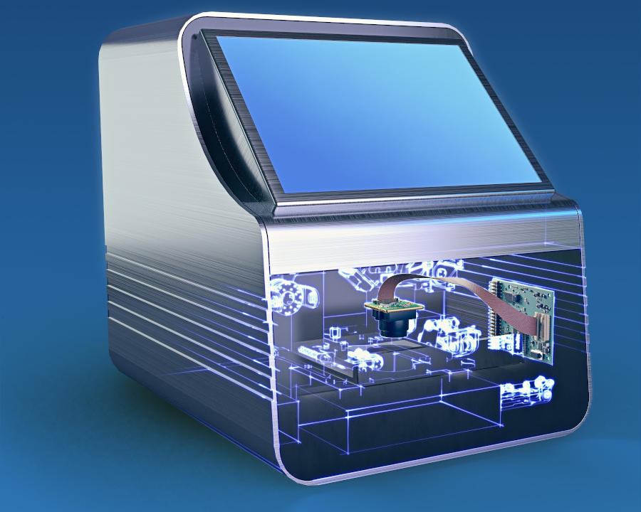
Caption: MIPI camera modules and embedded vision systems with high-end image sensors enable point-of-care diagnostics – portable and without additional computers

Vision Components is continuously expanding its range of MIPI camera modules for medical and life science applications; latest additions include sensors for SWIR imaging. The manufacturer also offers custom development. Drawing on the already completed groundwork and the modular design concept, customization and series qualification are time-saving, easy and economic. All MIPI camera modules and embedded vision systems from Vision Components are long-term available and suitable for commercial solutions.
Vision Components at the MedtecLIVE trade fair
Stuttgart, Germany, 3 – 5 May 2022
Hall 10, Stand 303

Image/s: | vc_mipi_appl_poc_diagnostics | Characters: | 1401
File name: | 202203008_pm_medteclive_en | Date: | 03-15-2022
About Vision Components
Vision Components is a leading international manufacturer of embedded vision systems. The freely programmable cameras with powerful onboard CPUs perform image processing tasks on their own without the need for an additional computer. Vision Components offers OEMs versatile Linux-based embedded systems for 2D and 3D image processing, supplied as board cameras or in protective casings. These are complemented by a growing range of ultracompact MIPI camera boards, which connect to a variety of different CPU boards. In addition, Vision Components offers software libraries and develops customized solutions on request. The team of experts can draw on extensive knowledge and over 20 years of experience with imaging applications. The company based in Ettlingen in southwestern Germany was founded in 1996 by Michael Engel, the inventor of the first industrial-grade intelligent camera. More world premieres followed, including the world's first intelligent vision sensors and the first-ever embedded 3D laser profiler. Today, Vision Components has sales offices in the United States and Japan and works with local partners in over 25 countries to provide consistent customer focus and readily available expertise throughout the world.
Contact:  Vision Components GmbH  Jan-Erik Schmitt  Ottostr. 2  76275 Ettlingen  Germany  Phone: +49 . 7243 . 21670  Email: schmitt@vision-components.com  Internet: www.vision-components.com |  | gii die Presse-Agentur GmbH  Immanuelkirchstr. 12  10405 Berlin  Germany  Phone: +49 . 30 . 538 9650  Email: info@gii.de  Internet: www.gii.de

